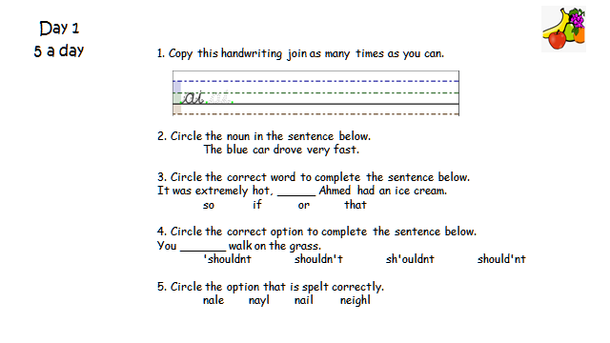

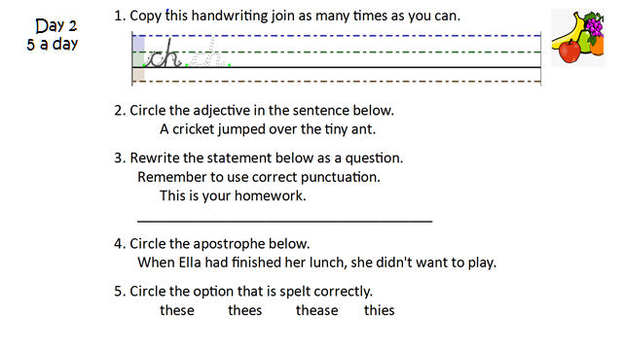
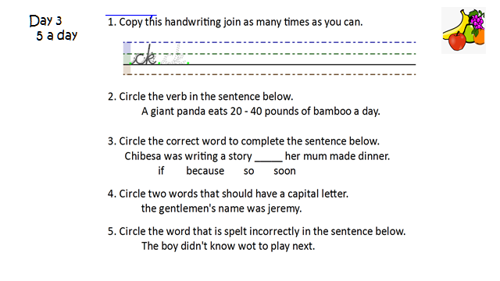
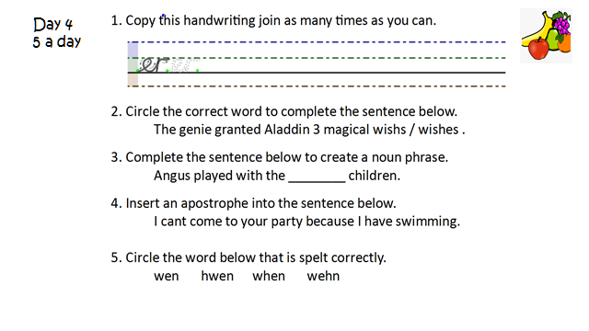
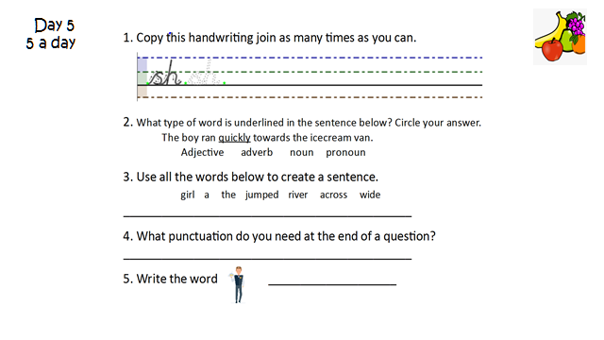
Task one:

Type the URL into Google and watch this video:

https://youtu.be/lvMFQoOk4To

Underline the verb in each sentence:

I like to walk in the park.

The boy likes to play in the garden.

The girl threw the ball.

I eat fruit every day.

The dog drinks water from the bowl.

Task two:

Below is a picture of The Edge at Paulton’s Park.
Write 5 sentences about the ride and underline the verbs you have used.
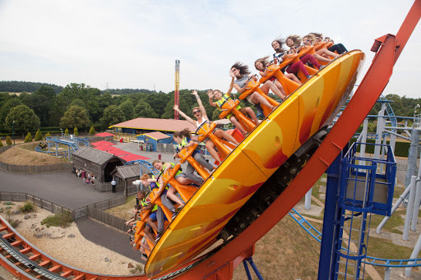

- _________________________________________________________________________________________________________
- _________________________________________________________________________________________________________
- _________________________________________________________________________________________________________
- _________________________________________________________________________________________________________
- _________________________________________________________________________________________________________
Task three:

Type the URL into Google and watch the video: https://youtu.be/nn39CxCzHjg

Write a paragraph describing The Edge at Paulton’s Park.

When writing you paragraph, think about about:
What can be heard?
What does the ride do?
What is the motion of the ride?

________________________________________________________________________________________________________________________________________________________________________________________________________________________________________________________________________________________________________________________
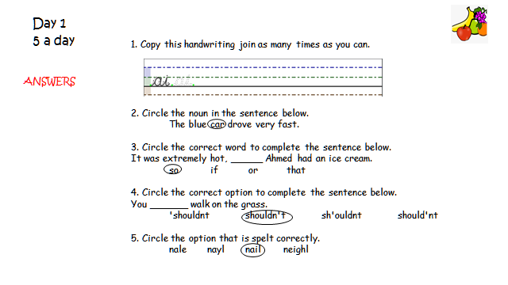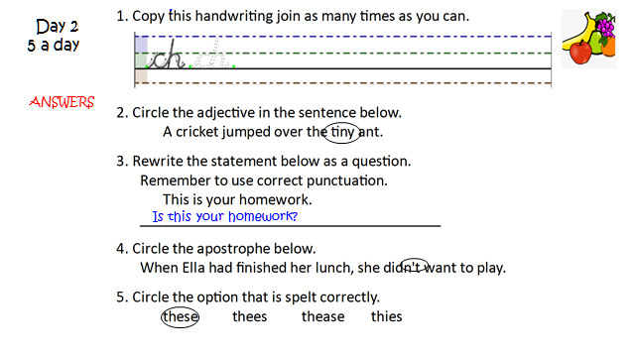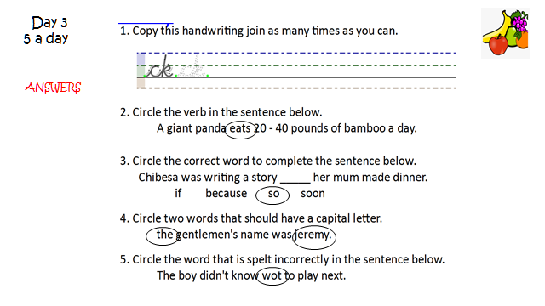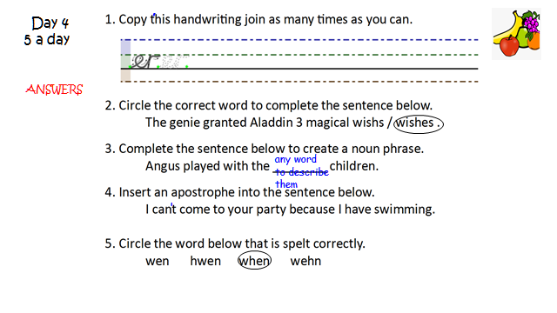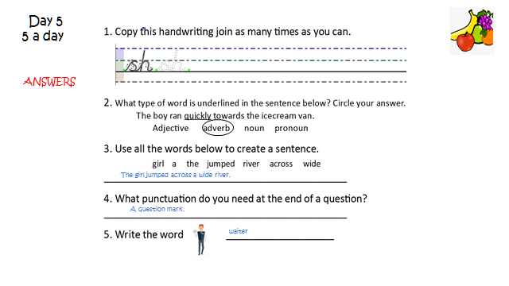

Task one answers:

I like to walk in the park.

The boy likes to play in the garden.

The girl threw the ball.

I eat fruit every day.

The dog drinks water from the bowl.

