Monday
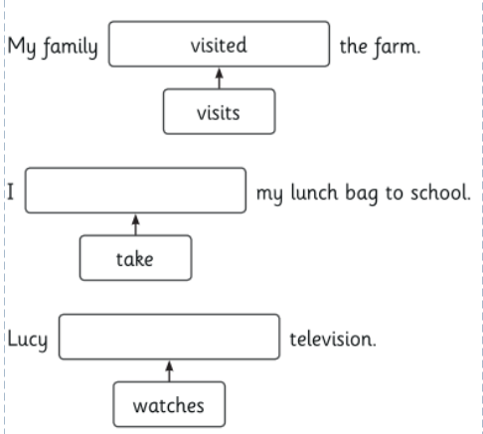
- The verbs in the boxes are in the present tense.

Write these verbs in the past tense. One has been done for you.

- Underline all the direct speech in the sentence below.
“Buster!” shouted Dad. “Come here, boy!”

- Change the verb in the sentence below to use the present perfect form of the verb.
She eat all of the chocolate cake.

- Can you add commas to this list sentence?
“Would you like garlic mushrooms baked cod lamb chops or squid rings?” asked the waitress.

- Read the sentence below. Circle the preposition that tells you where.
The Butcher’s shop is between the Café and the Bakery.
Tuesday
- Which conjunction would fit best into this sentence?
Nathan had been given lots of money for his birthday _________ he went to the shopping centre to spend it.

- Write these as contracted apostrophe words:
did not - _________ I am - ___________

- Underline the adverb in this sentence
The dog barked softly.

- Write these verbs in their past tense form.
I walk - ______________
I sleep - _____________
I take - _____________

- Can you write the correct pair of homophones to match these pictures?

______________

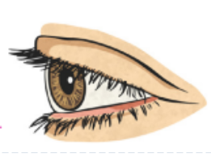

Wednesday
- Add inverted commas in the correct places in the sentence below.
Please could you get your shoes in, Michael? asked Mum.

- Draw lines to match the words below to the appropriate prefix
- Read this sentence. Underline the subordinate clause

We are going to Cornwall on holiday because we like the scenery there.

- Write these verbs in their past tense form:
I stand - __________
I try - __________
I blow - __________

- Can you turn these words into plurals?
church - _______
fly - _________
loaf - _________
leaf - ________

Thursday
- Which sentence is punctuated correctly?
Our parents always say “work hard and do your best.” _____
Our parents always say, “work hard and do your best.” _____
Our parents always say, “Work hard and do your best.” _____
Our parents always say “Work hard and do your best.” _____

- Underline the three nouns in the sentence below
The fire gave the room a cosy feeling.

- How does the conjunction change the meaning of the second sentence?
We listened to the music after we ate our lunch.
We listened to the music while we ate our lunch.
__________________________________________________________________________________________________________________________________________________________________

- Circle the word that shows that the sentence below is a command.
To see pictures of the rugby match, click here.

- What does the prefix ‘multi-‘ mean in the words multicultural, multipurpose and multi-coloured?
____some _____ few _____all _____many

Friday
- Circle two words in the passage below that are synonyms of each other.
Having queued for over an hour, Sanjit found that his tolerance was being severely tested, Most of the other children had lost patience and gone elsewhere.
- Which sentence must not end with an exclamation mark?
You really must wear a coat. _____
What a dreadful day I had. ___
What is the temperature now. ____
The wind is very strong today. ____

- Insert a comma in the correct place in the sentence below.
Every night Dad and my brother take the dog for a walk.

- What word class is him in the sentence below?
Josef’s friends rushed to meet him, desperate to see if he had won.
a preposition an adjective a pronoun a noun

- What kind of clause is underlined in the sentence below?
If they could afford to, the ancient Romans ate well
ANSWERS Monday
- The verbs in the boxes are in the present tense.

Write these verbs in the past tense. One has been done for you.
took

watched

- Underline all the direct speech in the sentence below.
“Buster!” shouted Dad. “Come here, boy!”

- Change the verb in the sentence below to use the present perfect form of the verb.
She ate all of the chocolate cake.

- Can you add commas to this list sentence?
“Would you like garlic mushrooms, baked cod, lamb chops or squid rings?” asked the waitress.

- Read the sentence below. Circle the preposition that tells you where.
The Butcher’s shop is between the Café and the Bakery.
ANSWERS Tuesday
- Which conjunction would fit best into this sentence?
Nathan had been given lots of money for his birthday ___so___ he went to the shopping centre to spend it.

- Write these as contracted apostrophe words:
did not - _didn’t__ I am - __I’m___

- Underline the adverb in this sentence
The dog barked softly.

- Write these verbs in their past tense form.
I walk - __I walked____
I sleep - _I slept__
I take - __I took____

- Can you write the correct pair of homophones to match these pictures?

___sea____

see

ANSWERS Wednesday
- Add inverted commas in the correct places in the sentence below.
“Please could you get your shoes in, Michael?” asked Mum.

- Draw lines to match the words below to the appropriate prefix
- Read this sentence. Underline the subordinate clause

We are going to Cornwall on holiday because we like the scenery there.

- Write these verbs in their past tense form:
I stand - __I stood___
I try - __I tried____
I blow - __I blew____

- Can you turn these words into plurals?
church - __churches__
fly - __flies___
loaf - _loaves___
leaf - _leaves__

ANSWERS Thursday
- Which sentence is punctuated correctly?
Our parents always say “work hard and do your best.” _____
Our parents always say, “work hard and do your best.” _____
Our parents always say, “Work hard and do your best.” __X___
Our parents always say “Work hard and do your best.” _____

- Underline the three nouns in the sentence below
The fire gave the room a cosy feeling.

- How does the conjunction change the meaning of the second sentence?
We listened to the music after we ate our lunch.
We listened to the music while we ate our lunch.
The conjuction while shows that the listening to music and eating were happening at the same time but in the first sentence after indicates the ate and then listened to music.

- Circle the word that shows that the sentence below is a command.
To see pictures of the rugby match, click here.

- What does the prefix ‘multi-‘ mean in the words multicultural, multipurpose and multi-coloured?
____some _____ few _____all ___X__many

Friday
- Circle two words in the passage below that are synonyms of each other.
Having queued for over an hour, Sanjit found that his tolerance was being severely tested, Most of the other children had lost patience and gone elsewhere.
- Which sentence must not end with an exclamation mark?
You really must wear a coat. _____
What a dreadful day I had. ___
What is the temperature now. _X___
The wind is very strong today. ____

- Insert a comma in the correct place in the sentence below.
Every night, Dad and my brother take the dog for a walk.

- What word class is him in the sentence below?
Josef’s friends rushed to meet him, desperate to see if he had won.
a preposition an adjective a pronoun a noun

- What kind of clause is underlined in the sentence below?
If they could afford to, the ancient Romans ate well
_____Subordinating clause_________

