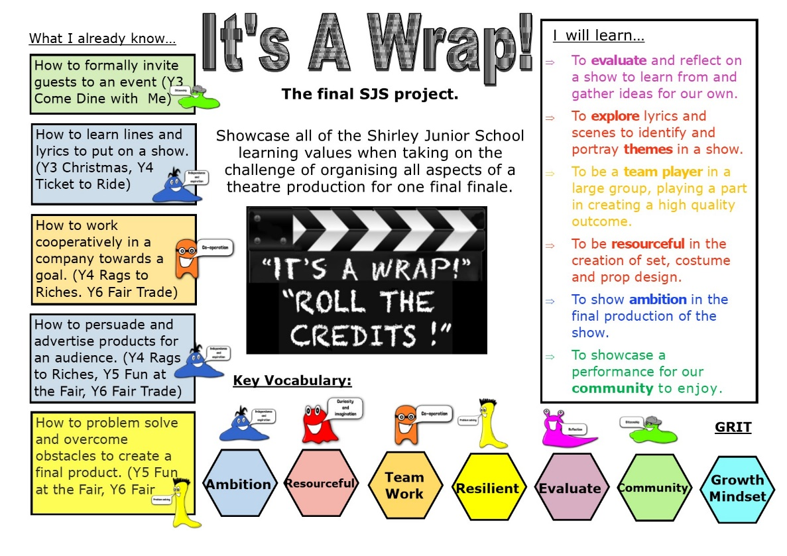
Year 6
It’s a Wrap - Project
Home Learning

Hi Year 6,
This is week ten of your home learning. You will need to complete the steps and tasks in order. The learning value we are mainly focusing on is Independence this week. As always we want you to take care with your handwriting and presentation and are really looking forward to seeing some of the great learning we know you will complete this week so we can add this to our year 6 Star Learning page on the website.

Have fun with your learning!

Mrs Davie, Mrs Booth, Mrs McQuay and Mr Richards

This week we will be exploring the script (the written story for actors to use to perform) and will be writing our own script for a scene.
Year 6 - Task one* – To explore the features of play scripts
Read the script below
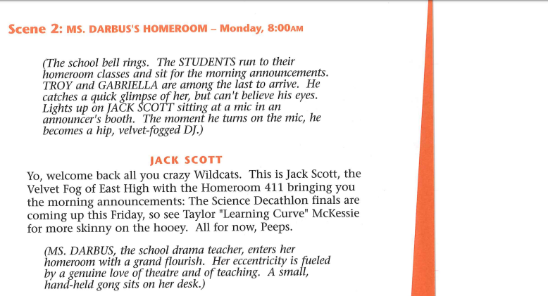

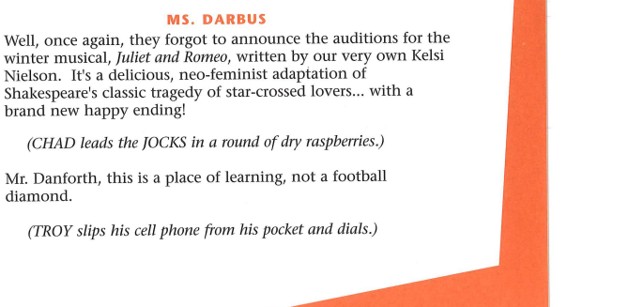

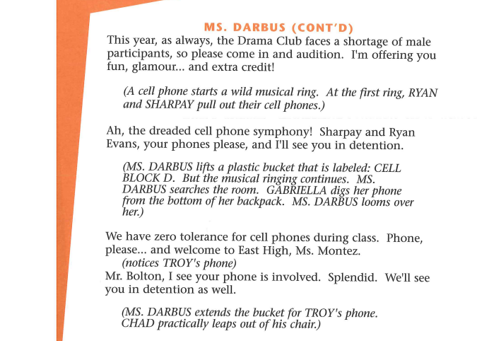

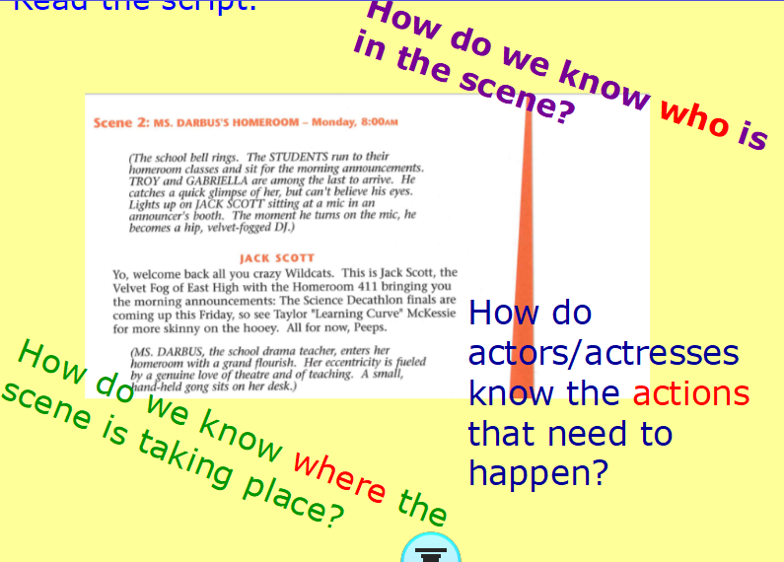

Watch this BBC Bitesize clip that reminds you about how scripts are written
https://www.bbc.co.uk/bitesize/topics/zsn4h39/articles/zx8kng8
Cut out the script above and stick it into your project book under the title – To explore the features of Playscripts. Annotate the features that can be found in the High School Musical Script.
(Character list, Scene title, Setting description, Stage directions, Dialogue, Character, Colon)
Which features are missing?
Can you rewrite a section of the initial script (Scene 2 – Mrs Darbus’ Homeroom) to include all the features above?

Year 6 - Task two* – To plan a ‘deleted scene’ from High School Musical .
Reflect on High School Musical (you could re watch it with this idea in mind) is there any part of the movie that needs more detail? That could have been made more important? Or is there an alternative scene you would love to create?
Choose from:
a)Whispers – the whispers in the corridor after the call backs are announced
b) Team Meet – the Basketball team meeting to plan to stop Troy auditioning
c) Your own scene that you would like to create that would fit into the movie – an alternative ending, a different beginning etc
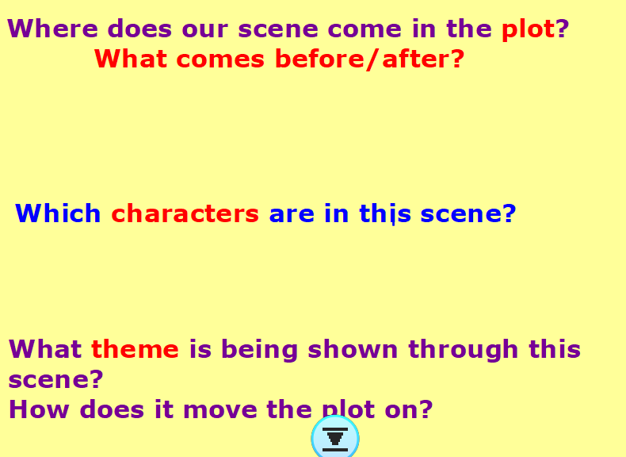

Step 1: Plan where the scene comes in the plot and who the characters involved would be. Cut out the planning proforma and stick it into your book under the title- To plan a deleted scene from High School Musical

Deleted Scene:
Where does it come in the High School Musical plot? | Before the deleted Scene | After the deleted Scene
Who are the characters in this scene?
What are the events in your scene? How do they show the themes/ move on the story?
My title for the scene:

Step 2: In your book create a story plan for your scene – this could be a map, a story mountain, timeline or even a comic strip of how the scene progresses.
Think about where the story is happening, which characters are interacting, which characters are extras in the scene and the purpose of the scene.

Year 6 - Task three* – TKD features of play scripts in a ‘deleted scene’
Look carefully at your scene plan. Who is in the scene? What are they saying? Why is the scene important? How do the characters react/act?
Step 1: Using your learning from task 1, create your own steps to success for an effective play script.
Steps to Success:
Have I…
-
-
-
Step 2: In your book, write your deleted scene in the style of a play script.

Step 3: Read your script a loud – you could even recreate the scene with your family and send it in (we’d love to see it if you’re brave enough to film it). Is there anything that needs editing? Adapting? Are there extra stage directions that need to be included?

As always we cannot wait to see your work - whether in written form or via video replay of your scene! Have fun with the script!

Please send your learning to Y6teachers@shirleyschools.co.uk. We really can’t wait to hear from you!

