Literacy – Monday 5-a-day
1. Correctly punctuate the sentence below with inverted commas.

Gemma? asked Chloe. Do you like these sweets?

2. Re-write these words with a or an before them. Eg:

elephant à an elephant
fox _____________
giraffe _____________
aardvark _____________
deer _____________

3. Underline the nouns in the sentence below.

George looked at the giant wardrobe and felt a shiver of fear.

4. Underline the preposition in the sentence below.

Lucy reached out and stroked the fur of the coat hanging next to her mother’s favourite dress.

5. Complete the sentence with the correct punctuation.

Grandma eyed James warily. “And where, exactly, do you think you’re going __”

Literacy – Tuesday 5-a-day
1. the children met at the park it was very busy
Re-write this sentence and put in any missing full stops and capital letters.
______________________________________
______________________________________
2. “Does it work ” asked the young girl.
Write in the missing punctuation.

3. The lions raced through the long grass.
Put a circle around the word that shows there is more than one lion.

4. The small kitten tried to climb up the tall tree.
Put a circle around the adjectives in this sentence.

5. The boys ran as fast as they could towards the ice cream van.
Put a circle around the verb in this sentence.

Literacy – Wednesday 5-a-day
1. Owls are brilliant hunters because they have excellent hearing to help catch their prey.
Put a circle around the conjunction in this sentence.

2. Which of these sentences needs a question mark? Tick the correct answer.
I am very unhappy to hear your news
Why are you making such a mess
Go and help your dad
I want some chocolate now

3. John Mary and Peter walked home from school.
Put a comma in the correct place in the sentence.

4. Write the following verbs in the past tense:
jump _______________________
run _______________________
cry _________________________

5. I don’t think that is a good idea said Molly.
Put inverted commas in the correct place in this sentence.

Literacy – Thursday 5-a-day
1. Add either a or an before the following words (one has been done for you.)
a rock
_______ tree
_______ chair
_______ apricot
_______elephant
2. _________ coats were hanging on the pegs outside the new classroom.
Select the correct homophone (there, their or they’re) and complete the sentence

3. Underline the vowels in this word
dinosaur
4. You do not need to worry about that, grumbled Dad. You just need to worry about shutting the door.
Put inverted commas in the correct place in this sentence.
5. Write the un-contacted forms of these words:

don’t _____________________
can’t _____________________
won’t_____________________

Literacy – Friday 5-a-day
1. Correctly punctuate the sentence below.

miss fearn who is the year leader read a book to her class

2. Re-write these words in the past tense. e.g.:

playà played
ask _____________
awake _____________
come _____________
buy _____________

3. Underline the adjectives in the sentence below.

Eva saw the enormous, juicy peach and grinned widely.

4. Underline the plurals in the sentence below.

The children were all keen to help round up all the sheep.

5. Complete the sentence with the correct punctuation for relative clauses.

James who by now was falling asleep asked where his room was.

Literacy - Lesson 1
Task One
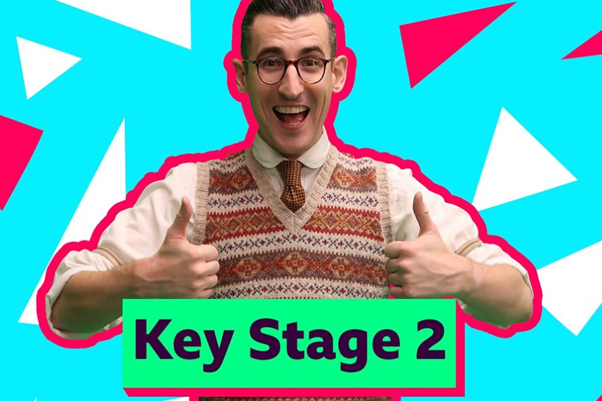
Watch the video about parentheses on the BBC Bitesize website:
https://www.bbc.co.uk/bitesize/articles/zn8c47h#:~:text=Parenthesis%20is%20a%20word%20or,the%20information%20to%20be%20read.

Parentheses
Brackets, dashes and commas show parentheses (plural of parenthesis).
Parenthesis is a word or clause inserted into a text to show an afterthought or as extra information.
A pair of brackets, commas or dashes can be used to enclose the extra information or afterthought. You can choose which to use depending on how you want the information to be read.
Example
- Brackets: ‘The otter (who was very cute) swam down the river.’ Brackets are used here as the parenthesis isn’t vital to the sentence.
- Commas: ‘The otter, who was swimming in the river, caught a fish.’ Commas are used here as the parenthesis is important to the sentence.
- Dashes: ‘The otter - who wasn’t very clever – stood on some rocks.’ Dashes are used here as the parenthesis is informal.
Watch the second video for added detail on brackets.
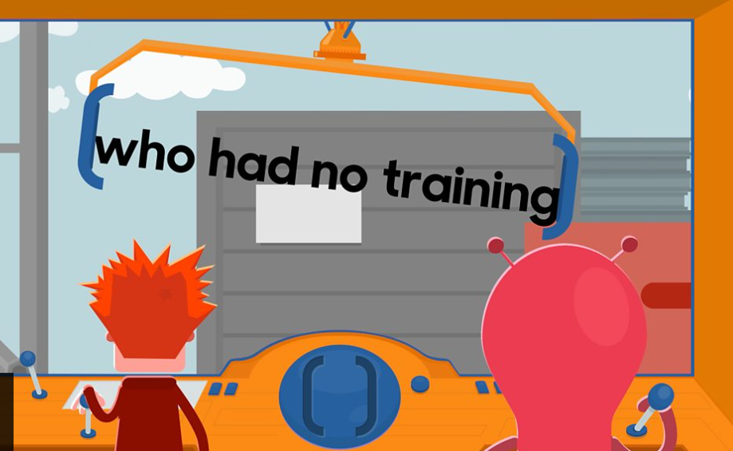

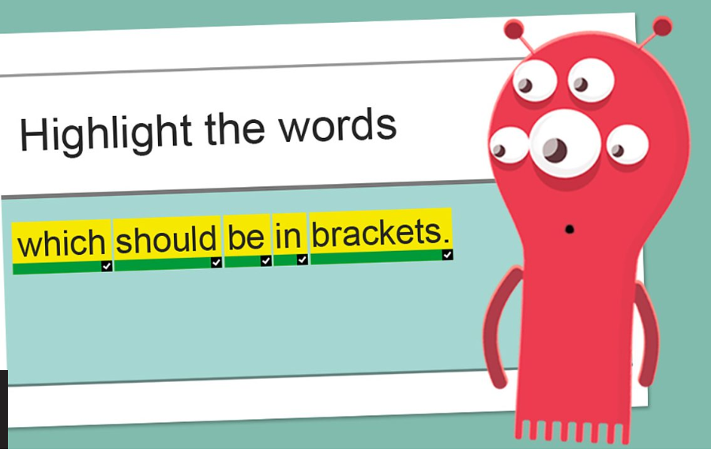
Task Two

Complete the activity beneath the videos.
You will need to highlight 2 parentheses.

Task Three

Look through the PowerPoint (also available as PDF) on the Website for additional detail.
https://www.shirleyjuniorschool.org/page/?title=Week+9+%2815th+June%29&pid=168&action=saved

https://www.shirleyjuniorschool.org/attachments/download.asp?file=579&type=pdf

Literacy - Lesson 2
https://www.youtube.com/watch?v=AseBaZWID7w - Watch the video to start
Parenthesis reminder - Using Viking facts
Commas
Used to punctuate fronted adverbials and relative clauses.
Fronted adverbials = telling you when, where or how something is happening.
Relative clause = adds extra information about the noun.
Brackets
Add extra clarity about something or someone – it could be a name, description or explanation.
Eg – The Vikings kept their meat fresh by covering it in salt (because they didn’t have fridges).
Dashes
To add extra emphasis to your sentence.
Eg – The Vikings would battle for days - often with no chance to sleep – until they had a victor.

Task One
For each of these sentences, add an extra information clause (parenthesis) in the spaces. Remember to mark the start and end of your parenthesis with brackets, commas or dashes.
Vary your punctuation; don’t use just one!
e.g. My brother never brushes his hair!
My brother, who thinks he’s really cool, never brushes his hair! OR
My brother - Jason - never brushes his hair OR
My brother (the scruffiest boy in history) never brushes his hair!

1. I watched a horror film_______________________________________________ and it really scared me! [hint: title?]

2. Dinosaurs _____________________________________________________were a type of reptile. [hint: extinct]

3. We’re not allowed peanut butter _______________________________________in school because there’s a girl who’s allergic to nuts. [hint: packed lunch]

4. The bats ________________________________________________ sleep in our attic during the day. [hint: nocturnal]

5. I lost my phone ___________________________________________ when we went on the Thunder Roller ride. [hint: birthday present]

6. We made popcorn____________________________________________________ for my birthday party. [hint: type?]

7. Simone _______________________________________________ doesn’t speak much English yet. [hint: from where?]

8. We were helping the caretaker____________________________________ to carry all the chairs into the hall. [hint: back ache]

9. There aren’t many apples left ____________________________________because we used them to make a pie. [hint: lots earlier]

10. ‘Blue Peter’ ___________________________________________________has been on TV since the 1960s. [hint: children’s programme]

11. Put some cushions ________________________________________ on the floor and we can lie down to watch the film. [hint: how many?]

12. My dog____________________________________________________ is a very curly labradoodle [hint: name?]

Task Two
For each of these sentences, you need to choose a suitable parenthesis from the box and work out where it should go. Remember to mark the start and end of your parenthesis with brackets, commas or dashes.
Vary your punctuation; don’t just use one!
e.g. The main door of the office is in the basement.
The front door (with the square ‘enter’ button to press) is in the basement.
1. My favourite teddy has only one ear.
_____________________________________________________________________

2. The Empire State building is in New York.
_____________________________________________________________________

3. Most smart phones can be used to play games.
_____________________________________________________________________

4. The cycle track went right through the woods.
_____________________________________________________________________

5. You’ll never guess what I heard Sadie say to Katie!
_____________________________________________________________________

which was full of pot holes | the kind with touch screens | my sister’s friend
with the square ‘enter’ button | to press he’s called Marvin | 381m high

Task Three
Now write three sentences of your own. Each one should be a complex sentence and include a parenthetical piece of information. Remember to use brackets, dashes or commas.
1. __________________________________________________________________

_____________________________________________________________________

2. __________________________________________________________________

_____________________________________________________________________

3.__________________________________________________________________

_____________________________________________________________________

Literacy - Lesson 3
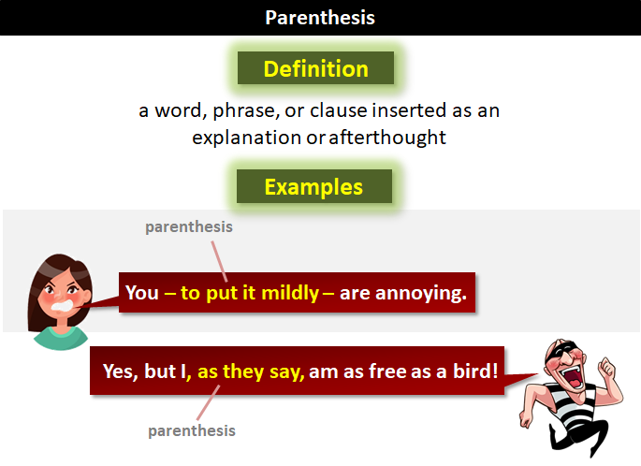
Write about what happened in one of the science investigations you have carried out - including parenthesis for extra information.
If you haven’t completed any of the investigations watch the video and write about what happens in the video with the apple and gravity.
https://www.youtube.com/watch?v=2ydh7AShMzM&feature=youtu.be

Write about your science investigation or Isaac Newton’s science investigation here - how creative could you be?

Now, go back through and check:
-You have used capital letters at the beginning of sentences and for names of people or places
- You have used full stops
- You have used skills we’ve already covered (relative clauses, fronted adverbials, modal verbs, expanded noun phrases and pronouns)
- You have checked any spellings you were unsure of
Have you used a variety of punctuation for your parentheses? Underline the ones you have used.

Literacy - Monday 5-a-day ANSWERS

1. Correctly punctuate the sentence below with inverted commas.

“Gemma?” asked Chloe. “Do you like these sweets?”

2. Re-write these words with a or an before them. Eg:

elephant an elephant
fox a fox
giraffe a giraffe
aardvark an aardvark
deer a deer

3. Underline the nouns in the sentence below.

George looked at the giant wardrobe and felt a shiver of fear.

4. Underline the preposition in the sentence below.

Lucy reached out and stroked the fur of the coat hanging next to her mother’s favourite dress.

5. Complete the sentence with the correct punctuation.

Grandma eyed James warily. “And where, exactly, do you think you’re going ?”

Literacy – Tuesday 5-a-day Answers
1. the children met at the park it was very busy
Re-write this sentence and put in any missing full stops and capital letters.
The children met at the park, it was very busy.

2. “Does it work?” asked the young girl.
Write in the missing punctuation.

3. The lions raced through the long grass.
Put a circle around the word that shows there is more than one lion.

4. The small kitten tried to climb up the tall tree.
Put a circle around the adjectives in this sentence.

5. The boys ran as fast as they could towards the ice cream van.
Put a circle around the verb in this sentence.

Literacy – Wednesday 5-a-day Answers
1. Owls are brilliant hunters because they have excellent hearing to help catch their prey.
Put a circle around the conjunction in this sentence.

2. Which of these sentences needs a question mark? Tick the correct answer.
I am very unhappy to hear your news
Why are you making such a mess ?
Go and help your dad
I want some chocolate now

3. Joh, Mary and Peter walked home from school.
Put a comma in the correct place in the sentence.

4. Write the following verbs in the past tense:
jump jumped
run ran
cry cried

5. “I don’t think that is a good idea,'' said Molly.
Put inverted commas in the correct place in this sentence.

Literacy – Thursday 5-a-day - Answers
1. Add either a or an before the following words (one has been done for you.)
a rock
a tree
a chair
an apricot
an elephant
2. Their coats were hanging on the pegs outside the new classroom.
Select the correct homophone (there, their or they’re) and complete the sentence

3. Underline the vowels in this word
dinosaur
4. “You do not need to worry about that,” grumbled Dad. “You just need to worry about shutting the door.”
Put inverted commas in the correct place in this sentence.
5. Write the un-contacted forms of these words:

don’t do not
can’t can not
won’t will not

Literacy – Friday 5-a-day Answers
1. Correctly punctuate the sentence below.

Miss Fearn, who is the year leader, read a book to her class.

2. Re-write these words in the past tense. e.g.:

play played
ask asked
awake was awake/woke
come came
buy caught

3. Underline the adjectives in the sentence below.

Eva saw the enormous, juicy peach and grinned widely.

4. Underline the plurals in the sentence below.

The children were all keen to help round up all the sheep.

5. Complete the sentence with the correct punctuation for relative clauses.

James, who by now was falling asleep, asked where his room was.

Literacy - Lesson 2 ANSWERS

Task One
Answers may vary.
1. I watched a horror film (Haunted Dreams) and it really scared me! [hint: title?]

2. Dinosaurs, which are now extinct, were a type of reptile. [hint: extinct]

3. We’re not allowed peanut butter (sandwiches) in school because there’s a girl who’s allergic to nuts. [hint: packed lunch]

4. The bats, which are nocturnal, sleep in our attic during the day. [hint: nocturnal]

5. I lost my phone, which I got for my birthday, when we went on the Thunder Roller ride. [hint: birthday present]

6. We made popcorn (sweet & salty) for my birthday party. [hint: type?]

7. Simone, who is from Spain, doesn’t speak much English yet. [hint: from where?]

8. We were helping the caretaker, who had a bad back, to carry all the chairs into the hall. [hint: back ache]

9. There aren’t many apples left - there were lots earlier - because we used them to make a pie. [hint: lots earlier]

10. ‘Blue Peter’ (a popular children’s programme) has been on TV since the 1960s. [hint: children’s programme]

11. Put some cushions - four will be plenty - on the floor and we can lie down to watch the film. [hint: how many?]

12. My dog, whose name is Pickles, is a very curly labradoodle. [hint: name?]

Task Two
1. My favourite teddy has only one ear. My favourite teddy - he’s called Marvin - has only one ear.

2. The Empire State building is in New York. The Empire State building (381m high) is in New York

3. Most smart phones can be used to play games. Most smart phones - the kind with touch screens - can be used to play games.

4. The cycle track went right through the woods. The cycle track, which was full of potholes, went right through the woods.

5. You’ll never guess what I heard Sadie say to Katie! You’ll never guess what I heard Sadie (my sister’s friend) say to Katie!

Task Three
Will be your own ideas

