Summer Term Week 6
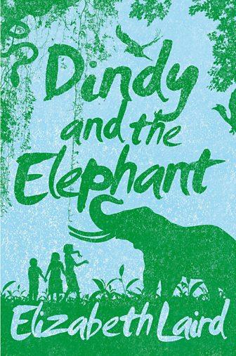
Lesson 1
Visit this website and open the lesson
https://www.bbc.co.uk/bitesize/articles/z62fvk7
Watch TV presenter Ed Petrie read this extract from Dindy and the Elephant .
Think about the following questions.
- Do you know what a cobra snake is and what it looks like?
- How do you think Pog is feeling in this extract?
- Do you think that they will go home now?
Now watch Ed read another extract from Dindy and the Elephant and think about the following questions.
- Are you surprised about the description of the elephants?
- Is it always rude to shout?
- Can we shout sometimes?

Read extract 1:
Something was moving on the ground behind him, across the very bit of the path we had just come down. Something long and thin and grey, that slithered from one side of the path to the other.
I grabbed Pog’s hand.
‘Come on! Run!’
He tried to snatch his hand away.
‘I won’t. I’m going home.’
He turned as if to go back up the path. ‘Pog, you can’t! There’s a snake. A cobra! I saw it!’
And then we were both running, crashing through the bushes, tearing our clothes, scratching our bare legs, until we almost fell out on to the wide track below that ran down to the stream.
Pog was crying. “I told you we shouldn’t have come. I told you! I hate you, Dindy! We might have been bitten to death!’
‘Yes, but we weren’t, were we?’ I was feeling so guilty that I needed to sound extra brave to cover it up. ‘And it mightn’t have been a cobra. It might have been one of the harmless ones.’

Act out this scene with someone at home.
Focus on this part of extract 1 and answer the question below.
Pog was crying. “‘I told you we shouldn’t have come. I told you! I hate you, Dindy! We might have been bitten to death!’
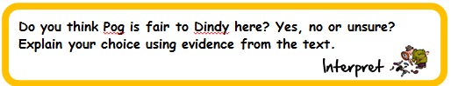
Use the following questions to help you make your decision.
- Is it Dindy’s fault?
- Should Pog say that he hates Dindy?
If you choose ‘Yes’ or ‘No’, you will need two pieces of evidence that support Yes or No.
If you choose ‘Unsure’, you will need one piece of evidence from ‘Yes’ and one from 'No ’.
You might want to organise your answer like this:
I chose...
First Piece Of Evidence | Second Piece Of Evidence
Evidence - | Evidence -

Lesson 2
Read extract 2:
The four working elephants were standing in the shade. They were chained by the back legs to huge posts. They stood quite still, their trunks limp and drooping, as if they were resting. Only their ears flapped from time to time as they tried to shake off the flies that buzzed around their eyes.
Pog and I had seen the estate’s tame working elephants quite often before. They weren’t usually at this end of the tea plantation, but sometimes, when they were, Daddy would drive us down in his car as a treat to look at them. We’d even ridden on an old one once. I’d been a bit scared of falling off, but Pog had loved it. He’d shouted so loudly that the mahout (the man who looked after the elephants) had to tell Daddy to keep him quiet in case the elephant got upset.
'Why don’t we shout and see if anyone will come?’ I said.
‘You don’t want to scare the elephants,’ said Nikhil. ‘And, anyway, we don’t shout. It’s rude.’
I bit my lip. Daddy was always shouting at people. Mother shouted at Sunderam all the time too.

Task 1
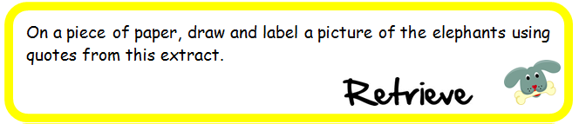
Task 2
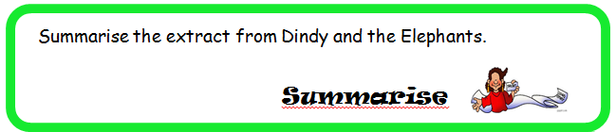
Think about what new information you know now, what has the writer told you.
If a friend who hadn’t read this extract asked you what happened in it, what five things would you tell them?
Have a look back through the text and jot down some important information – it may be an event, a theme, a feeling.
Then number your five pieces of information 1-5 with number one being the most important.
You could share this with somebody at home. Or even better, you could ask somebody at home to do this too and then check each other’s to see if you have chosen any of the same information.
Click here to type
Lesson 3
Read both extracts again and imagine that you are writing a diary entry as one of the children.
You have two decisions to make.
Whose diary do you want to write? Do you feel more in tune with Dindy or Pog?
Which event would you like to recount – the snake or the elephants?
Once you have made your decisions, you can start writing your short diary entry. Aim to write three paragraphs.
Here are some tips to help when writing a diary entry:
- greeting (Dear Diary/Hi Diary) Your greeting should reflect your character
- write in the first person – you are Dindy or Pog so use 'I'/'me'/'my'
- recount the event in the past tense (it has already happened)
- engage with your diary
For example:
- ‘You won’t believe what happened next…’
Remember to end your diary entry appropriately.
For example:
- 'Got to go, dinner is ready.’
Click here to type

Now check that every sentence starts with a capital letter!
We look forward to seeing your diary entries.

