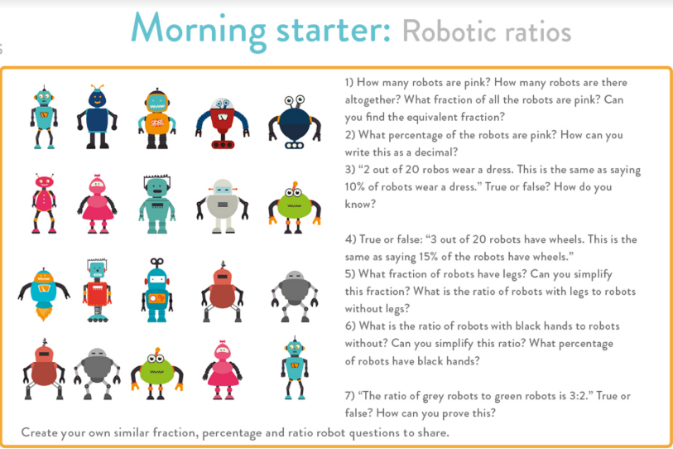**Evidence**

ARE 1

1:5

3:15

2:3

4:6

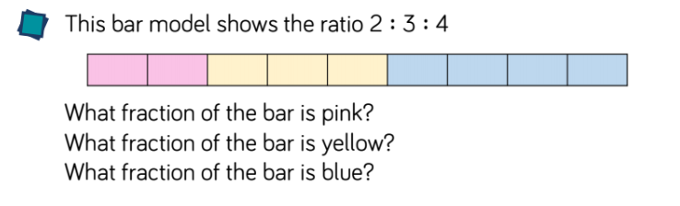

4/9

3/9 or 1/3

2/9

ARE 2

4:3:1

8:6:2

4:5

12:15

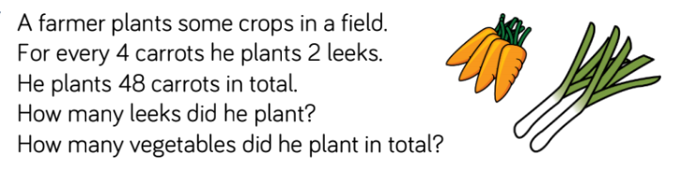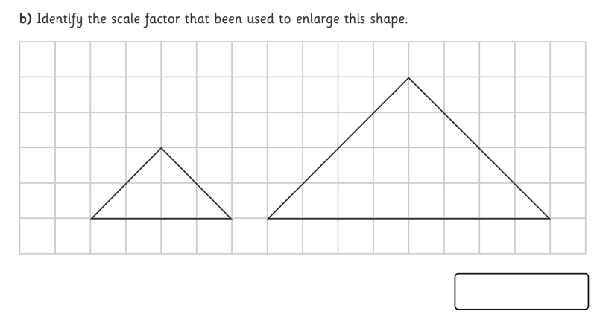File:Green tick.svg - WikipediaFile:Green tick.svg - WikipediaWrong Cross Clipart No BackgroundWrong Cross Clipart No BackgroundFile:Green tick.svg - WikipediaFile:Green tick.svg - WikipediaFile:Green tick.svg - Wikipedia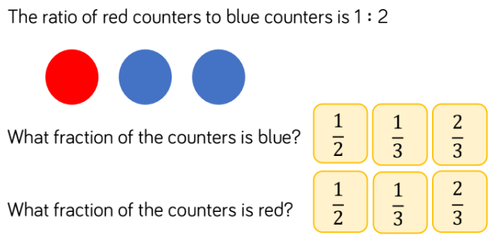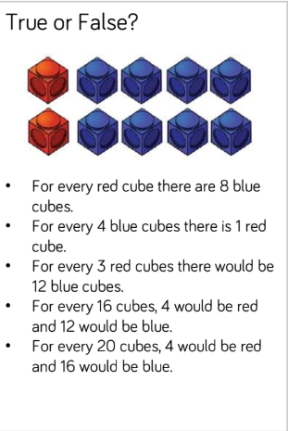

2

ARE 6

The ratio is 4:2. If we multiply by 12 we get 48:24 so he planted 24 leeks and there were 72 vegetables planted in total.

ARE 5

ARE 4

ARE 3

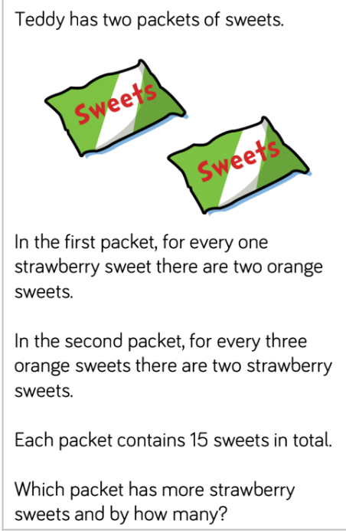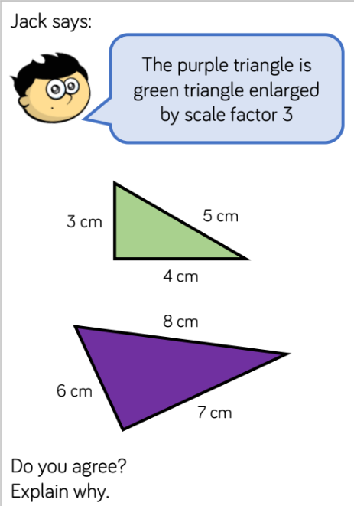

Packet 1

Strawberry : Orange = Total

1 : 2 = 3 (need to x5)

5 : 10 = 15

Packet 2

Strawberry : Orange = Total

2 : 3 = 5 (need to x3)

6 : 9 = 15

Packet 1 has 5 strawberry sweets and Packet 2 has 6 strawberry sweets so Packet 2 has more.

ARE 8

I do not agree. Jack is confused because each side has increased by 3cm, but that does not mean it has increased by a scale factor of 3 because the measurements have not been multiplied.

ARE 7

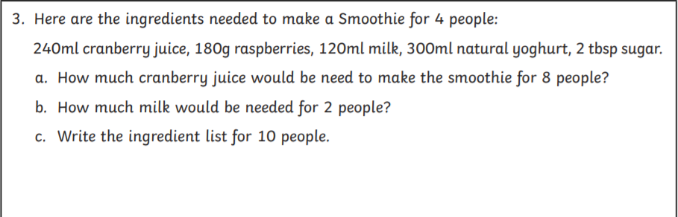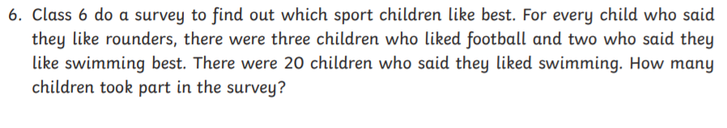

C : R : M : Y : S = Total

240ml : 180g : 120ml : 300ml : 2 tbsp = 4 people

480ml : 360g : 240ml : 600ml : 4 tbsp = 8 people

600ml : 450g : 300ml : 750ml : 5 tbsp = 10 people

b) half the amount for 2 people, so 60ml of milk

c) For 10 people, multiply by 2.5

ARE 10

Rounders : Football : Swimming = Total

1 : 3 : 2 = 6 (need to multiply by 10)

10 : 30 : 20 = 60

60 children took part

ARE 9