Year 6 Maths Questions:
Using a compass, draw and label (radius, diameter, circumference) the following:
- A circle with a radius of 4cm
- A circle with a diameter of 6cm
- A circle with a radius of 5cm
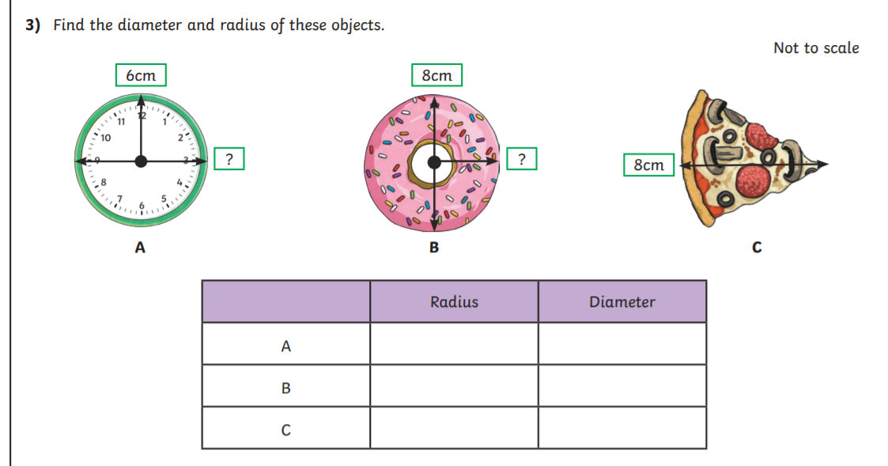
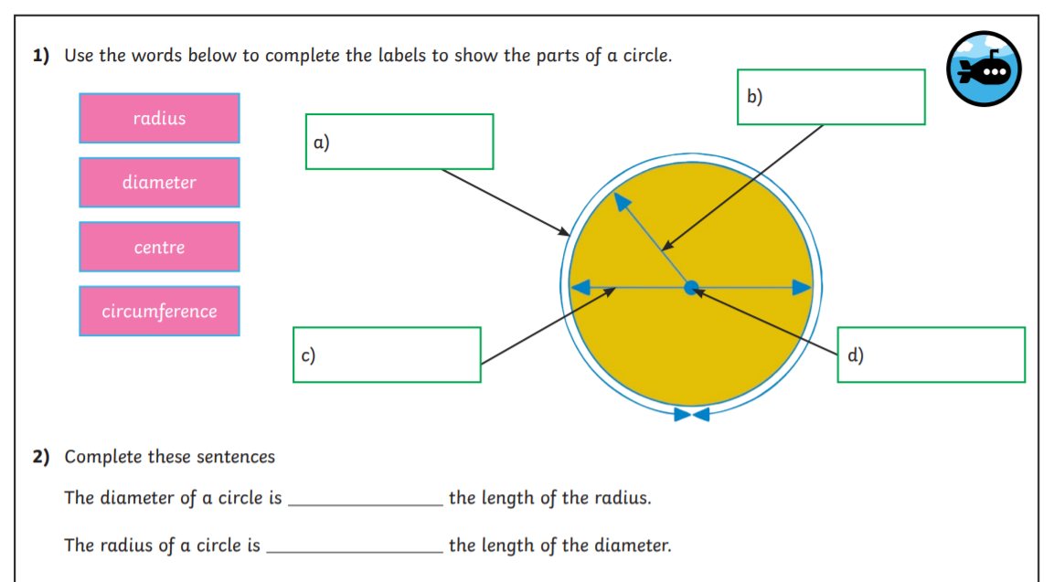
- A circle with a diameter of 12cm
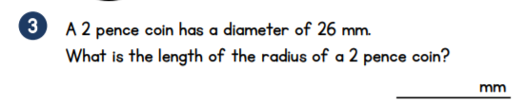
ANSWERS:~
Using a compass, draw and label (radius, diameter, circumference) the following:
- A circle with a radius of 4cm
- A circle with a diameter of 6cm
- A circle with a radius of 5cm
- A circle with a diameter of 12cm
16cm
8cm
4cm
8cm
12cm
6cm
half
Twice/double
Radius
Centre
Diameter
Circumference
13cm

