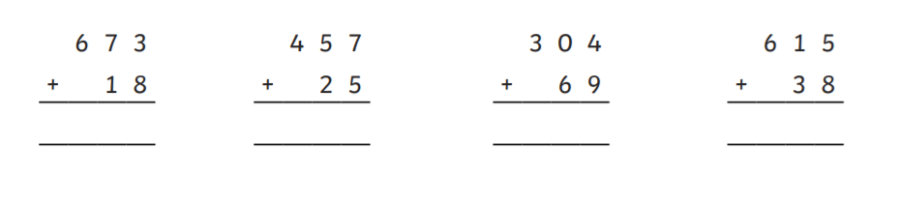5 a day- Day 1:

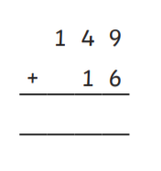

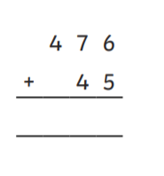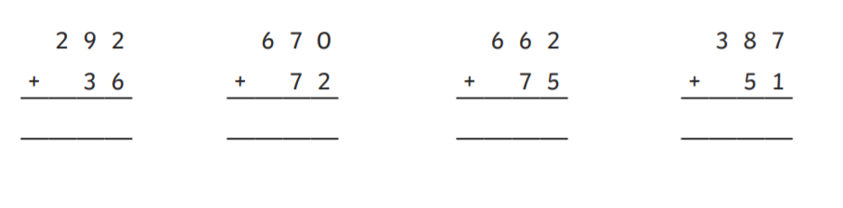5 a day- Day 2:

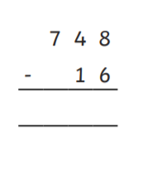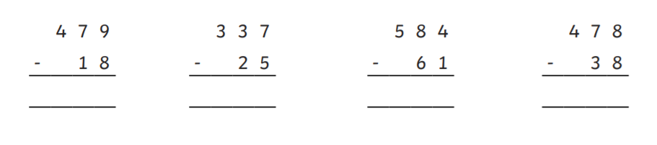5 a day- Day 3:

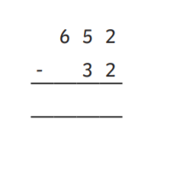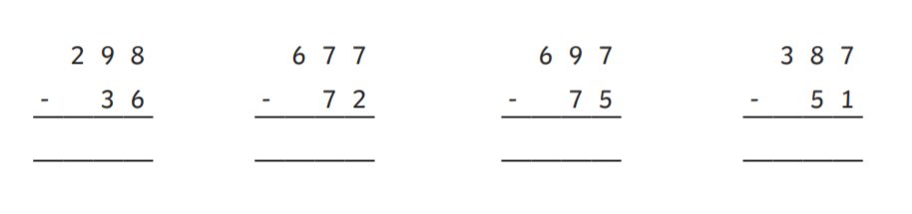5 a day- Day 4:

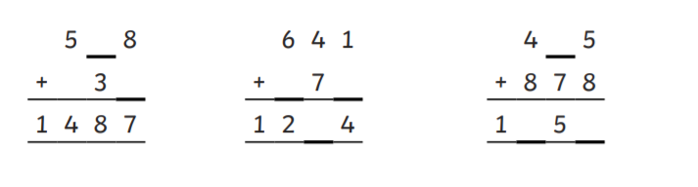5 a day- Day 5:

Task 1: 1s, 10s and 100s.

Watch this video:

<https://kids.classroomsecrets.co.uk/resource/100s-10s-and-1s-video-tutorial/>

The video will ask for you some questions which you can work out on a blank piece of paper.

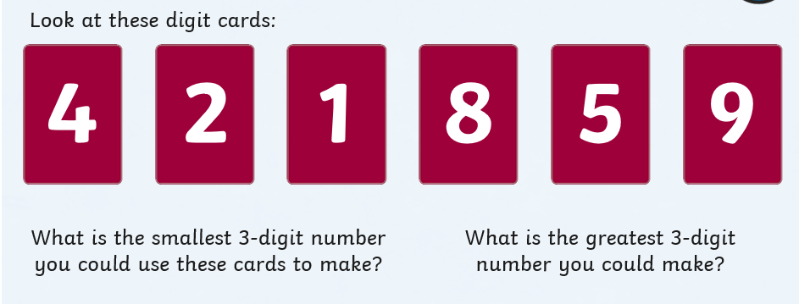Once you have watched the short video, have a go at answering these questions.

Answer:

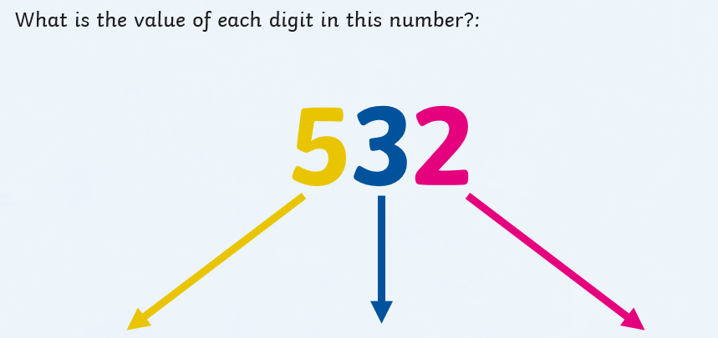

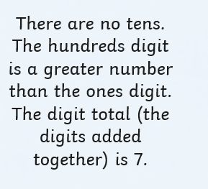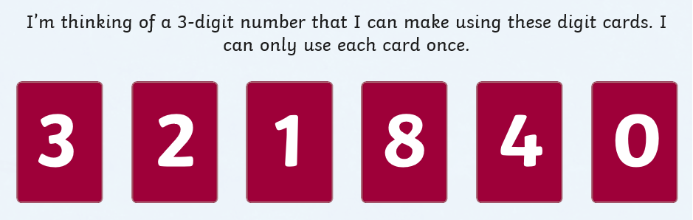

Answer:



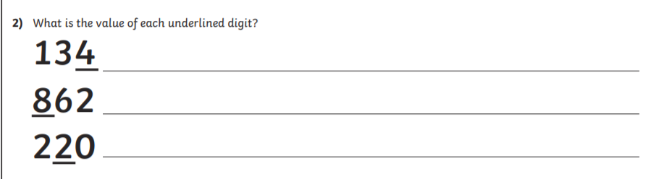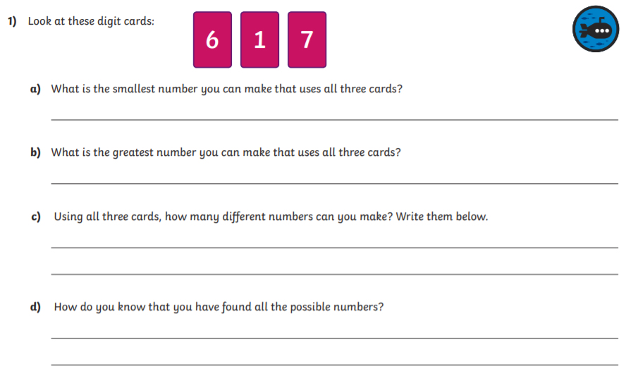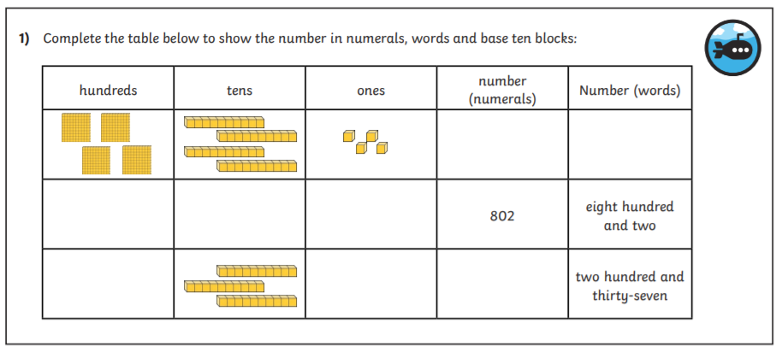Task 2:

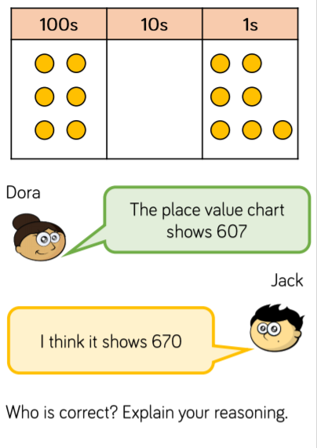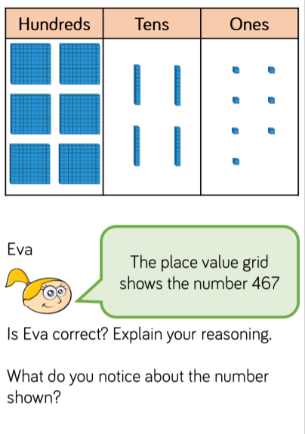Task 3: Challenge.

Answer:

Answer:

Answers:

5 a day:

1. 691
2. 482
3. 373
4. 653
5. 165
6. 328
7. 742
8. 737
9. 438
10. 521
11. 461
12. 312
13. 523
14. 440
15. 732
16. 262
17. 605
18. 622
19. 336
20. 620

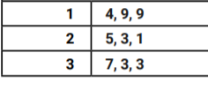

Task 1:

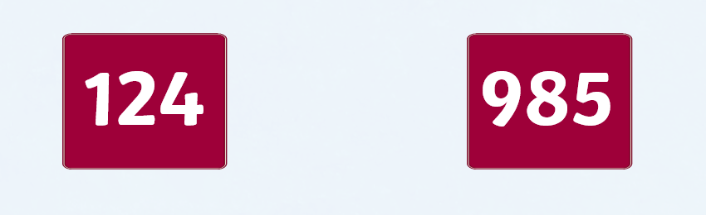

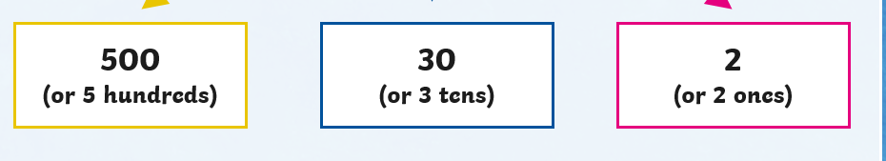

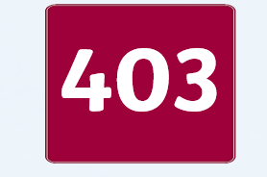

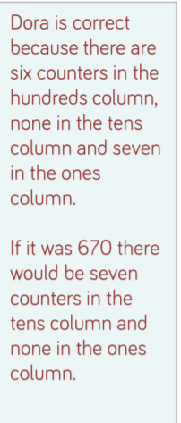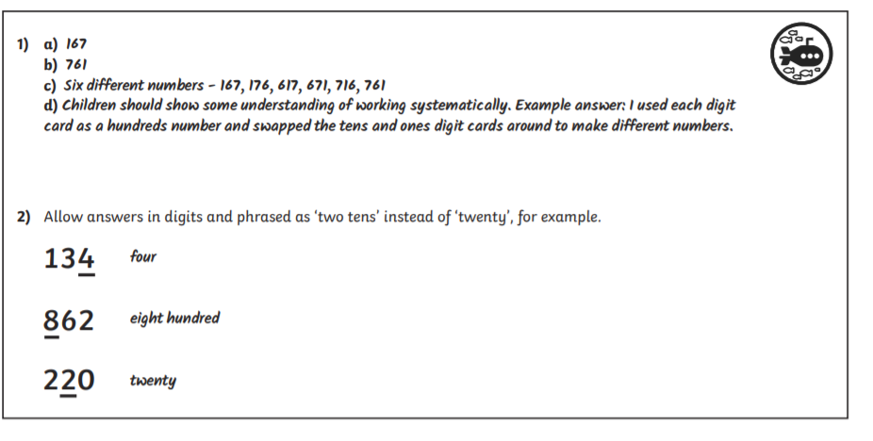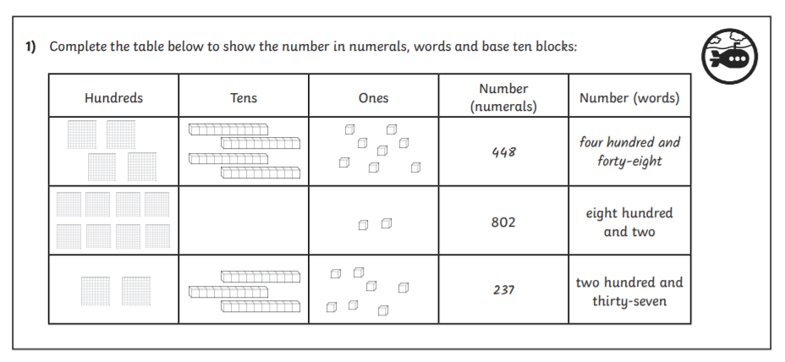Task 2:

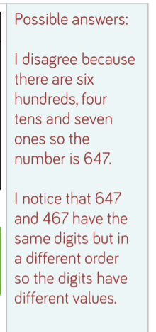

Task 3: