|  |  |
| --- | --- |
| **1st June** | |
| 14 ÷ 1 | 135 − 40 |
| Draw a 4cm line |  |
| Emma is 14 years old.  Her grandmother is 70 years old. | How many years younger is Emma than her grandmother? |
| Here are the heights of five hills. Which hill is the tallest? |  |

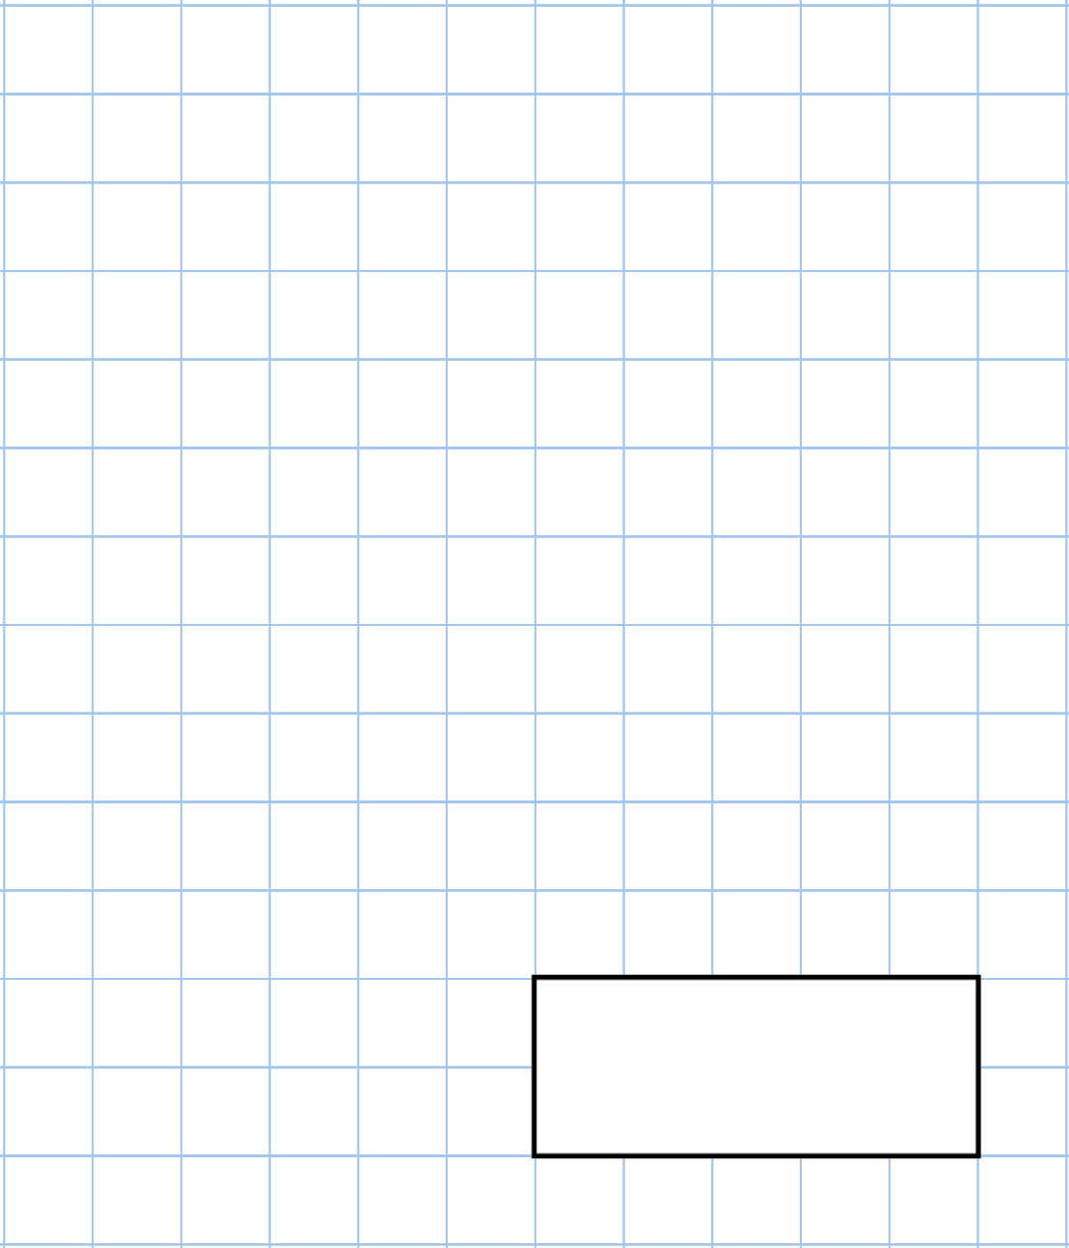

|  |  |
| --- | --- |
| **2nd June** | |
| *7* × 5 | 80 − 33 |
| Scarlett works 8 hours on Monday. She is paid £9 an hour.  How much is Scarlett paid in total? |  |
| Show the time **twenty past seven** on the clock. Move the arms into place on the clock face. |  |
| Circle the cone |  |



|  |  |
| --- | --- |
| **3rd June** | |
| 44 ÷ 4 | 30 × 30 |
| Laura wants to buy a teddy bear. She has £2  How much more money does she need? |  |
| !  Circle the shape that is **not** ! shaded |  |
| Lindsey has written down a three-digit number    All the digits are odd The digits add up to 25 | What could her number be? |



|  |  |
| --- | --- |
| **4th June** | |
| 379 − 200 | 75 + 35 |
| Andrew is putting eggs into cartons Each carton holds 6 eggs.  Andrew has 48 eggs.  How many cartons can Andrew fill? |  |
| The bar chart shows how children at a primary school travelled to school each morning | How many children travelled to school by  **bicycle**? |
| How many **more** children travelled to school by **walking** than by **train**? |



|  |  |
| --- | --- |
| **5th June** | |
| 40 ÷ 8 | 30 × 5 |
|  | Complete the tally chart |
| How many **faces** does a triangular prism have? |  |
| There are 60 people on a coach.  At the next stop, 47 people **get off the coach** and 38 people **get on the coach.**  How many people are on the train **now?** |  |



