**Day 1 – Task 1**

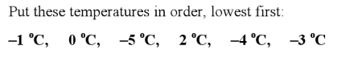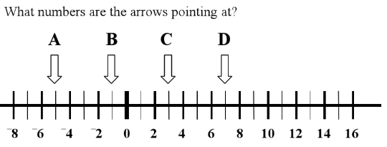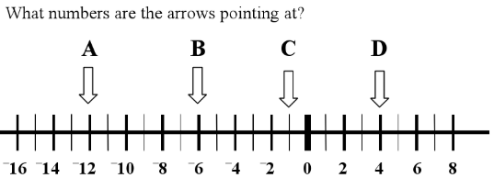1.  
  
  
  
  
  
  
  
  
  
  
  
A = B = C = D =  
  
  
2.   
  
  
  
  
  
  
  
  
  
  
  
A = B = C = D =   
  
  
3.

  
  
  
 0

**Day 2 Questions**  
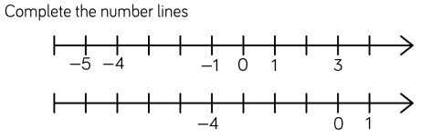  
1.



























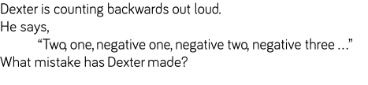2.

3. Complete the thermometer on the right hand side.

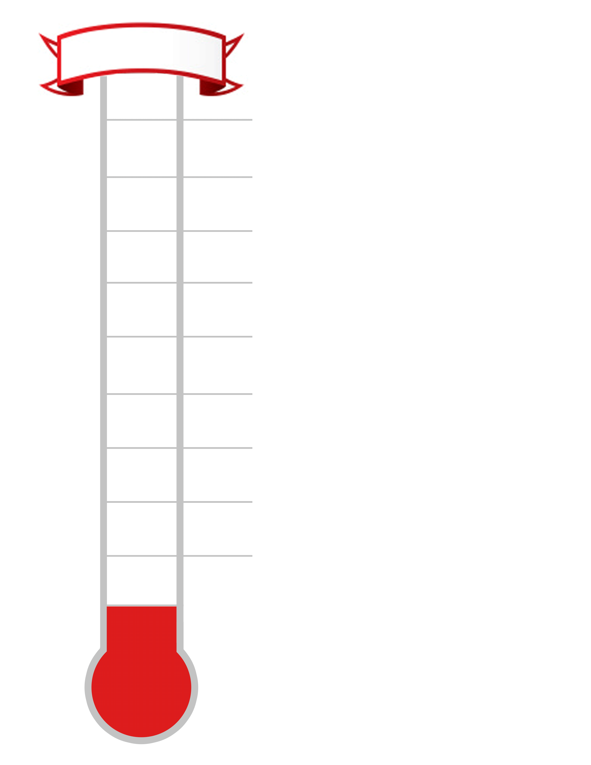

-7oC

-3oC

0oC

9oC

5oC

Use your thermometer to help answer the questions

below.

a) What is 3 more than 6oC? _________

b) What is 5 less than 7oC? __________

c) What is the difference between 8OC and 2oC?

__________

d) What is 3 less than 1oC? __________

e) What is 9 more than -3oC? ___________

f) What is 5 less than -2OC? ___________

g) What is the difference between 3OC and -4OC?

____________

h) What is the difference between -2oC and -8oC?  
 __________

**Day 3 Questions**

***The temperatures of 8 world cities are shown below.***

|  |  |  |  |
| --- | --- | --- | --- |
| **Toronto:** 7oC | **New York:** 9oC | **Harare:** 0oC | **Dubai:** 13oC |
| **Auckland:** -2oC | **Reykjavik:** -7oC | **Tokyo:** 4oC | **Helsinki:** -3oC |

Use the table and your thermometer from yesterday’s questions to answer the questions below:

a) Which city is the coldest? __________________

b) Which city is 3 degrees colder than Toronto? __________________

c) Which city is 5 degrees warmer than Tokyo? __________________

d) Which city is 13 degrees colder than Dubai? __________________

e) Which city is 2 degrees colder than Harare? __________________

f) Which city is 1 degree warmer than Helsinki? __________________

g) Which city is 7 degrees colder than Tokyo? __________________

h) What is the difference in temperature between Reykjavik and Auckland?  
______________

i) What is the difference in temperature between New York and Reykjavik?   
_______________

***The table below shows how the temperatures changed 6 months later.***

|  |  |  |  |
| --- | --- | --- | --- |
| **Toronto:** fell by 10oC | **New York:** fell by 8oC | **Harare:** rose by 8oC | **Dubai:** fell by 5oC |
| **Auckland:** rose by 9oC | **Reykjavik:** fell by 6oC | **Tokyo:** fell by 6oC | **Helsinki:** rose by 4oC |

***Use this information to fill in the table below showing the temperatures in 6 months time.***

|  |  |  |  |
| --- | --- | --- | --- |
| **Toronto:** ___oC | **New York:** ___oC | **Harare:** ___oC | **Dubai:** ___oC |
| **Auckland:** ___oC | **Reykjavik:** ___oC | **Tokyo:** ___oC | **Helsinki:** ___oC |

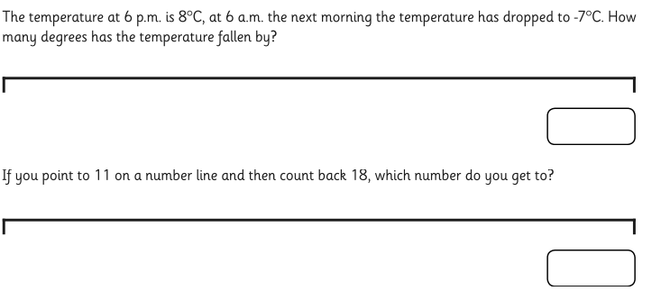2.  
  
  
  
  
  
  
  
  
  
  
  
  
  
  
  
  
  
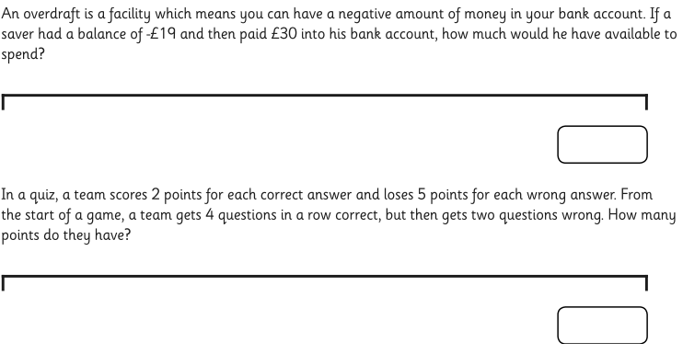

Extra Challenge!

Can you solve this problem?

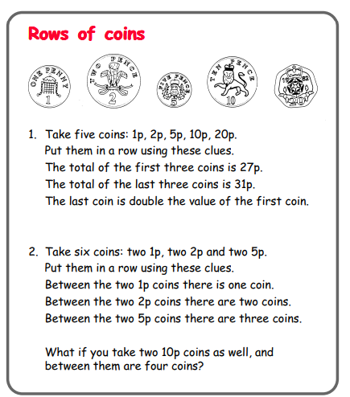

Email your answer to your teacher on   
  
[Y4teachers@shirleyschools.co.uk](mailto:Y4teachers@shirleyschools.co.uk)

**ANSWERS**

1.  
  
  
  
  
  
  
  
  
  
  
  
A = -12 B = -6 C = -1 D = 4   
  
  
2.   
  
  
  
  
  
  
  
  
  
  
  
A = -5 B = -1 C = 1 D = 7  
  
  
3.

  
  
  
 0

-5c, -4c, -3c, -1c, 0c, 2c

**ANSWERS**

Day 2 questions  
  
1.

-1

-2

-3

-5

-6

-7

-8

-9

4

2

-6

-2

-3

2.

He has forgotten to say zero in between one and minus/negative one

3. Complete the thermometer on the right hand side.



-7oC

-3oC

0oC

9oC

5oC

8

Use your thermometer to help answer the questions

7

below.

6

4

a) What is 3 more than 6oC? ____9_____

3

b) What is 5 less than 7oC? _____2______

2

c) What is the difference between 8OC and 2oC?

1

_____6______

-1

-2

d) What is 3 less than 1oC? _____-2______

e) What is 9 more than -3oC? ______6_______

-4

-5

f) What is 5 less than -2OC? ______-7______

-6

g) What is the difference between 3OC and -4OC?

-8

_________7______

h) What is the difference between -2oC and -8oC?  
 _______10_____

**ANSWERS**

Day 3 Questions

***The temperatures of 8 world cities are shown below.***

|  |  |  |  |
| --- | --- | --- | --- |
| **Toronto:** 7oC | **New York:** 9oC | **Harare:** 0oC | **Dubai:** 13oC |
| **Auckland:** -2oC | **Reykjavik:** -7oC | **Tokyo:** 4oC | **Helsinki:** -3oC |

Use the table and your thermometer from yesterday’s questions to answer the questions below:

a) Which city is the coldest? Reykjavik

b) Which city is 3 degrees colder than Toronto? Tokyo

c) Which city is 5 degrees warmer than Tokyo? New York

d) Which city is 13 degrees colder than Dubai? Harare

e) Which city is 2 degrees colder than Harare? Auckland

f) Which city is 1 degree warmer than Helsinki? Auckland

g) Which city is 7 degrees colder than Tokyo? Helsinki

h) What is the difference in temperature between Reykjavik and Auckland? 5c

i) What is the difference in temperature between New York and Reykjavik? 16c

***The table below shows how the temperatures changed 6 months later.***

|  |  |  |  |
| --- | --- | --- | --- |
| **Toronto:** fell by 10oC | **New York:** fell by 8oC | **Harare:** rose by 8oC | **Dubai:** fell by 5oC |
| **Auckland:** rose by 9oC | **Reykjavik:** fell by 6oC | **Tokyo:** fell by 6oC | **Helsinki:** rose by 4oC |

***Use this information to fill in the table below showing the temperatures in 6 months time.***

|  |  |  |  |
| --- | --- | --- | --- |
| **Toronto:** -17oC | **New York:** 1oC | **Harare:** 8oC | **Dubai:** 8oC |
| **Auckland:** 7oC | **Reykjavik:** -13oC | **Tokyo:** -2oC | **Helsinki:** 1oC |

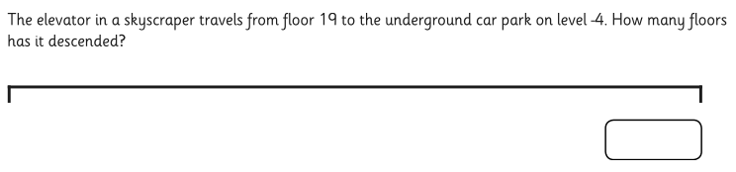2.  
  
  
  
  
  
  
  
  
  
  
  
  
  
  
  
  
  


23

-7

15

-2

£11