Summer 2 Week 6
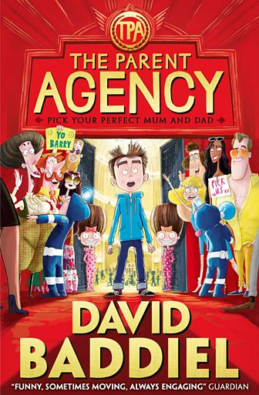
Lesson 1
Barry Bennett hates being called ‘Barry’ and has made a list of ten other things he hates. Barry feels that his friends have better names, better clothes, better birthdays and definitely better parents. Barry wishes he had better parents and is transported to a world where children choose their own.
In the first extract, Barry is planning his birthday party and his younger twin sisters, who he refers to as TSE, The Sisterly Entity, are winding him up with their dad.
Visit this website
https://www.bbc.co.uk/bitesize/articles/zc7dbqt
and watch David Baddiel, the author of The Parent Agency, read an extract from the book.
Think about the following:
- How do Ginny and Kay (the twins) react to Barry?
- Do you think Barry’s suggestions for his birthday are over-the-top?
- Are you surprised by his parents’ reactions?
Extract 1
'... so I thought maybe on my birthday, next Saturday, when I wake up, it would be good if waiting outside was an Aston Martin DB6...' Barry was saying, in between forkfuls of low-sugar, low-salt baked beans on jacket potato.
'An Aston Martin! Write that down, Ginny!'
'I’m writing it down, Kay!'
Barry carried on looking at his dad. He had chosen not to recognise his younger twin sisters. Barry often snuck a glance at his dad’s Daily or Sunday Express, as he knew that James Bond would have to be aware of when dangerous stuff was happening in the world, and he had read that some countries did this to other ones, sometimes. So similarly he did not call his eight-year-old twin sisters Ginny and Kay but The Sisterly Entity or TSE for short.
He did, however, out of the corner of his eye, catch them doing that sarcastic thing they did, when one of them – Barry didn’t like separating TSE into two, as that was kind of recognising that they existed, but if he had to, he would refer to them as Sisterly Entities One and Two – would pretend to write down something he said, as if it was really important. Which of course was their way of saying that it wasn’t important at all. Barry really hated it when they did that.
'... so, Dad, on our birthday can you take us somewhere in a Rolls-Royce? Which you can keep in the garage next to the Aston Martin!' said Sisterly Entity One.
'Ha ha ha!' laughed Sisterly Entity Two, who was still running her index finger across her palm as part of the pretending-to-write-down-stupid-stuff-Barry-says mime.
'Yeah, well, they’re not that expensive to hire. I checked online,' said Barry, trying as much as possible not to look at them. 'And then maybe you can have, like, a tuxedo Dad ready for me to wear and a cake with 007 on it, and all my friends can come dressed as Bond villains, and maybe you can have the film soundtrack playing, and you, Dad, you can be Q, showing me gadgets, like a jet pack and a pen that’s actually a gun, and - '
'Sorry, Barry, what?' His dad put down his Sunday Express.
'Weren’t you listening? Da-ad!'
'Barry, please don’t say 'Dad' like that.'
'Like what?'
'Like when you give it two syllables. And go right down on the second one. On the -ad.' This was Barry’s mum speaking.

- Do his Mum and Dad defend him or make the situation worse for Barry?
- Is it just harmless fun with some sarcasm?
- Or do you actually feel sorry for Barry?
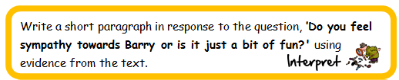
You might want to record your evidence in a table before you start:
 | Evidence That Supports Sympathy For Barry | Evidence That Supports It Is Just A Bit Of Fun
1.
2.
3.

Lesson 2
Revisit the website and watch David Baddiel read Extract 2
Extract 2
'Write that face down, Ginny!'
'I’m... a... really... stupid... looking... boy...' said Sisterly Entity Two, moving her finger slowly across her palm.
And suddenly a feeling that had been welling up inside Barry for... well, since his dad had closed the door on Jake and Taj and Lukas just before tea, but in another way for much longer than that, maybe ever since he’d understood that, unfortunately, his name was Barry – a feeling that he wanted to both cry and shout and break something all at the same time – exploded out of him.
'I hate you because you’re boring! And tired ALL THE TIME! And always TELLING ME OFF FOR NOTHING! And saying, ‘That’s a swear,’ when all I’ve done is say 'BUM!''
'Barry. That’s a swear!' said his mum.
'NO IT ISN’T! And because you’re so much nicer to THEM...' He pointed at TSE. They both grinned at the same time. '...than to ME! And because...' Barry realised by now that he was doing the list in his bedroom. He decided to miss out Numbers 8 and 9 – ‘Not being glamorous’ and ‘Being poor’ – since even in his rage he knew that they might just sound a bit too horrible out loud. especially as loud as he was speaking now. 'And... YOU NEVER, EVER MAKE MY BIRTHDAY REALLY GOOD!!'
There was a short pause after he shouted this. Then Sisterly Entity One said:
'Write that down, Ginny.'
'I’m writing it down, Kay.'
'Right,' said Barry’s dad. 'Well, if that’s how you feel, we won’t have a screening of Casino Royale on your birthday!'
'GREAT!' shouted Barry and he threw the DVD across the room. It spun round in the air as it made its way towards the sink. Barry was secretly quite proud of the throw; his wrist had flicked sharply as he’d released the disc, like an Olympic discus champion.
'BARRY!!' his dad shouted. So loudly that, for the first time this dinner time, Barry’s mum looked up from the dishwasher. Just in time to be hit in the eye by a copy of Casino Royale, starring David Niven.
'OW!' she said, falling backwards and out of sight again.
Barry heard a bump. Then one of the egg-timers, the red one, fell of the kitchen counter and smashed.
'Uh-oh', he thought.
'RIGHT, BARRY, THAT’S IT! GO TO YOUR ROOM!' said his dad, pointing upstairs – stupidly, really, as Barry knew the way.
'ALL RIGHT I WILL!' Barry shouted back.
And because he was a little frightened by now, he ran out of the kitchen as fast as he could, swerving at the last minute to avoid the bits of glass and sand from the egg-timer which was sprinkled all over the floor.
Many different events happen in this extract. What do you think is the turning point, the pivotal moment?
Is it when Barry realises that he is getting angrier? Is it something that somebody says? Is it when he throws the DVD?
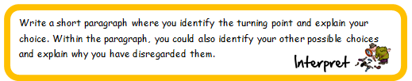

Lesson 3
What are your impressions of Barry?
Imagine that you have the opportunity to ask Mum, Dad, Kay and Ginny that question. What do you think they would say?
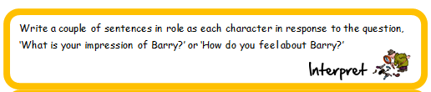
Have some fun writing in role as four different characters.
Do you think you would like to read all of this story? Why/why not?
Now, you could design an alternative front cover for this book.

