Monday

- Which word in the following sentence is an adverb?

She carefully balances the cup on the saucer.

- Which words below make a compound word when combined?

box park bird board
water skate jump black

- How would you correct these sentences?

We was going to the airport.
If we was not at school, I’d go to the park.
Lily were with her friends.
I were at Noah’s house.

- Put brackets into these sentences.

My favourite book The Hobbit is a fantasy story.
The girls who were called Molly and Ella sat next to each other in class.
The parcel which was wrapped in blown paper was sitting on the doorstep.

Tuesday

- Which conjunction would you use in this sentence?

The squirrel hurtled up the tree _______ the dog barked at the bottom.
[ ] while [ ] before
[ ] so [ ] when

- Why do we start new paragraph?

[ ] To indicate a new subject or theme.
[ ] To break up the page.
[ ] To change the time or place in our story.
[ ] To make our story look longer.
[ ] To group relevant information together.

- Where should the apostrophe be in these sentences?

Hannahs mum worked at the hospital.
Barry, my sisters rabbit, was grey and white.
Im going to the skatepark to see my friends.
Mum hasn’t got time to go to the hairdressers.

- Which fronted adverbial would make sense?

… the atmosphere changed and everyone began to feel rather sleepy.
[ ] Without a sound, [ ] As the clouds parted,
[ ] Sometime earlier, [ ] Later that evening,
Wednesday

- What is the rule for adding these suffixes to the words below?
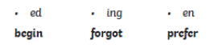

- What do these prefixes mean? Match them up.
sub against
auto under
inter self
anti amongst

- What is the correct spelling of the missing words in these sentences?

I ______ you’re going on holiday soon. here/hear
We ______ you at school today. missed/mist
The hamster died so we had to _______ it. berry/bury
Mum needed some _______ and quiet. piece/peace

- In the following sentences the apostrophe is used to make one word instead of two. Which two words would these be?

We haven’t had a spelling test for ages.
“Don’t Shout!”
“Who’s your class teacher?” asked the secretary.
“How’s you Gran doing?” my neighbour asked me.
Thursday

- Put the comma in the correct place.

The policeman said “Where did you find that bag?”
The flowers were bright yellow the brightest yellow Jasmine had ever seen.
It was later that night when the sirens started.

- What does this sentence need? Rewrite the sentence correctly.

Carrie went to the pizza shop. Carrie liked the pepperoni pizza. Carrie’s brother didn’t like pepperoni. Carrie’s brother preferred chicken.
[ ] nouns
[ ] adjectives
[ ] pronouns

- Improve these sentences using adverbs,

The dog barked throughout the night, waking everyone up. The neighbours shouted from their windows. The owner was embarrassed.

- Put the inverted commas in these sentences.

I can’t find it! shouted my brother.
Harry yelled Eureka! I have the answer!
The vet said what seems to be the problem with Rover?
Where are you going? asked the bus conductor.

Friday

- Spot the conjunctions in the following sentences.

Kim was talking on her phone as she watched TV>
The cat ran into the house whilst carrying a mouse!
Mix the sugar and butter until it looks white.

- Use prepositions that makes sense in these sentences.

I went to the part ______ school.
The new girl sat ______ me on the bus.
after during beside before

- There is something wrong with these sentences. Rewrite them correctly

We was going to the concert
I done a good piece of writing
She seen the new shopping mall.

- Underline the determiners

The boy rode his red bike home.
There were some girls from our school, on the bus.
The park wasn’t far away.
It was a good hotel.
That girl won the race.
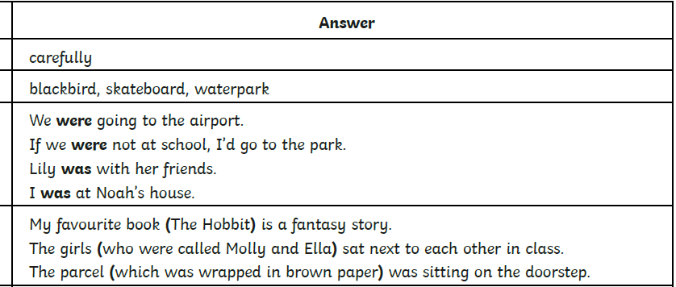
Monday – Answers

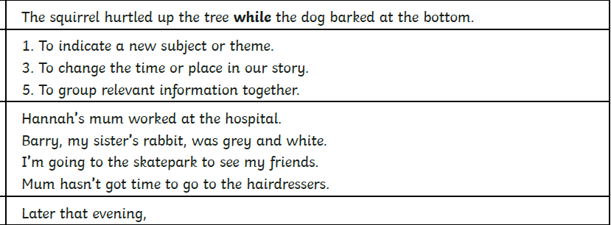
Tuesday – Answers

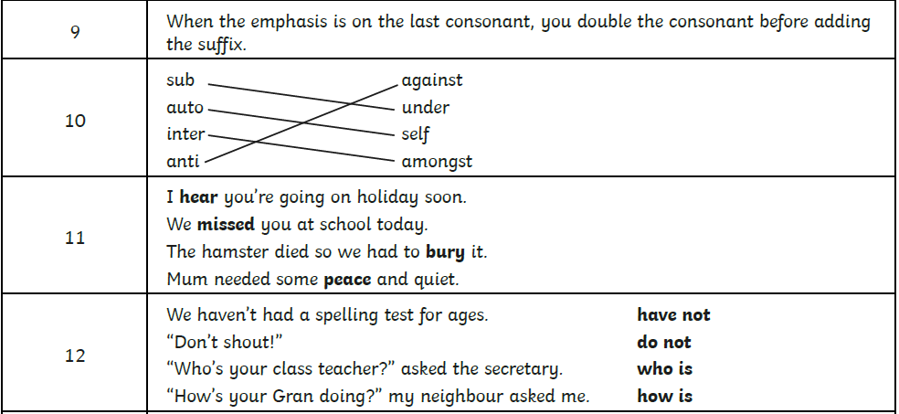
Wednesday – Answers

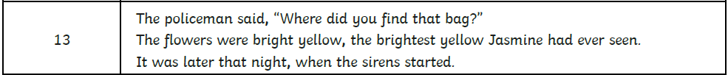
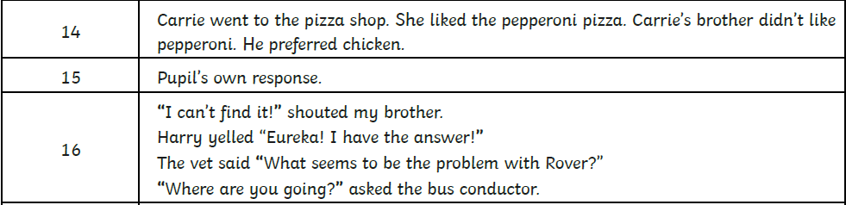
Thursday – Answers

Friday – Answers
