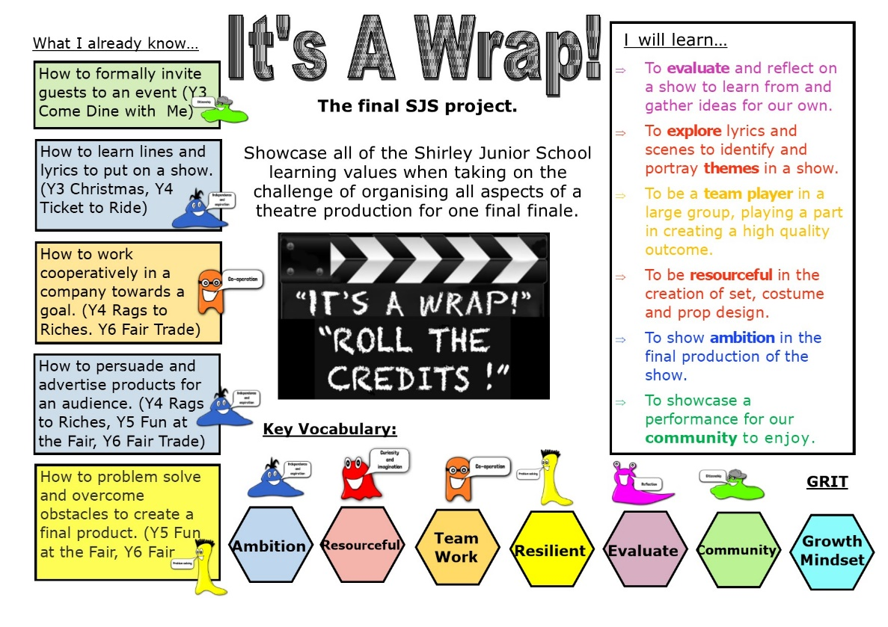
Year 6
It’s a Wrap - Project
Home Learning

Hi Year 6,
This is week eleven of your home learning. You will need to complete the steps and tasks in order. The learning value we are mainly focusing on is Independence this week. As always we want you to take care with your handwriting and presentation and are really looking forward to seeing some of the great learning we know you will complete this week so we can add this to our year 6 Star Learning page on the website.

Have fun with your learning!

Mrs Davie, Mrs Booth, Mrs McQuay and Mr Richards

This week we will be exploring the characters of High School Musical to then focus on one character to create a character profile of.
Year 6 - Task one* – To explore the links between the characters in High School Musical
Reflect on the main characters of High School Musical – Who is the story about?
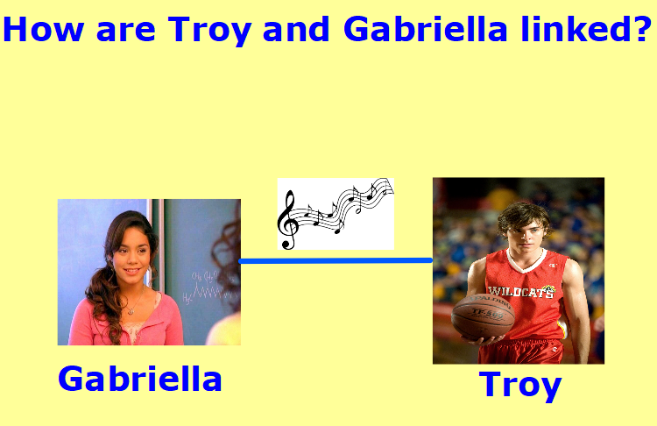
Troy and Gabriella are the main characters – they are linked at first by music at the karaoke party.
The bond over their singing.
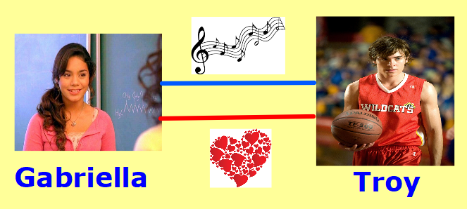
As the plot progresses Gabriella and Troy begin to fall in love.
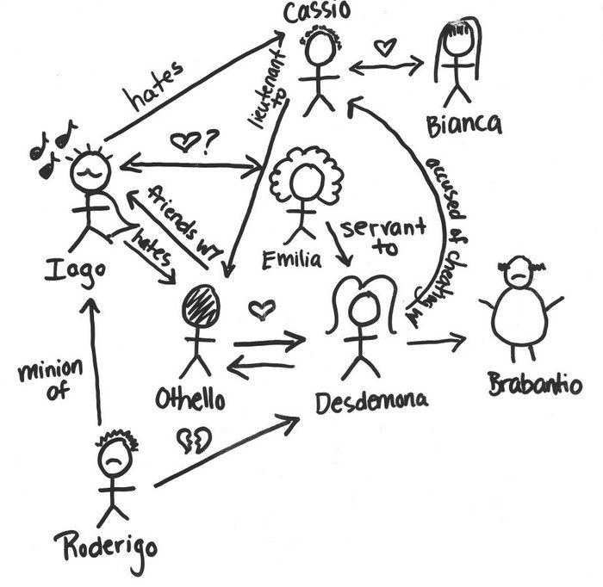
In your project book write the date and title. In the middle of your put the name Troy and Gabriella and show their links. Create a character web showing how the key characters in the show are linked.
Key Characters:
Ryan
Sharpay
Taylor
Chad
Kelsey
Mrs Darbus
Mr Bolton

Year 6 - Task two* – To explore, in depth, the key characteristics of a character
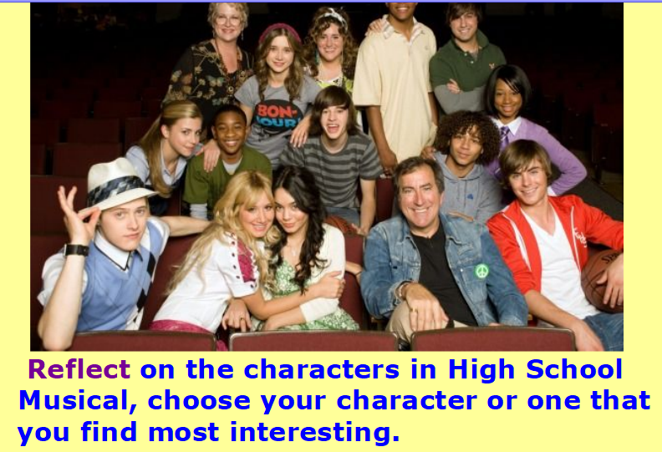
Choose from: Gabriella, Troy, Chad, Taylor, Ryan or Sharpay. Cut out the picture of your chosen characters and stick it in the middle of your next double page.
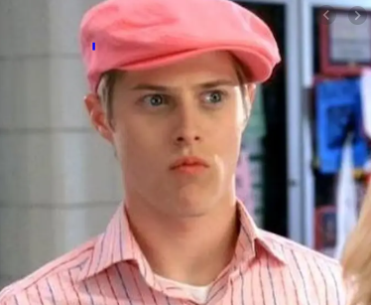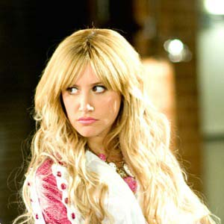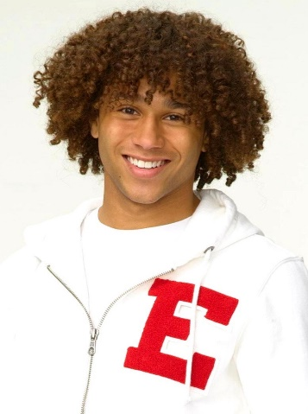

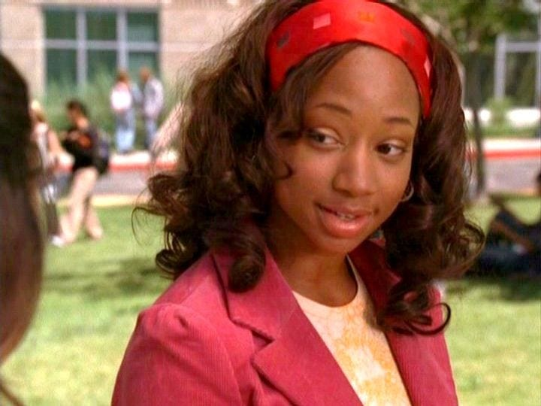

Split your double page into four quadrants then work through the question for each section.
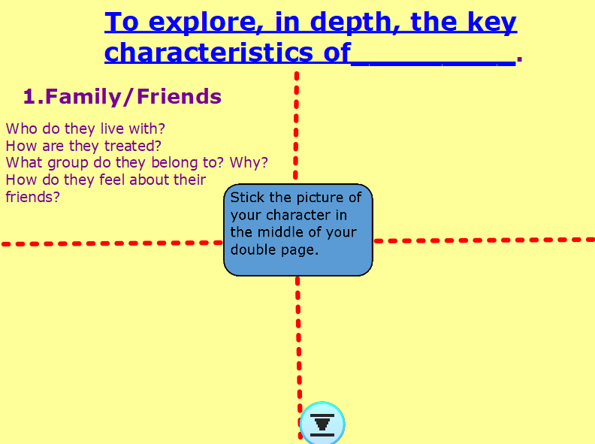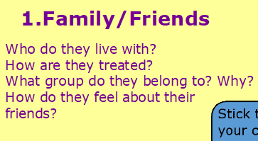

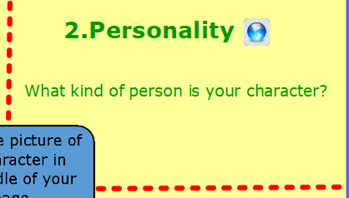
Watch the link https://www.youtube.com/watch?v=uRGVtGfoXvI to understand different types of personalities that people can have. Note down any description you feel fits your character.

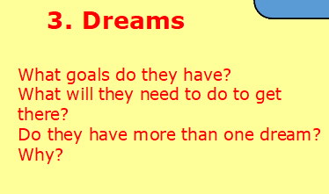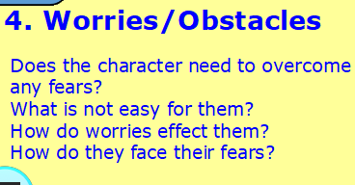

Year 6 - Task three* – To write a character profile
- Read the character profiles below:
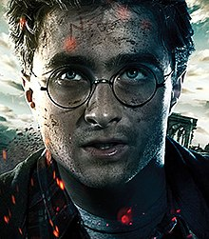

Clever Harry Potter never liked to be defeated; he always rose to the non-stop magical or deadly challenges that were thrown his way. Due to his flexibility, quick thinking and bravery, he was a talented quidditch player and his hiding skills weren’t too bad either. After a lot of practise, he became the king of magic spells and could use this to his advantage in many life-threatening situations. He was underestimated! Because he was so loving and gentle, he was often naïve to the evilness at Hogwarts, but he never let his bad luck spoil his good nature. He was recognised by everybody. You couldn’t miss the glaring lightning bolt stamped on his young forehead or his distinguishable stare. Round glasses hung in front of his glossy blue eyes which glowed with a mixture of determination, sorrow and confusion. His once quivering hands turned to steel over time and it was rare to see him without his pointed, life-saving wand or a jet-black cape. Although he had a relatively ordinary appearance, he was far from ordinary! Harry Potter was the kind of wizard that you could meet once but never forget!

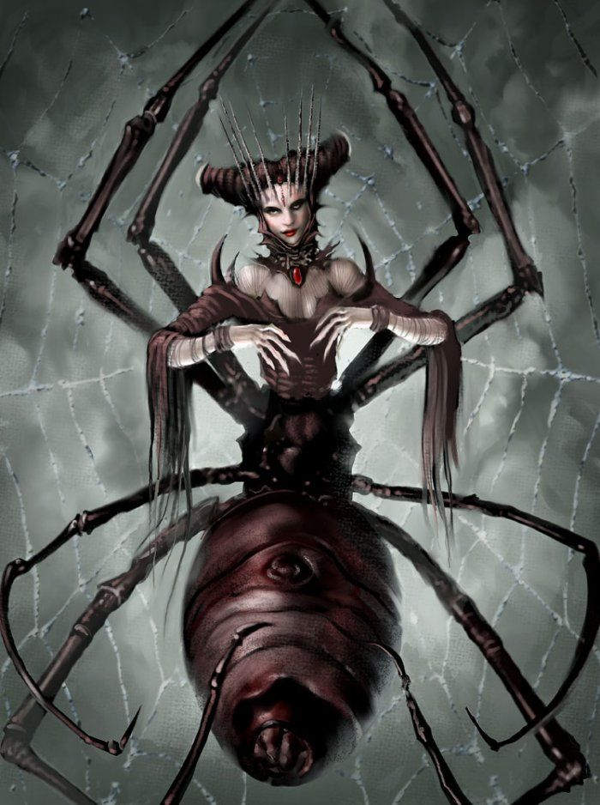
Athenerus
Appearance
Athenerus is part woman, part spider. She has eight huge, terrifying legs that are able to crush bones and metal. She has a luminous, scarlet stone around her neck that gives her special powers. Her lustrous, jet-black hair shimmers in the moonlight. On top of her head, she wears a crown of long, razor-sharp spikes.

Behaviour
Athenerus lives in the gloomy, haunted caves of Norway. She creeps into huts in the dead of night and snatches people from their beds as they sleep to feed to her nightmarish babies. She has a petrifying, haunting scream that can be heard in the dead of night.

Special Powers
Athenerus’ colossal, spindly legs can crush bones and metal. Her mystical, ancient amulet that she wears around her neck is able to hypnotize humans she meets. Athernerus is an intelligent killer, intelligent because she is able to read minds and lay traps with webs.

How to Defeat
Athenerus’ weakness is her large, swollen tail in which she carries her eggs. It is best to attack this tail with a sharp dagger as here her skin is soft. She is also terrified of water, terrified because she is unable to swim. If you can make her fall into water she would surely die.

Hades
On the grave, regal throne of the Underworld, next to his three-headed pet dog Cerberus, Hades would more than likely be found. Following the triumph of him and his brothers, he became Lord of the Underworld. He was feared by mortals and disliked by the other Olympians; this was one of the reasons he rarely left his dark abode in the Underworld. The activity he enjoyed deeply was observing guilty mortals being tortured. Besides this, Hades generally was most happy when in solitude. Nothing got Hades blood bubbling more than the din created by mortals- the noise often made Hades lose him temper. He was known to be formidable in battle but surprising to some he was not an evil God. Sure, he was unpitying, fierce and relentless. But he was also just. He took pride in abiding by the rules. There were even rumours that the God of Death could show kindness and generosity on the rare occasion. Unlike most other Gods, he was hardworking and took his duties seriously.

Most people didn’t know the reason Hades was so morbid. They didn’t know about his past and how his father had treated him and his siblings. Hades dwelled on his past which made him bitter. As the eldest son of Kronos, who was the king of the Titans, he inherited his father’s dark side and often found himself engulfed in dark thoughts that he could not escape from.

He had oily, ebony hair that snaked around his shoulders and intense black eyes that would flare with purple fire. He had a muscular stature and would often been seen wearing his Helm of Darkness that was made with a mixture of the precious metals. Hades beard looked like ashes of charcoal coiling down to his tattered black robes which had been threaded with evil souls. Clasping his spindly fingers around his beloved spectre, he was the living embodiment of Death. Due to living in darkness for the majority of his life, Hades had albino white skin.

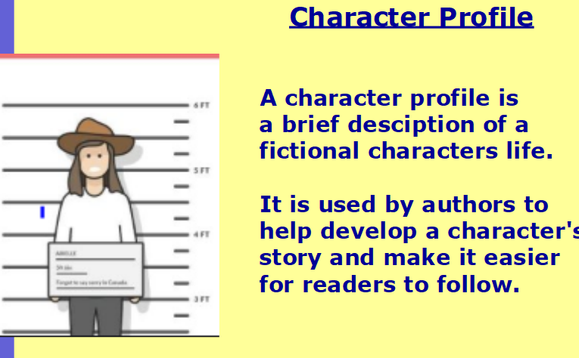
- Reflect on the three examples. What was the same in each profile? How did they differ in style?
Which style did you prefer? Why?
- Write the date and title in your book. In your book write a character profile for the character you explored in the previous lesson. Choose your style of profile and use the steps to success to ensure you include all the details you need.

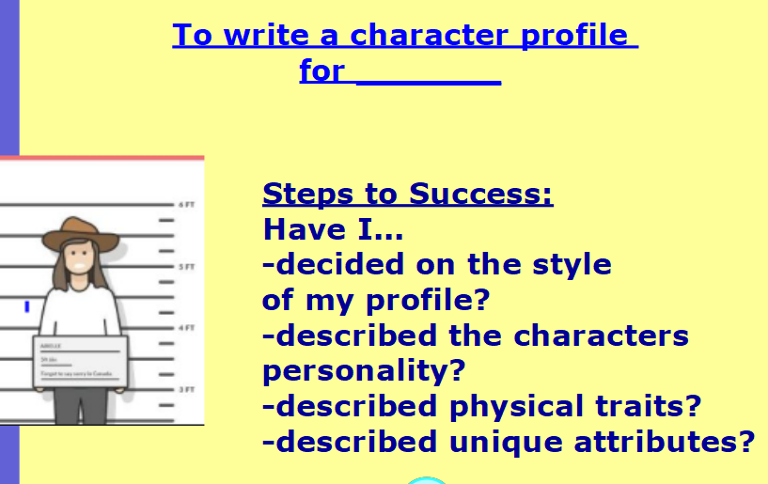

Please send your learning to Y6teachers@shirleyschools.co.uk. We really can’t wait to hear from you!

