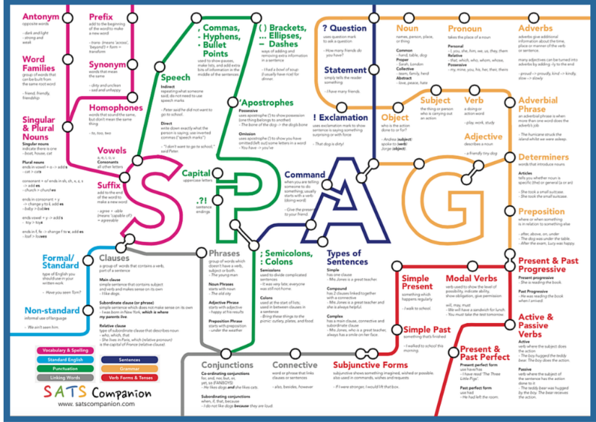
Year 6
SPaG
Home Learning

Week one includes:
- SPaG 5 a day – one for each school day (15 minutes)
- Spellings I do you do – read the power point (20 minutes)
- Spellings activity (20 minutes)
- Answers 5 a day

SPAG WEEK 1 DAY 1

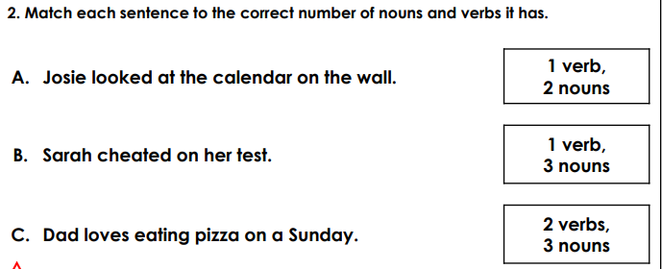
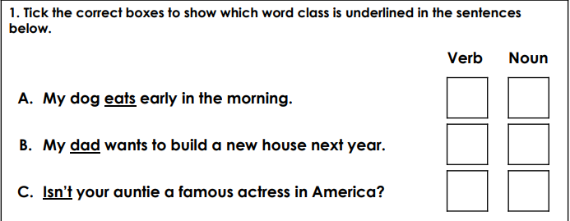
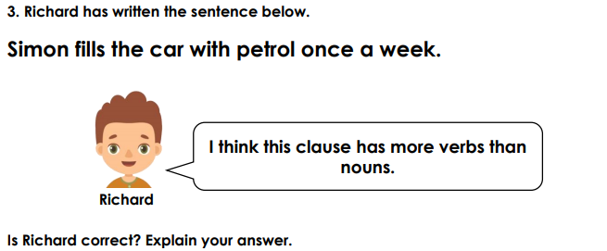
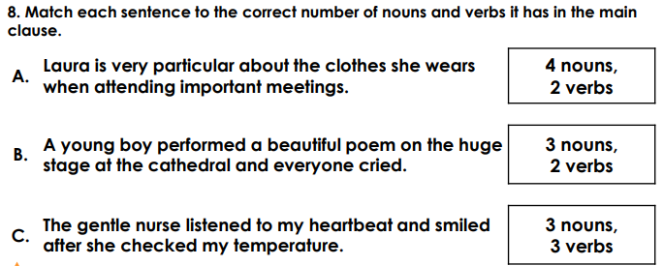
4.
5.
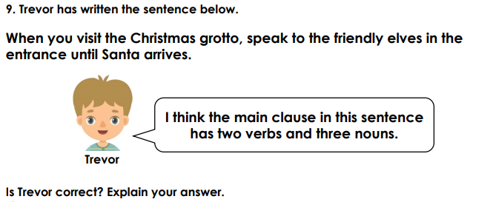
4.

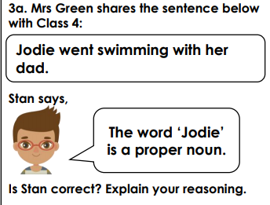
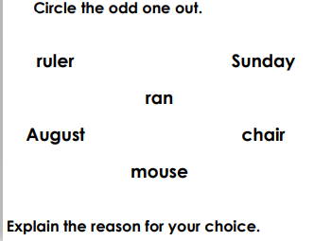
SPAG WEEK 1 DAY 2
2.
22.22
1.

4.
3..
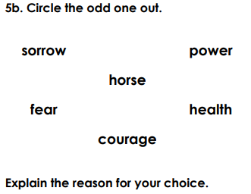
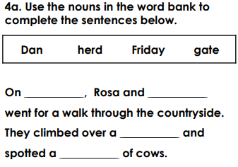
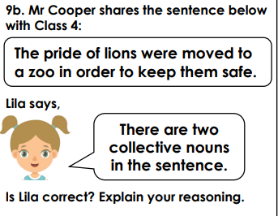
5.

SPAG WEEK 1 DAY 3
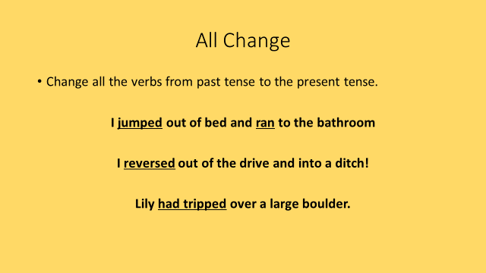
1.

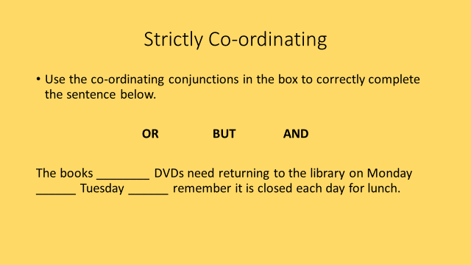
2.

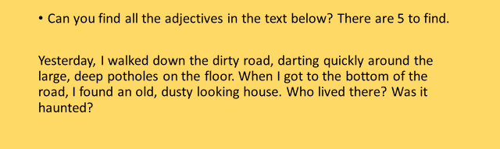
3.

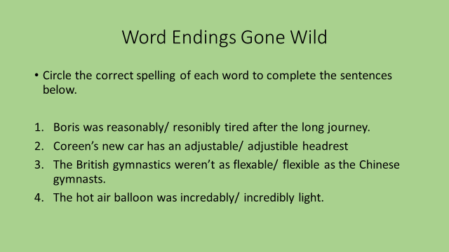
4.

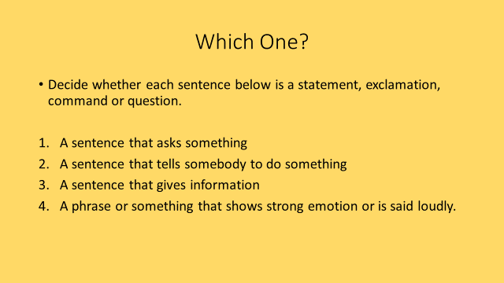
5.

SPAG WEEK 1 DAY 4
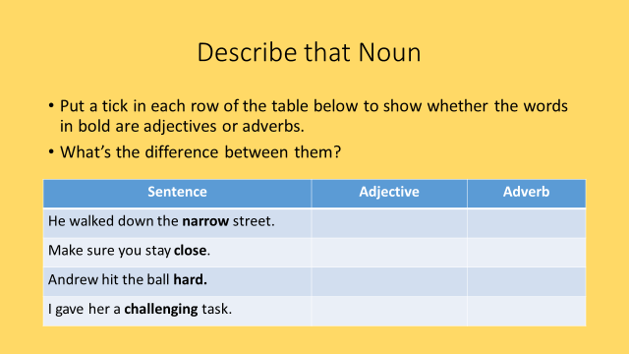
1.
2.
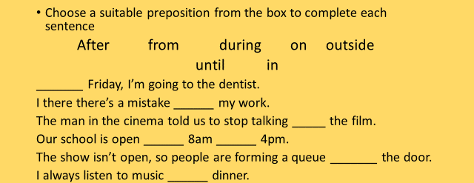
3.

4. 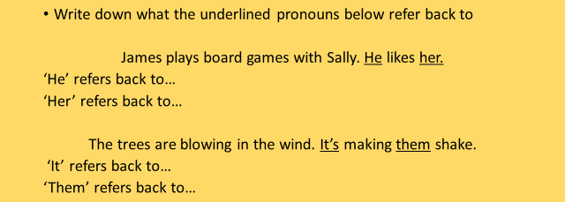

5. 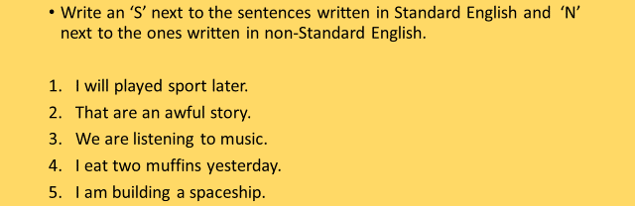

SPAG WEEK 1 DAY 5
1. Circle the words that are spelt correctly. Re-write the other words correctly.
2. 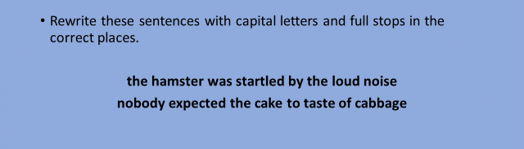
3. 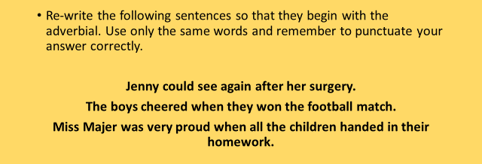
4. 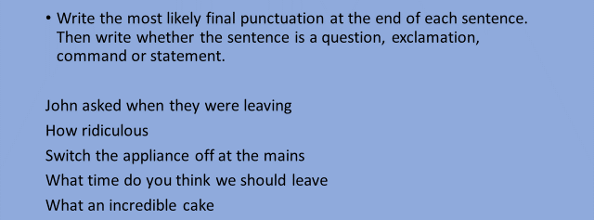

5. 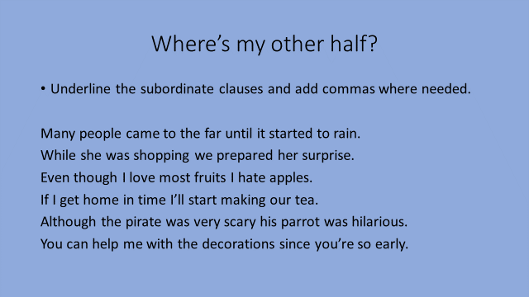

Spellings
- Look at the power point Mrs Andrews has created for you.
- Complete this task

Choose and Write –cial endings

Circle the correct spelling AND write a sentence below using that word.
Top TIP: If you do not know the meaning of each word, use a dictionary (book or on line) to help you.

special | spetial
I only eat cake on special occasions like on my birthday.

fatial | facial
sotial | social
official | offitial
crucial | crutial
beneficial | benefitial
crucial | crutial
ANSWERS WEEK 1

1. A. verb; B. noun; C. verb
2. A. 1 verb, 3 nouns; B. 1 verb, 2 nouns; C. 2 verbs, 3 nouns
3. Richard incorrect because his sentence has four nouns (Simon, car, petrol, week) and only one verb (fills).
4. A. 3 nouns, 2 verbs; B. 4 nouns, 2 verb; C. 3 nouns, 2 verbs
5. Trevor is incorrect because the main clause has two nouns (elves, entrance) and one verbs (speak).

ANSWERS WEEK 1 Day 2

1. Ran is the odd one out because it is a verb. The other words are nouns.
2. Stan is correct. Jodie is a proper noun because it is a person’s name.
3. Friday, Dan, gate, herd
4. Horse is the odd one out because it is a common noun. The other nouns are abstract nouns.
5. Lila is not correct. There is only one collective noun in the sentence. Pride is a collective noun, lions and zoo are common nouns.

HELP
Abstract nouns name a quality or an idea. They are concepts that cannot be experienced with the senses, like love and happiness.
Collective nouns – used to represent a group of people or animals. They are sometimes called grouped nouns as they represent a number of things. E.g. government, family and team.

ANSWERS WEEK 1 Day 3

1. jump run / reverse / trips
2. and or but
3. dirty, large, deep, old , dusty
4. reasonably adjustable flexible incredibly
5. question command statement exclamation

ANSWERS WEEK 1 Day 4

1. narrow – adjective close – adverb hard – adverb challenging – adjective

2.

3. on in during from until outside after

4. he – James her-Sally it – the wind them-trees

5. 1. N 2. N 3. S 4. N 5. S

ANSWERS WEEK 1 Day 5
1. classic occupy school
2. The hamster was startled by the loud noise.
Nobody expected the cake to taste of cabbage.

3. After her surgery, Jenny could see again.
When they won the football match, the boys cheered.
When all the children handed in their homework, Miss Majer was very proud.

4. John asked when they were leaving.
How ridiculous!
Switch the appliance off at the mains.
What time do you think we should leave?
What an incredible cake!
5.
Commas:
While she was shopping,
Even though I love most fruits,
If I get home in time,
Although the pirate was very scary,

