Year 3: The Suffixes –ness and –ful.
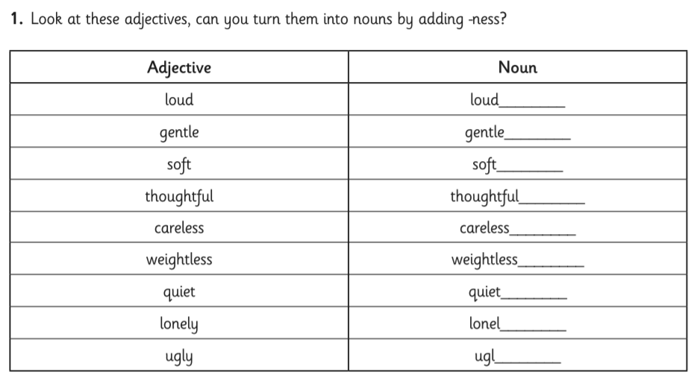
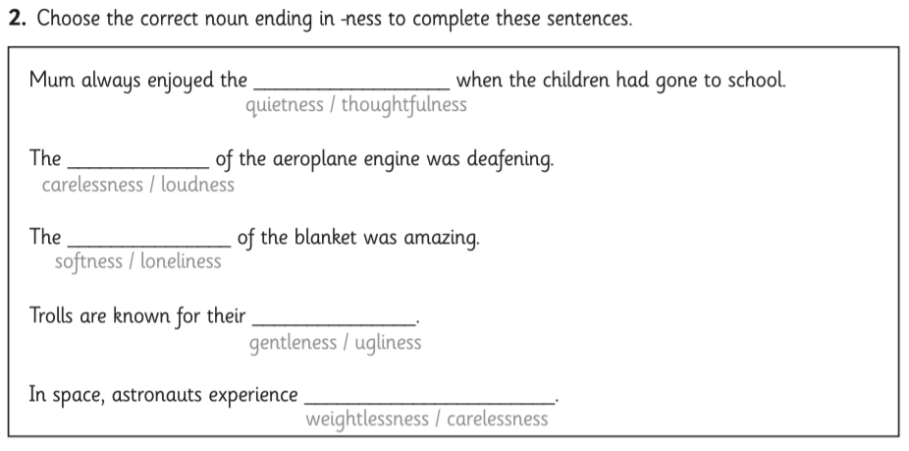
3. Add the suffix –ful to turn these words into adjectives.
