
Shirley Junior School Behaviour & Relationships policy

We are an emotionally literate school where everybody develops the skills of self-regulation and learns from mistakes by reflecting and repairing. We foster a sense of belonging and acceptance, so children grow to become honest, responsible citizens of their community.

In our school we believe that people do well when they can. Our environment and the attachment relationships we form with our children, colleagues and parents are important. We help children to manage their emotions in order to access their learning effectively. In turn, this empowers them to be valued members of our community, who believe they can contribute positively.

Behaviour is a form of communication. We do not shame children for their behaviours. We endeavour to understand, unpick and remove barriers so that all children can be successful learners and communicators. In our school, throughout all aspects of the curriculum, we are mindful of ensuring all children develop the tools to self-regulate, and communicate effectively, to become emotionally literate learners.

We have developed our own curriculum for behaviour, based upon our school values of Kindness, Integrity and Respect. We aim to teach these values through everything we do, with extra learning available for children who need additional input.

We aim to provide a safe, secure and caring school environment in which every child is able to learn confidently and happily in order to fulfil their potential, and in which parents/carers can be listened to with integrity rather than defensiveness or judgement. All staff are trained in attachment theory, trauma-informed practice and the impact of ACEs on early childhood development, and we recognise that children learn best in a calm, orderly and nurturing atmosphere. We are a Rights Respecting School (UNICEF) and we adopt the language and behaviours that encompass these principles.

We also aim to nurture our staff so that they feel truly valued and emotionally regulated. This supports everybody in our wider school community to interact with kindness, integrity and respect which promotes positive social engagement.

Behaviour and relationships in school
Everybody at Shirley Junior School is a leader of behaviour. We have adopted a Distributive Leadership approach to support pupils with challenging behaviour so that all staff support behaviour and are aware of their roles and responsibilities, including Governors, Senior leaders, teachers and support staff. See Appendix A
We understand that behaviour needs to be taught. All our teaching reflects the Equality Act 2010 ensuring there is no discrimination for any pupil or family with protected characteristics.
Adults in the school aim to develop their relationships with all children so that children feel cared for and are happy to receive influence from the adults around them, in the classroom and on the playground.

Each class draws up its own Positive Classroom charter, where the class decides together what children would be thinking, saying, doing and feeling in a positive classroom, and explore the barriers to this. This is revisited daily and children choose a target for themselves

Continual, daily practice throughout our school:

School aim and values

We aim to make the most of Every Chance, for Every Child, Every Day:
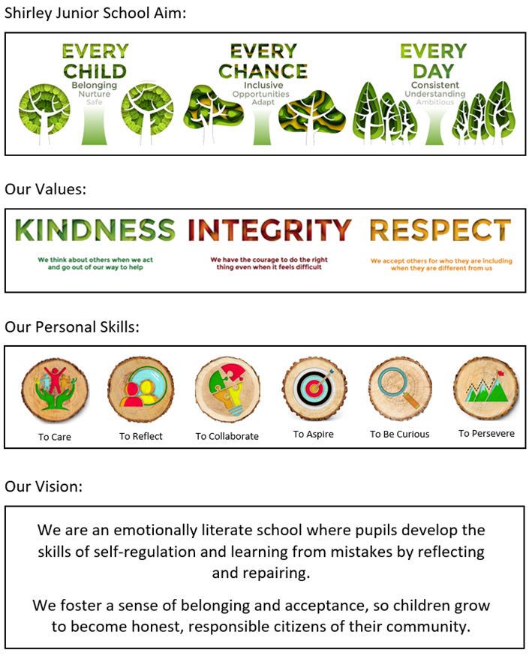

Learning about Behaviour and Relationships in the Curriculum

Our school values underpin everything we do and are referred to in lessons, in assemblies and around the school:

These values are taught and developed through pupil leadership (encompassing House Captains and pupil-led clubs), pupil voice (Learning Ambassadors and Eco Warriors) and initiatives such as Citizenship Award, SJS Job Agency, House competitions.

Our values lead to our six ‘personal skills’. During their time with us, we aim to develop children’s abilities:

These skills are referred to and taught progressively throughout our curriculum, with one receiving a more in-depth focus every half term. This is done through a combination of themed assemblies, classroom work and special days and events (such as Careers Fair to help children Aspire, and Remembrance Day to help children Reflect).
The Relationships Education within our PSHE and eSafety curriculum focuses on teaching the fundamental building blocks and characteristics of positive behaviour and relationships, with particular reference to friendships, family relationships, and relationships with other children and adults. Children are also taught how to respond effectively and assertively to inappropriate behaviour such as bullying and prejudicial language. This reinforces our values and personal skills.

Daily routines

Staff welcome children every morning at the classroom door and ensure there is a calm environment for children to start the day which includes music and quiet activities. Visual timetables and consistent morning presentations in each class help children to know what to expect each day. Morning moves are an enjoyable, active whole-class activity before the morning learning begins.

Staff respond quickly to inappropriate language using the tagline “it’s not ok”, linking to the value of Respect.

Relationships on the playground

Play leaders are on the playground at lunch times to play with the children and help them resolve conflicts using the Repair and Rebuild approach. Information is then passed on to the class teacher at the end of lunchtime so they are aware if a child has had a difficult time. Pupil Repair and Rebuild leaders are visible on the playground to support children to resolve issues.
Constructive play is encouraged in the playground by all staff through: -
- Defined zones on the playground and field for different activities.
- Group games led by adults
- Sports activities led by sports coaches
- Providing play equipment in different zones.
- Quiet hut activities for those who prefer to sit and do something more mindful
Lunchtime clubs cater for children who find it hard to be out on the playground for the whole lunch hour. These could include ELSA clubs, reading clubs and indoor games clubs.

Rewards and celebrations

Verbal Praise
We aim to recognise effort rather than achievement, and recognise that this may look different for each child. Staff give verbal praise as often as possible, so that all children know that their efforts are noticed and appreciated. Verbal praise is given where pupils demonstrate our school Values. One house point at a time will be awarded by adults around the school which are regularly collected and houses celebrated in assemblies.

Children are given positive recognition by adults during learning time when they have demonstrated improving one of the personal skills within their learning. This recognition will be explicit, naming the skill they are demonstrating and how they are showing this skill. One house point at a time will be awarded by adults.

Being Proud of own efforts
We encourage our children to develop self-efficacy through identifying when they have made extra effort and produced work they are particularly proud of. Regular opportunities are built into the learning so pupils reflect on what they are proud of. Pupils can choose to share this work they are proud of with peers in their class, other staff members, the headteacher or deputy headteacher where they will be awarded a Headteacher Award sticker. The child is encouraged to send a Marvellous Me message home to their parents/carers.

Peer to Peer recognition
Peer to Peer recognition is used in the classroom to encourage pupils to recognise and praise the effort of others in their class. Strategies such as sticky notes, 2 stars and a wish, lolly stick signs and learner of the week book cover are used by teachers to encourage peer to peer positive recognition.

Each class agrees on a class target that they feel they need to develop that supports their positive classroom charter. At the end of each session the class decides if they have earnt a marble for demonstrating the target. The class agrees to a celebration activity when they have achieved an agreed number of marbles set at the start of the challenge.

Whole school recognition
Personal Skills certificates are given by the class teachers during assemblies, with a focus on one of the school’s personal skills. Values certificates are given by the Head Teacher during whole school assemblies, with a focus on one of the school’s three values each half term.

House Points
All pupils belong to a house for their time at Shirley Junior school They are awarded house points from adults along with verbal praise given for a range of reasons. House points are collected regularly, rewards and celebrations are given to the house with the most points and various points throughout the year.
​​

Emotional Regulation

All adults in school are trained to help children learn to regulate. Some children will need additional support, and there are specific adults who are emotionally available for this. If children are feeling anxious about something out of their control, either in school or at home, they can write their worry down and put it in the class Worry Box. The teacher will check the Worry Box daily.

We use the Zones of Regulation in all classrooms and learning spaces, to help children learn to recognise and name their emotional state, and to learn the ways that they can most effectively regulate their state when feeling silly, agitated or sad.  Zones of Regulation is a concept developed by a licensed occupational therapist that helps children gain self-regulation skills. They encourage children to think and talk about how they are feeling, and to recognise when their feelings lie in different zones, as well as to learn how to use strategies to return them to a calm state of mind. | 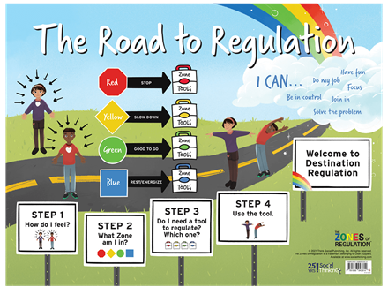
Children are supported to regulate their emotions within the classroom environment, unless their provision includes use of an agreed calming strategy or a safe space outside the classroom.

Dealing with conflicts

We foster the belief that making mistakes is normal, it is how we repair and rebuild from them that matters. When conflicts occur, we use a restorative approach called Repair and Rebuild. The children (and/or adults) involved, with a neutral third-party if helpful, ask and answer a set of questions to help them share their perspective and listen to each other. This develops their empathy skills.  Children from each year group have been trained to act as Repair and Rebuild monitors on the playground, so they can help their peers resolve conflicts. | 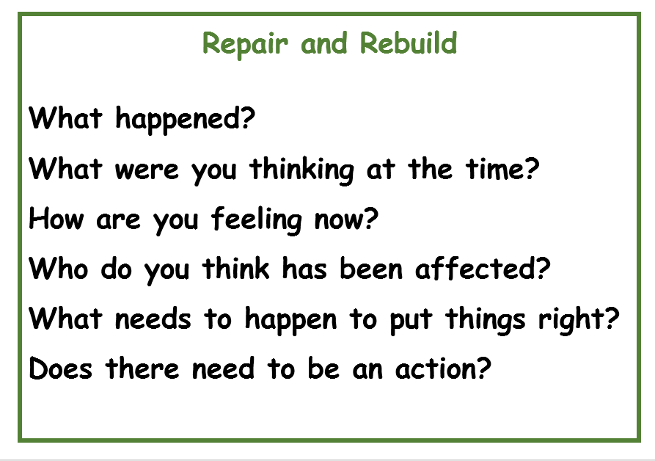
When any child or adult witnesses potential child-on-child abuse or inapropriate behaviour they are expected to intervene immediately. This may involve challenging assumptions and/or prejudicial language, using questions/comments such as;
- Would you be happy if someone talked about a member of your family in that way?
- I hope you recognise it is important to treat everyone with respect.
- You might not think the remark is offensive but many would.
- What do you think that word means?
Pupils are encouraged to communicate the behaviour to an adult (if the witness is a child) or to the class teacher.

When children find it difficult to follow instructions
If children are finding it difficult to follow instructions in the classroom, communal spaces or on the playground, adults respond using a graduated approach. This begins by recognising the emotional needs of the child at the time and their ability to receive and process the guidance being given. Agreed scripts are used to ensure that children receive a consistent, calm approach, and to ensure that they are left thinking about their actions and knowing the adult believes they are able to behave positively.

Step 1: Redirect
Initially, adults will redirect and use low-level strategies, such as strategic ignoring, non-verbal signals, positive language, further adaptation of learning, connection before correction.
Step 2: Explain
If the child is still struggling, the adult will explain, discreetly and gently, what the issue is, and aim to find out the child’s barrier, using the following language:
“I’ve noticed you are/aren’t… what’s up?” (let child explain barrier)
“In our class/school we… so let’s …” (suggest way forward)
Step 3: Remind
If the Explain step does not solve the problem, the adult will give a reminder, still discreetly, that they care about the child and their learning and expect the child to do as they have been asked:
“I’ve noticed you still are/aren’t … do you remember what I asked you to do? What do you think will happen if you keep/don’t… Is that what you want?”
Step 4: Action
If Explaining and Reminding does not enable the child to follow instructions then the adult will decide on an action. The aims of this are for children to reflect on their behaviours, understand how their actions impacted others, make amends and understand how to prevent future occurrences. Tha action is not about embarrassing or shaming the child, both of which should be avoided:
“Because you…, I need to ….”

The action can be reflective, restorative or protective:
  - Reflective: to help them understand the impact of their actions on themselves and others, the child fills out a reflection form, and a copy is sent home. (see appendix C)
  - Restorative: to help them make amends, the child takes action to restore relationships or learnings (e.g. completing disrupted learning in own time, tidying up anything displaced, Repair and Rebuild)
  - Protective: to help them develop the skills to handle situations which they are not currently managing well, adults may remove vulnerable or traumatised pupils from these situations in a kind and non-judgmental way (e.g. moving the child’s place in the classroom, having a rota for playtime, agreeing rules for a particular situation, friendship contracts, staying in at playtime until a plan has been agreed so that everyone is protected)
The action will be recorded and shared with parents/carers.

Collaborative Problem Solving

When unhelpful behaviours are repeatedly or regularly leading to issues, due to a child lacking the appropriate skill, we use a Collaborative Problem Solving approach (see flowchart in Appendix B). A time will be arranged for a collaborative conversation, during which the child’s concerns around the situation are sought and empathised with, the adult’s concerns are shared, and a solution worked out together that is realistic and addresses both sets of concerns. The plan will be shared with all relevant adults, including the child’s parents

Further Measures
If the plan has been used but the situation does not improve, the steps below will be followed, stopping at whatever point the problem is resolved. Parents will be kept aware at every stage.
1) Return to the plan agreed during the Collaborative conversation and improve it
2) Help the child use their own Zones of Regulation toolkit; use the Reach to Teach app to give extra insight
3) Move to the Graduated Behaviour Response resources

Individual pupil support and intervention

Graduated Behaviour Response
We follow the Graduated Behaviour approach recommended by Hamwic, which ensures that unhelpful behaviour is addressed using the least intrusive measures first, beginning with the class teacher reviewing their provision and the child’s barriers.
Level 1: Universal Provision.
- Class teacher or TA carries out targeted observations for behaviour
- Assessments carried out in class by class teacher to unpick issues/barriers.
- Class teacher responds to this information by modifying the environment/approach/provision/planning or putting an intervention in place
Provision includes the agreed whole school strategies in this policy that are actively promoted and taught to all pupils, including those new to the school
Level 2: Early Intervention Support.
- With support from the phase leader, class teacher carries out inclusive checklist and behaviour risk assessment
- Inclusive Teaching checklist used to ensure the child can access all classroom activities
- Classroom Environment reviewed, along with use of rewards and motivation, to support with managing behaviour
- Parental engagement and communication of concerns and provision
Provision may include: Morning meeting and greet, regular check ins, visual timetable, individualised positive praise charts, specific support to understand Zones of regulation
Level 3: Targeted Additional Support.
- With support from the Inclusions team, the teacher writes a behaviour response plan, which is shared with all adults and carers who interact with the child.
- Consideration is given to whether the child would benefit from 1:1 ELSA sessions for teaching of specific social, emotional or behavioural skills for a period of time, or from some nurture support, and whether multi-agency support would be beneficial
Provision may include: ELSA, Time to Talk, small group intervention, daily success/reflection book, lunch time provision, social skills group, nurture with emotionally available staff.
Level 4: Targeted Intensive Additional Support.
- With support from the Inclusions team, an Individual Behaviour Plan is written with personalised behaviour targets, and targeted teaching of the lagging skills is planned in, with children logging these in class.
- A Plan-Do-Review cycle is put in place, with the child and parents/carers included.
- Consideration is given to whether the child would benefit from statutory assessment of SEN, and an EHC Plan.
- The curriculum for the child is modified to support their engagement
- It may be necessary to consider alternative provision or a part timetable to ensure the continuation of the pupils' education.
Provision may include: One to one Behaviour Skills card intervention, environmental adaptations, timetable alterations e.g daily ELSA, one to one SOLE with adult and support from external agencies e.g No Limits, play therapy
Level 5: Provision over and above
- IEP or EHC Plan in place and reviewed annually
- Multi-agency support (eg CAMHS, Educational Psychologist, Outreach)
Provision may include: Alternative provision or regular one to one support

Responding to serious behaviour
This may include:
•Leaving the school premises without permission
•Showing extreme and threatening aggression including continuous bullying or racism
•Physically hurting another child or an adult
•Bringing in weapons, drugs or paraphernalia that may hurt others or intended to threaten others
• Deliberate damage/vandalism to school property
• Theft
• Actions which are deemed to be dangerous to self or others

Any serious incidents are fully investigated, ensuring that all parties are listened to. Decisions are made based on the extent and intent of the behaviour, taking into account what led up to it and any previous patterns. Depending on the severity of the behaviour and the child’s response, the Head teacher may decide on an immediate short-term exclusion or an internal exclusion the same day or the following day.

If formal exclusion is not deemed to be appropriate, there will at least be a phone call home by a senior leader to inform the parents/carers of their child’s unacceptable behaviour. Protective actions will be put in place to support the child to develop the necessary skills before they reintegrate - these measures may include an internal exclusion.

If the child continues to make poor behaviour choices, a short-term exclusion may be considered as the next step.

The adult who was with the pupil at the time of any misdemeanour must complete a CPOMS record as soon as possible following the incident, to alert the relevant staff members. Any follow-up actions must be recorded as an action.

Exclusions
The school adheres to the current guidance on Social Inclusion. It is rarely necessary to exclude a pupil for unacceptable behaviour except in extreme circumstances. Moreover, exclusion can have safeguarding implications and can negatively affect a child’s engagement with school on their return.

Exclusion often isn’t effective in changing pupil behaviour, particularly if it doesn’t address underlying problems. If a child or young person is excluded before they are offered help, it can represent a critical turning point increasing the likelihood of that child developing poorer mental health and other multiple poor outcomes. Children and young people who have been excluded from school are more likely to have behavioural difficulties, difficulties with peers and attention difficulties. They also have reduced wellbeing, emotional strengths and skills and support networks.

Due to these adverse effects, exclusion is a serious step and will only be used as a final sanction when the Headteacher has determined that allowing the pupil to remain in school would seriously harm the education or welfare of the pupil or of others in the school. Any exclusion will be reported to the Chair or Vice Chair of the Governing Body and to the Local Education Authority. We follow the Hampshire County Council Exclusion Guidelines.

If an exclusion becomes necessary the parent will be informed immediately by a phone call and on collection the child will receive a letter, Appendix C. The reasons will be explained and advice given to parents regarding representations that can be made. The Headteacher will also inform the Chair of Governors, HAMWIC and the LA giving details of the exclusion. The parent will be provided with a written record of the actual incident that led to the exclusion of their child.

The school recognises that extreme behaviour often occurs in moments of crisis in response to prior trauma. With this in mind, while the child is excluded the staff will follow trauma-informed practice, using the time to develop the supportive structures around the child (risk assessment, behaviour plan etc). The skills the child is lacking (that prevented them from responding more appropriately to the trigger) will be identified, and a plan put in place to help the child develop these skills so that they are better equipped going forwards to be successful members of the community.

Length of short-term exclusions is at the Headteacher’s discretion, and depends on several factors. The Head teacher may also exclude a pupil permanently - this would only be considered after extensive use of behaviour support and in discussion with a range of agencies. It will be used if deemed necessary in consultation with the Local Governing Committee, Local Authority and Trust Board.

Return from exclusions
Following a short-term exclusion, the provision and needs of the pupil will be assessed. The school will liaise with suitable outside agencies in order to ensure the environment and systems are in place so that the pupil has a successful return to school. A reintegration meeting with parents, child and senior leader will be held to discuss the planned provision for the pupil. A reintegration plan will be created and shared with parents to support the child’s successful reintegration to school. See Appendix D. There may also be a Behaviour Response plan agreed.

Modifications that may be made to support the child are: independent work station, one to one support, counselling, mental health referral, ELSA sessions, changes to the environment within and beyond the classroom and/or a reduced timetable. The arrangements that are put into place will be reviewed on a weekly basis to ensure that the needs of the pupil are continuously being met.

Physical Restraint

Use of reasonable force as stated in the DFE 2013 Guidance defines this as:

The term ‘reasonable force’ covers the broad range of actions used by most teachers at some point in their career that involve a degree of physical contact with pupils.

Force is usually used either to control or restrain. This can range from guiding a pupil to safety by the arm through to more extreme circumstances such as breaking up a fight or where a student needs to be restrained to prevent violence or injury.

‘Reasonable in the circumstances’ means using no more force than is needed.

As mentioned above, schools generally use force to control pupils and to restrain them. Control means either passive physical contact, such as standing between pupils or blocking a pupil's path, or active physical contact such as leading a pupil by the arm out of a classroom.

Restraint means to hold back physically or to bring a pupil under control. It is typically used in more extreme circumstances, for example when two pupils are fighting and refuse to separate without physical intervention.
6. School staff should always try to avoid acting in a way that might cause injury, but in extreme cases it may not always be possible to avoid injuring the pupil.

Who can use reasonable force?
• All members of school staff have a legal power to use reasonable force .
• This power applies to any member of staff at the school. It can also apply to people whom the headteacher has temporarily put in charge of pupils such as unpaid volunteers or parents accompanying students on a school organised visit.

When can reasonable force be used?
• Reasonable force can be used to prevent pupils from hurting themselves or others, from damaging property, or from causing disorder.
• In a school, force is used for two main purposes – to control pupils or to restrain them.
• The decision on whether or not to physically intervene is down to the professional judgement of the staff member concerned and should always depend on the individual circumstances.

The following list is not exhaustive but provides some examples of situations where reasonable force can and cannot be used. Schools can use reasonable force to:
• remove disruptive children from the classroom where they have refused to follow an instruction to do so;
• prevent a pupil behaving in a way that disrupts a school event or a school trip or visit;
• prevent a pupil leaving the classroom where allowing the pupil to leave would risk their safety or lead to behaviour that disrupts the behaviour of others;
• prevent a pupil from attacking a member of staff or another pupil, or to stop a fight in the playground; and
• restrain a pupil at risk of harming themselves through physical outbursts.

As stated in the guidance we understand and adhere to the fact that schools cannot:
• use force as a punishment – it is always unlawful to use force as a punishment.

There are times when a pupil’s behaviour may present as particularly challenging and may require restrictive physical intervention. We follow the Team Teach guidelines: Restrictive physical intervention in schools and the DFE’s ‘Use of reasonable force Advice for headteachers, staff and governing bodies 2013’ is referred to and adhered to. Only staff who are trained are permitted to carry out Physical restraint. All staff are trained using the Team Teach programme and carry out refresher training every two years.

We define restrictive physical intervention as follows:
Restrictive physical intervention is when a member of staff uses force intentionally to restrict a pupil’s movement against his or her will. Section 93 of the Education and Inspections Act (2006) enables school staff to use such force as is reasonable and proportionate to prevent a pupil from doing or continuing to do any of the following:
a) committing an offence (or, for a pupil under the age of criminal responsibility, what would be an offence for an older pupil).
b) causing personal injury to, or damage to the property of, any person (including the pupil himself). c) prejudicing the maintenance of good order and discipline at the school or among any pupils receiving education at the school, whether during a teaching session or otherwise. The main aim of restrictive physical intervention is usually to maintain and restore safety. Trained School staff will only use this as a ‘last resort’ and when there are no other options available to them. If physical intervention is ever used, the Headteacher and the parents/carers will be informed and the incident recorded as set out in the guidelines.

Trained staff will use the following physical restraints as set out by our academy HAMWIC:
• Wrap
• Sitting Wrap
• Single Elbow (1 person)
• Single Elbow (2 people)
• Double Elbow (1 person)
• Double Elbow (2 people)
• Figure of 4 (2 people)

For any physical restraint a form must be completed and sent via the Intranet to HAMWIC. Once received a copy of this should be loaded to the CPOMS account of the child. After the physical restraint, the child must be checked over by the first aider before going home so an accurate picture of the restraint and any after events can be reported to the child’s parents/carers.

If a child has restraint for the first time a meeting must be held with the class teacher, SLT and Inclusions team to review the incident and additional support that needs to go in for the child. If this is a pattern that is reoccurring for the child the behaviour response plan should be reviewed and a new copy shared with the parents/carers.

Power to search pupils without consent
In addition to the general power to use reasonable force, headteachers and authorised staff can use such force as is reasonable given the circumstances to conduct a search for the following “prohibited items” :
• knives and weapons
• alcohol
• illegal drugs
• stolen items
• tobacco and cigarette papers
• fireworks
• pornographic images
• any article that has been or is likely to be used to commit an offence, cause personal injury or damage to property.
Force cannot be used to search for items banned under the school rules.

Child on child abuse
In line with Keeping children safe in education 2022 Child on child abuse includes, but is not limited to:
Bullying (including cyberbullying)
Abuse in intimate personal relationships between peers
Physical abuse such as hitting, shaking, biting, hair pulling
Sexual violence, such as rape, assault by penetration etc
Online abuse, including facilitation, threats and/or encouragement of physical harm or sexual violence
Sexual harassment, including sexual comments and jokes
Causing someone to engage in sexual activity/conduct without consent
Consensual and non-consensual sharing of nudes and semi nudes images and or videos
Upskirting, which typically involves taking a picture under a person’s clothing without their permission
Initiation/hazing type violence and ritual

In 2022 the NSPCC reported a 29% increase in children seeking help with child on child abuse. We understand as a school:
it often goes unseen in schools.
it may take place online or away from school.
It is frequently seen as ‘banter’ or ‘kids being kids’ in some settings.

At Shirley Junior School we ensure we train staff to notice the signs and understand the seriousness of child on child abuse. This is in our yearly training and refreshed training throughout the year. We uphold that dealing successfully with child on child abuse is a whole-school responsibility, starting with the headteacher. Our approach and view of ‘it can happen here’ is fundamental in all of our record keeping. We take all individual incidents seriously.

Leadership and Management of Behaviour

Professional development
All staff will be fully involved in the implementation of behaviour documents. For this to happen it is important that behaviour features highly on any induction programme for new members of the school community whether they be adult or child. Staff will be provided with in-school support via their peers and the SENDCO to ensure that they have an understanding of the school’s approach to behaviour management. The SENDCO will also offer additional strategies for use within the school and at home and can be instrumental in providing additional training via the Behaviour Support Team for any staff who feel that there is a need to explore this area further.

The policy will be promoted and implemented throughout the school. Reading to support the writing of this policy includes:
• Paul Dix: ‘When the Adults Change, Everything Changes’
• Education Endowment Foundation: ‘Improving Behaviour in Schools, Guidance Report’
• The Primary Behaviour Service: ‘The Six Strands Learning Behaviours Curriculum’

Monitoring and reporting behaviour
The behaviour of the children at our school is monitored carefully by all staff and governors. Records of incidents are kept both in class and by the headteacher and SENDCo, and used to support parental discussions as well as target setting for individual provision.

All behaviours (from low-level to extreme) are recorded on CPOMS. This enables the senior and middle leaders to regularly review and track patterns in behaviours across the school, and support the children with agreed strategies. These records also support the school’s safeguarding policy, as the behaviour could be out of character for the child or could signify a change in the child which could be an indication of abuse.

Off-site expectations
On school outings and in public places the children will be expected to behave in the same way that they do at school. We uphold the same high expectations and will use the policy as it stands now matter where the children are.

•Any unacceptable behaviour or behaviour endangering themselves or others will be dealt with at the time by the nearest member of staff with warnings and closer observation.
•In certain cases where the pupils are on an individual behaviour management plan the teacher should prepare an individual risk assessment with additional plans and procedures which should be discussed, agreed and signed by the HT and Parent ahead of the outing.
•Every effort will be made to enable inclusion in all the activities

Our staff will:

- lead by example and respond to behaviour with a clear and consistent approach at all times.
- be kind/compassionate and empathetic towards themselves, the children and the wider community
- Embedding our school values to enable staff to feel confident in the behaviours to teach and acknowledge. Sharing the ethos of the school with the school community. Encouraging pupils to have high standards of their own and others’ behaviour. Understanding that everyone has rights and responsibilities and encouraging pupils to take responsibility for their actions.
- Establishing clear boundaries of acceptable and appropriate behaviour to ensure the safety of everyone in the school community.
- Raising awareness of appropriate behaviour and promoting it through positive reinforcement. Supporting pupils to make the right choices.
- Ensuring consequences for inappropriate behaviour take account of individual needs, age and stage of development, together with an understanding of the pupil’s specific and personal circumstances.
- Understanding every pupil has the right to learn but no pupil has the right to disrupt the learning of others.
- Understanding everyone has a right to be listened to, to be valued, to feel and be safe.
- Protecting everyone from disruption or abuse.
Identifying and providing, for pupils, staff, governors, parents and visitors, a framework of procedures which effectively manage instances of both positive and negative behaviour. Creating and maintaining a positive learning environment where pupils and adults receive positive feedback and discuss learning of behaviour openly.
This policy has been discussed and agreed with all school staff representatives and with the school trade unions, professional associations and the whole school community, including stakeholders. It is available to all staff in the school and any prospective applicant.

APPENDICES
- Distributive Leadership for Behaviour
- Behaviour Response Flowchart
- Reflection Sheet
- Exclusion letter
- Example Reintegration plan
- Toolkit for Responding to Allegations of Child on Child abuse

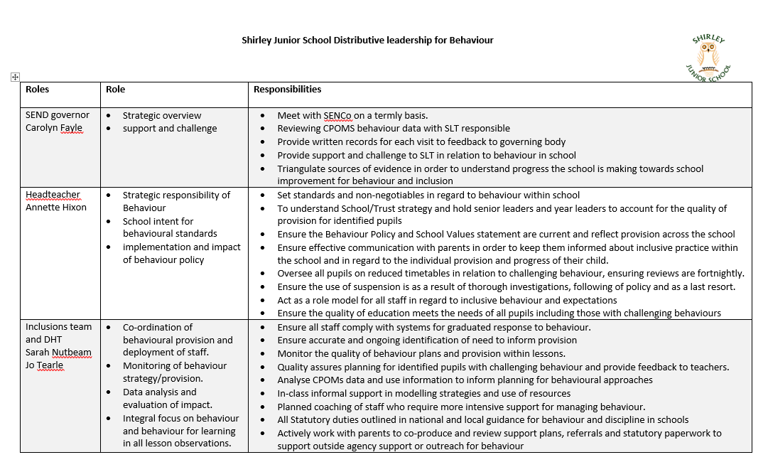
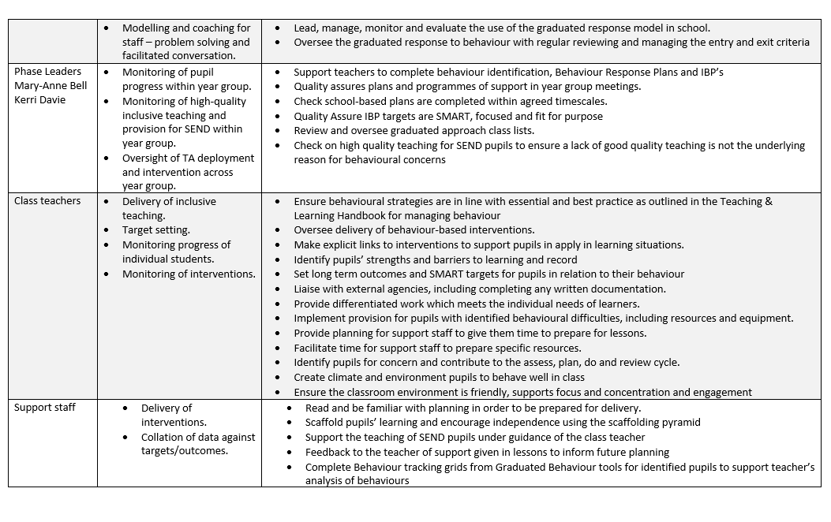
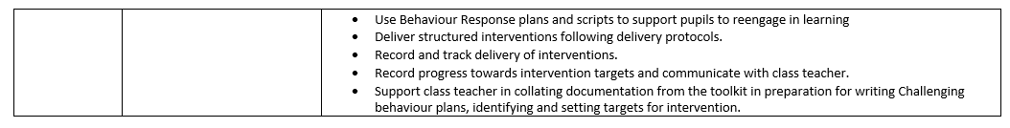

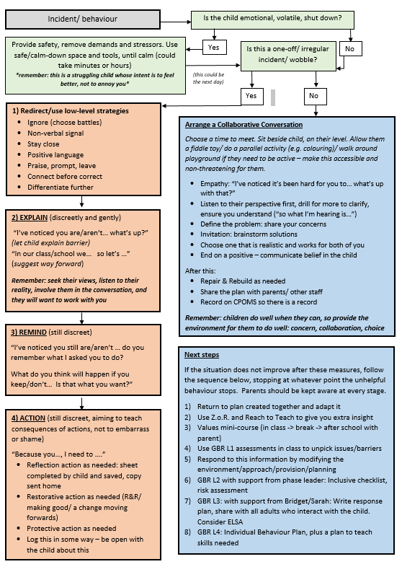
Reflections Form
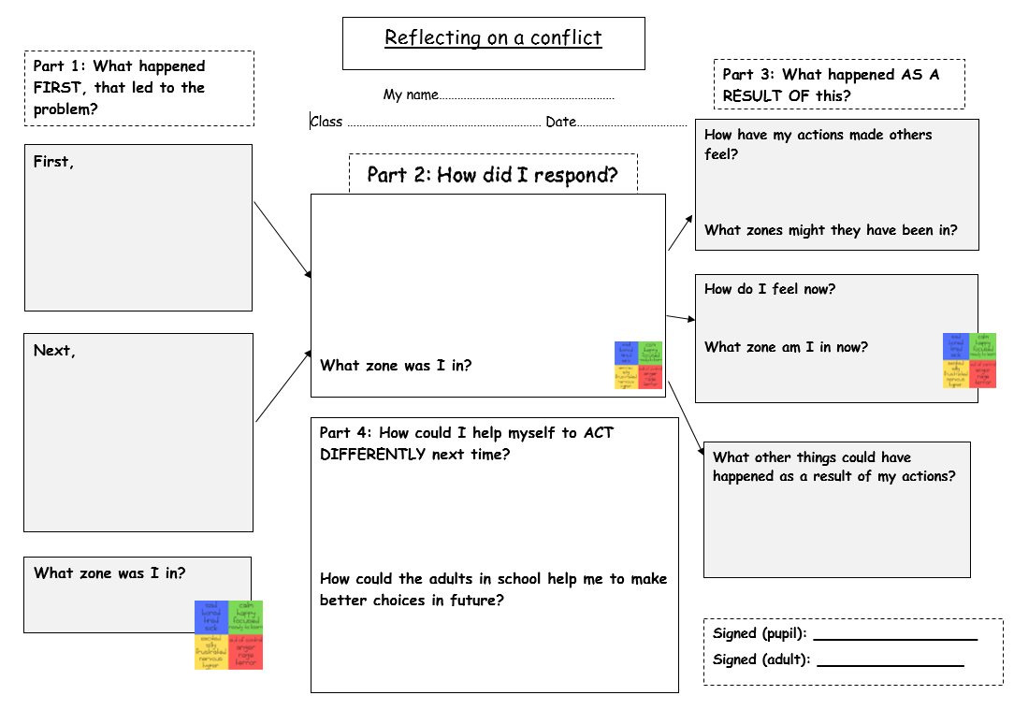
Exclusions letter

Address]

[Date]

Dear [Parent’s Name]
I am writing to inform you of my decision to exclude [Child’s Name] for a suspension of [specify period]. This means that they will not be allowed on the school site for this period.
The suspension starts on [Date] and ends on [Date]. Your child should return to school on [Date].
I realise that this suspension may be upsetting for you and your family, but the decision to suspend [Child’s Name] has not been taken lightly. [Child’s Name] has been suspended for [specify reason for exclusion].

You have a duty to ensure that your child is not present in a public place in school hours during this suspension on [specify dates] unless there is a reasonable justification for this. I must advise that you may receive a fixed penalty notice from the local authority if your child is present in a public place during school hours on the specified dates. If so, it will be for you to show reasonable justification.
We will set work for [Name of Child] to be completed on the school days specified in the paragraph above. [detail the arrangements for this]. Please ensure that work set is completed and returned to us promptly for marking.

You and [Name of Child] are requested to attend a reintegration meeting with [specify the name of the staff member] on [date] at [time]. If that is not convenient, please contact the school immediately to arrange a suitable alternative date and time.

You have the right to make representations about my decision to the school’s governing body. If you wish to make representations please contact [Name of Contact] on/at [Contact Details – Address, Phone Number, email]. Whilst the governing body has no power to direct reinstatement, they must consider any representations you make and may place a copy of their findings on your child’s school record.
You should also be aware that if you think this suspension relates to a disability your child has and you think disability discrimination has occurred, you have the right to appeal, and/or make a claim, to the First Tier Tribunal [Special Education Needs and Disability] http://www.justice.gov.uk/tribunals/send. Making a claim would not affect your right to make representations to the discipline committee.
You may wish to contact the following sources of advice about suspension/exclusion from school:
Kate Holmes, Exclusions Officer at Southampton City Council on 023 873 4613.

You may also find it useful to contact the Child Law Advice Service which has information about suspension/exclusion from school at https://childlawadvice.org.uk/information-pages/school-exclusion/ The Child Law Advice Service provides a limited telephone service on 0300 330 5485. The advice line is open from 8am to 6pm Monday to Friday, except Bank Holidays and 24th December to 1st January.
Department for Education statutory guidance on suspension/exclusion from school is published online at: www.gov.uk/government/publications/school-exclusion.

[Name of Child]’s suspension ends on [Date] and we expect [Name of Child] to be back in school on [Date] at [Time].

Yours sincerely

[Name]

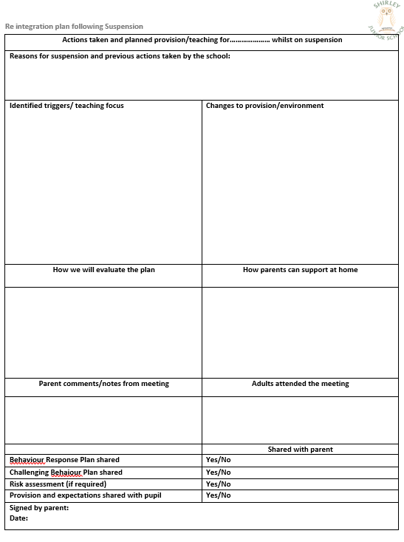
Toolkit for responding to allegations of child on child abuse
Any inappropriate behaviours that could be considered (as) ‘bullying’, will be taken seriously at all times. When written or verbal communications are received from a child/parent, whether for incidents occurring in school or offsite (such as via social media), these will be responded to in the following ways:
Any adult working in school will record any observed or communicated behaviour on CPOMs
⇩
A member of staff will speak to the child/ren concerned using the agreed school approach to identify any concerns/worries
⇩
Staff will observe child/ren in class and on the playground to identify whether the behaviours are deliberate, unwanted, ongoing and involving an imbalance of power.
⇩
Is this incident considered ‘bullying’? Consult with Senior Leadership Team
NO ⇙ | YES ⇘
Ensure the incident is recorded on CPOMs and regularly monitor the issue. Give children strategies to quickly report further concerns, e.g book/ key adult/worry box  The offender is given the opportunity to correct their behaviour, and a reflection sheet completed and shared with the offender's parents. Recorded on CPOMs | Child’s class teacher speaks to all parties involved.  This is recorded on CPOMs.  Head teacher will meet with parents of both parties, putting in place strategies to support, e.g ELSA, group sessions, and protective actions.

