13th July
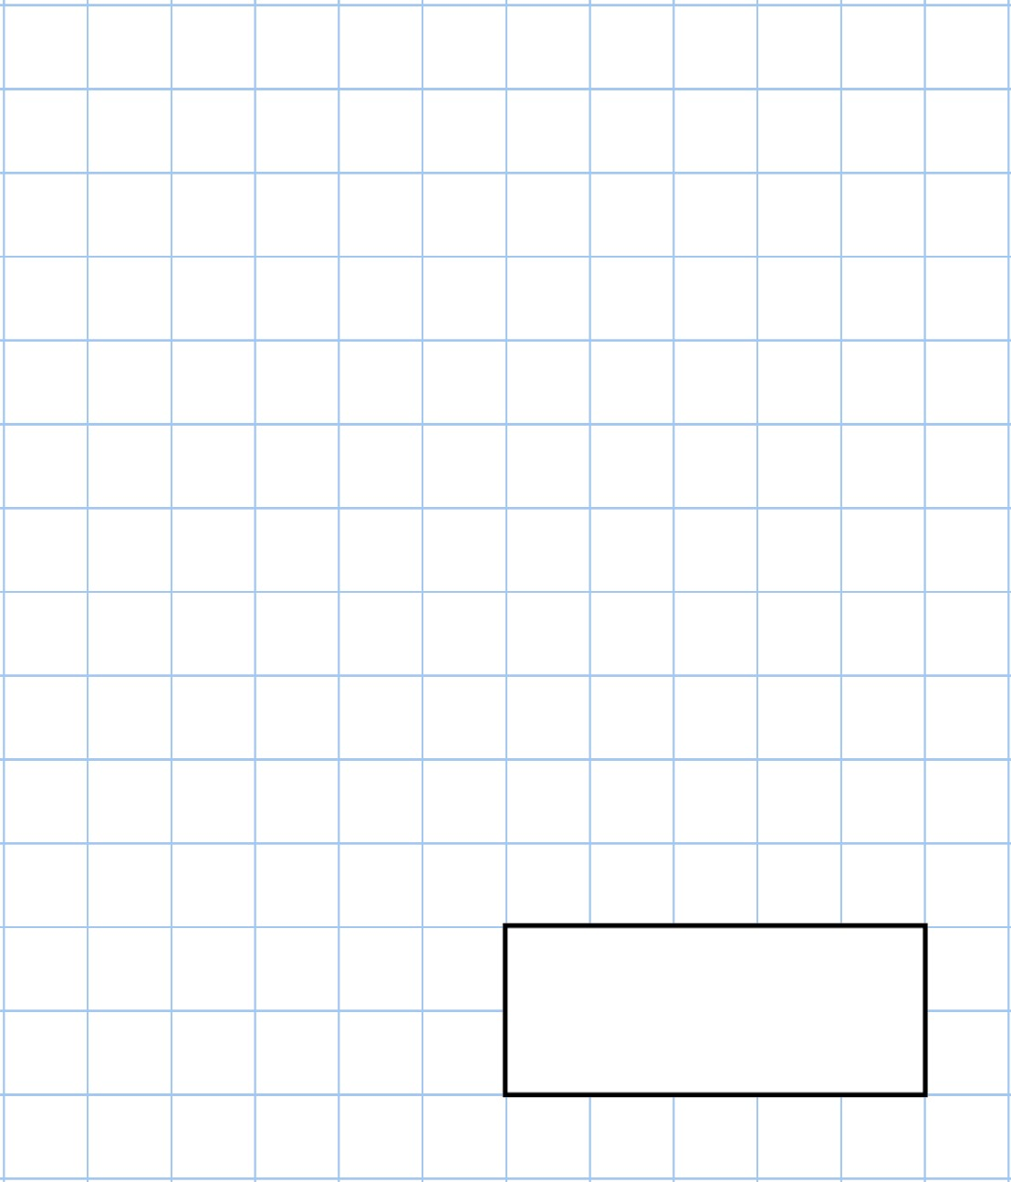    501  −  4 |   1  2  of  26
These are the opening times at a village library  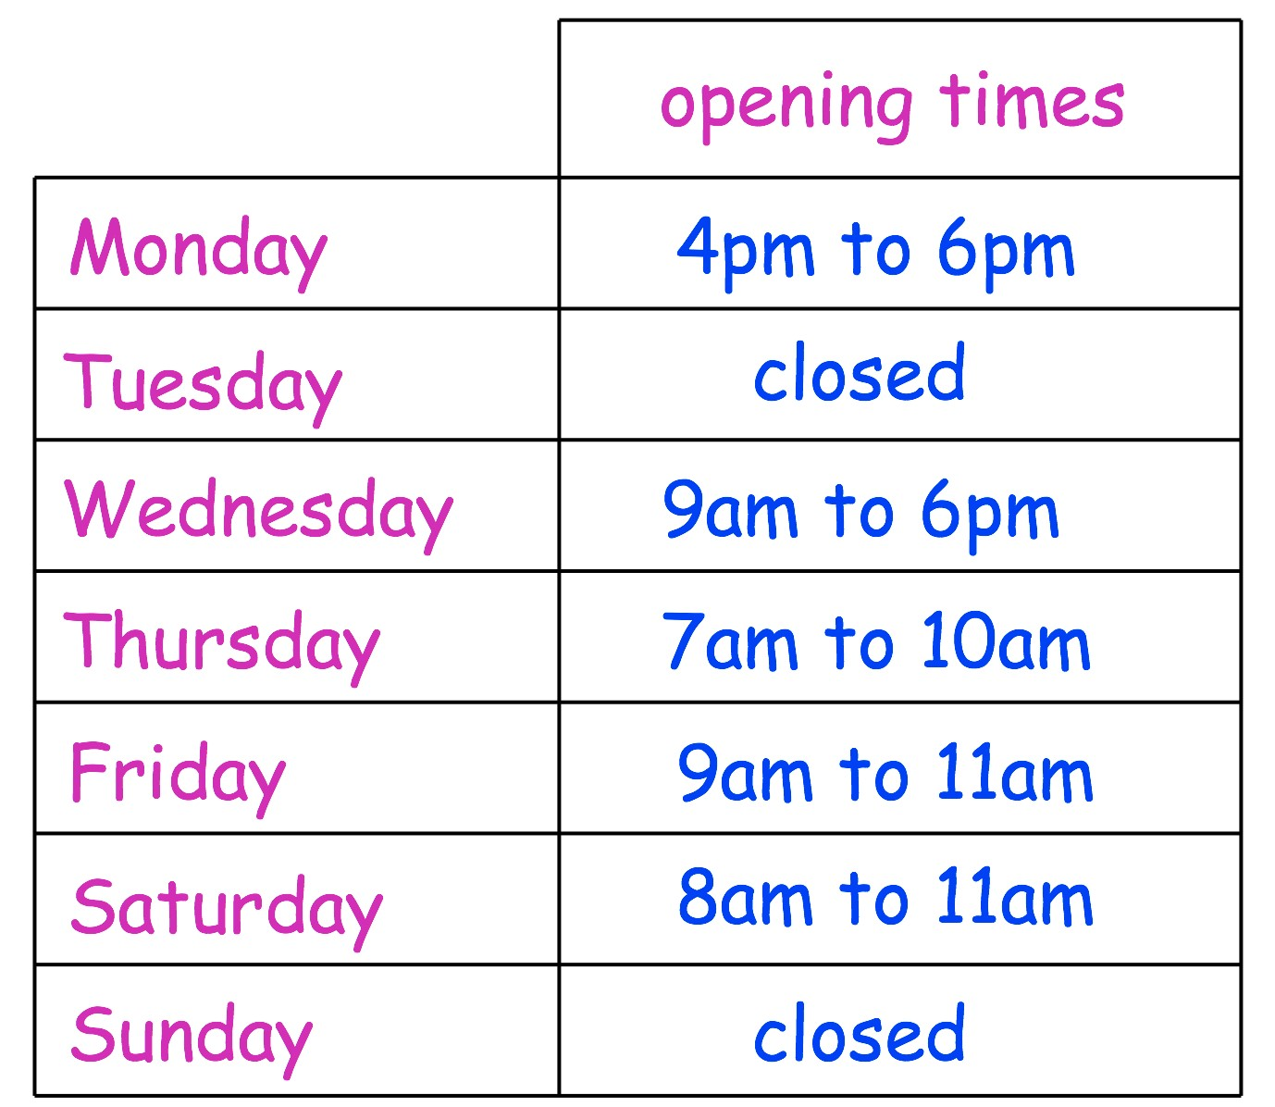 | On which days is the library closed?
 | On which day does the library open at 8am?
Circle three numbers which add to make
170

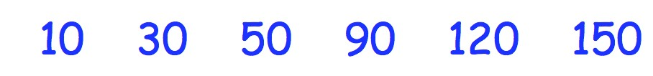

14th July
5  +  109 | 60  ×  2
A shop sells cupcakes in boxes of 8 and boxes of 6  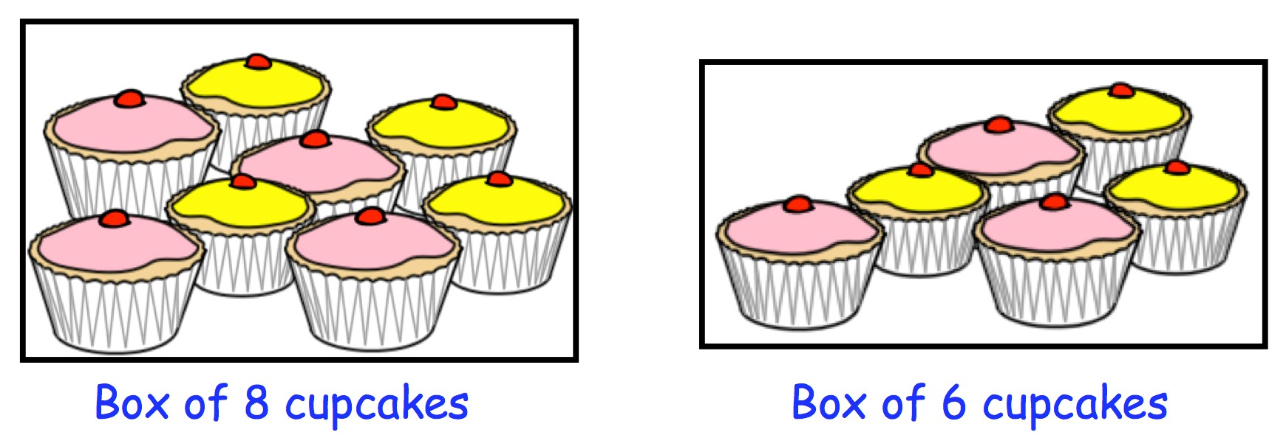 | Taylor bought 7 boxes of 6 cupcakes  How many cupcakes did she get?
Leah bought some boxes of 8 cupcakes

Altogether she has 40 cupcakes

How many boxes of 8 did she buy?
Draw a 6cm line

15th July
1  4  of  =  8 | 6  ×  9
The increases in bus fares is shown below  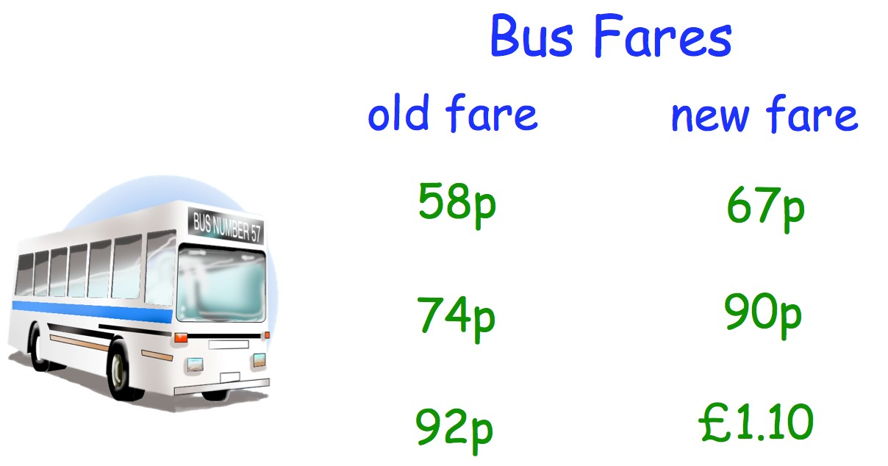 | David’s new bus fare is £1.10  How much was his old bus fare?
Jenson’s bus fare has gone up by 16p

How much is his new bus fare?

Complete the tally chart  - B A B B C A A B C  - C B C B A A B C B
  Letter | Tally | Frequency
  A
  B
  Cs

16th July
3  ,  000  +  60 | 12  ÷  1
A ruler cost 40p  A protractor cost 35p  A pencil cost 27p  A pen cost 10p  James buys one ruler, one protractor, one pencil and one pen. | 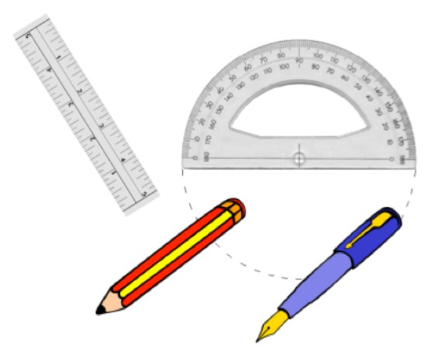
Work out the total cost? | How much change should he get from £2?
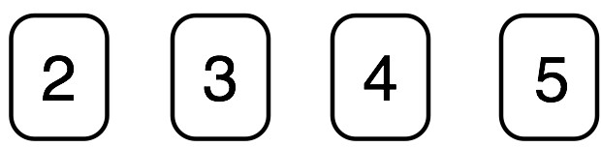  Look at the four digit cards above  You can only use each digit once. | Create the largest possible two digit even number

17th July
4  ×  4 | 135  −  40
Vicky put a pink block, yellow block and blue block beside each other  Work out the total length  cm | 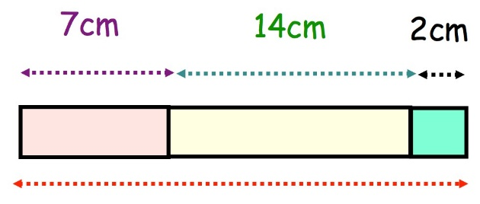
Draw lines to join all the pairs of number cards that have a difference of 30 | 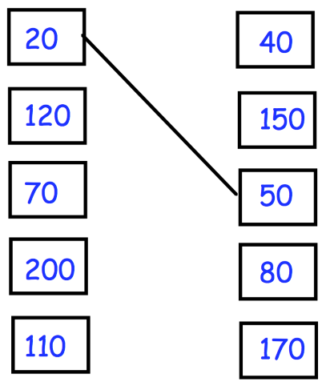
Draw a horizontal line | Draw a vertical line



