Summer 2 Week 7
Make a Board Game
What is your favourite board game?
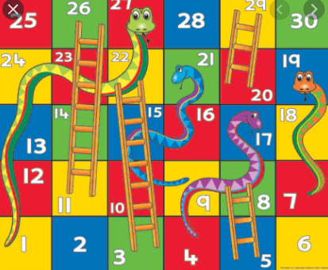
This week, we would like you to create a board game that reflects your experiences in your current year group, in what has been the craziest year ever!
First of all, write down 5 positive things that have happened this year. You should include things that you did in school, like going on a trip, and things that happened in lockdown.
Here are a few examples:
- Earned my pen license
- Took part in the Y3 Christmas play
- Made a new friend
- Got a new paddling pool
If your players land on these events, then something good will happen like:
- roll again
- move forward 3 spaces
- jump to square 10
- go up a ladder
Now, you need to think of 3 or 4 negative things, for example:
- spilt my water bottle on my work
- lost my glue stick
- missed my friends during lockdown
If your players land on these squares, the something sad will happen like:
- miss a go
- go back 3 spaces
- go back to the start
- go down a ladder
The design of your game is up to you BUT it should look colourful and inviting to play, like these examples:
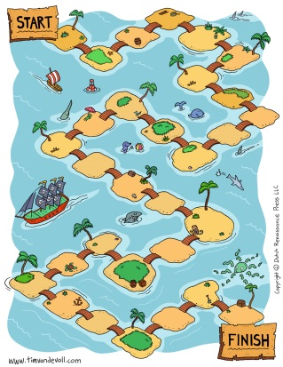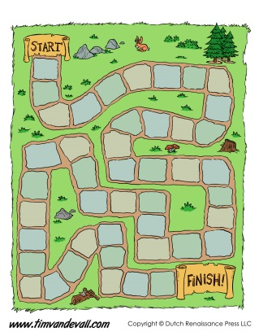
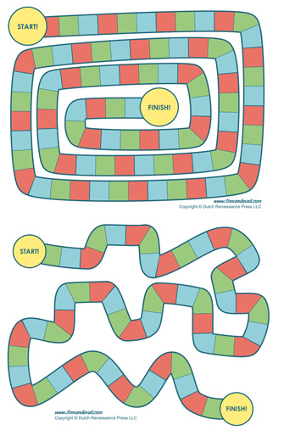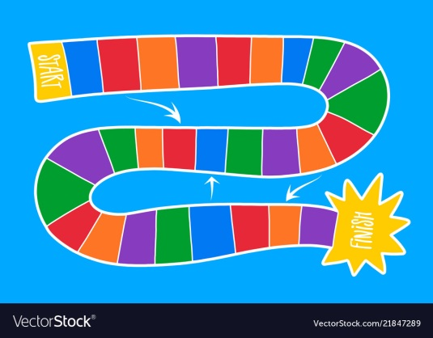
You will also need to make counters for all your players and you will probably need a dice. There is one here that you can make or you can get one online at https://www.online-stopwatch.com/chance-games/roll-a-dice/
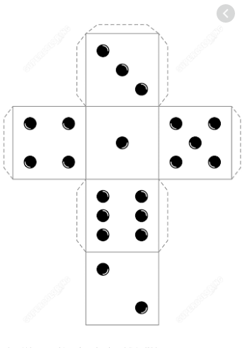
We would love to see a photo of you and your family playing your finished game!



