Summer 2 Week 6
Sound Poems
Lesson 1
When a word sounds like the noise it is describing, it is called onomatopoeia.
’Thud’, ‘crash’, ‘bang’, and ’buzz’ are all examples of onomatopoeia.
Visit this website and open the lesson
https://www.bbc.co.uk/bitesize/articles/zkvyxbk
Watch the short clip to see some more examples.
Onomatopoeia can help to bring a story or poem to life for the reader.
It is often used to add humour as well because the words usually sound quite strange or are fun to say.
Watch the clip in which poet Joseph Coelho talks about onomatopoeia and how you could use it in a poem.
You only need to watch up to 1 minute and 23 seconds.
Now, have a go at Activity 1 online and complete this activity sheet.
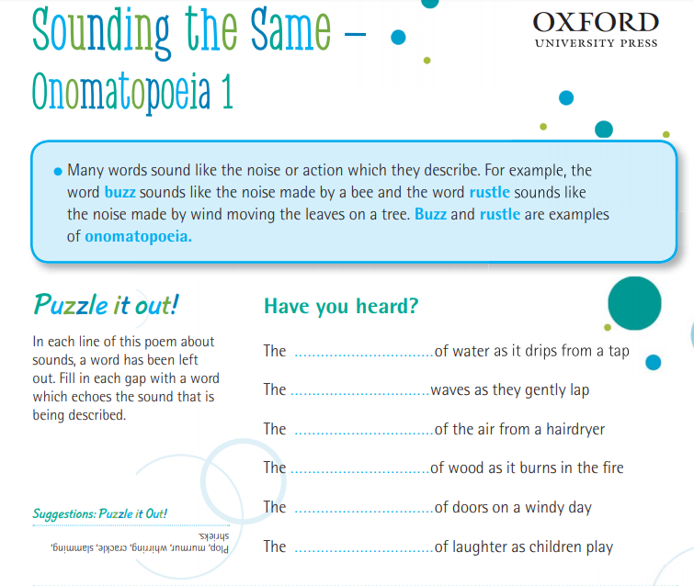
Now, you can make up your own sound words!

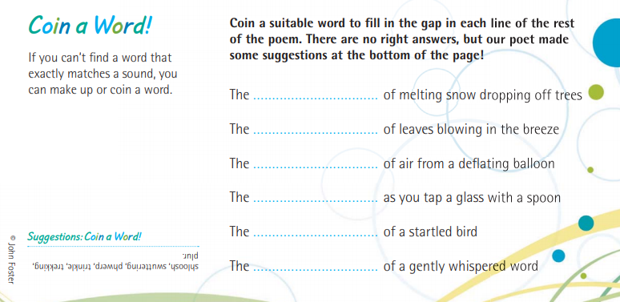
Lesson 2
Imagine you are visiting a zoo, like Joseph Coelho was in the previous video.
Write down a list of all the onomatopoeia words you might hear in a zoo and what is making those noises.
Aim to write at least eight noises in your list.
For example:
- Roar = an angry tiger
- Plop = a penguin jumping into the water
- Rustle = branches in the insect house
Top tip!
You could use some of the words from the activity sheet in Lesson 1, if you need some inspiration.


Lesson 3
Now write your own onomatopoeia poem using the ideas you came up with in Lesson 2.
You could use Joseph Coelho’s onomatopoeia poem from the video as inspiration.
For your poem you need to:
- Write in sentences.
- Write at least five lines.
- Use a different onomatopoeia word in each line.
You could also:
- Use rhyme (words that end with a similar sound)
- Use alliteration (words that start with the same first sounds)
We would LOVE to see or hear your poems. You could publish it and add some illustrations showing pictures of the things that are making the sounds in the zoo or send us a video clip.

