Day 1
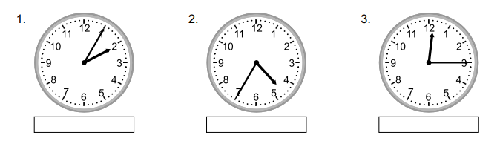
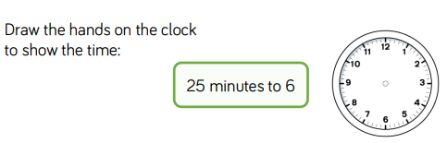
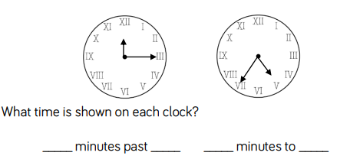
1.
2.
3. Write the time in numbers and words below each clock face. The first one has been done for you.

Five minutes past two.
2:05

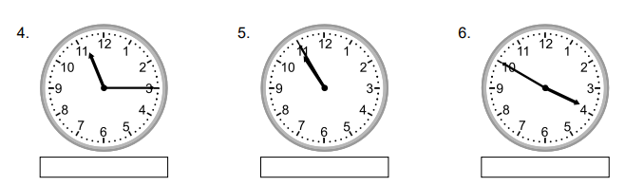

Day 2
1. Real life time problems
- Maths starts at 10.25am and lasts for 45 minutes. At what time does Maths finish?
_________
- Science lasts for 55 minutes and ends at 3.30pm. At what time does Science start?
_________
- Year 5 have a 40 minutes Maths lesson every day. In one week at school how long will Year 5 have spent in Maths?
_________
- Class 7 needs to get to the museum at 11.30am. It is a 17 minute walk from the museum. At which time must Class 7 leave school if they are to arrive at the museum at exactly 11.30am?
__________
- Shameila left home at 10am. She spent 10 minutes walking to Stacey’s house and then stayed with Stacey for 2 hours. Shameila then spent another 10 minutes walking home. At what time did Shameila arrive home?
__________
- Class 5 are meant to have 1 hour of English each day. Last week however, one of their lessons was cut in half because they had a special assembly. How long did Class 5 spend in English last week
__________

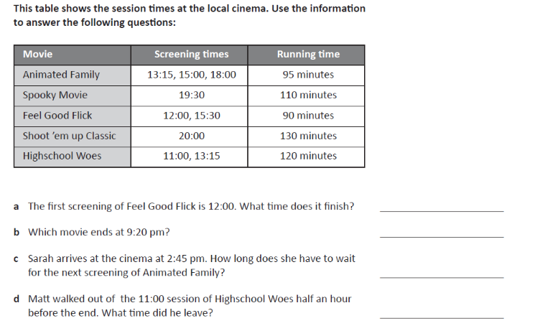
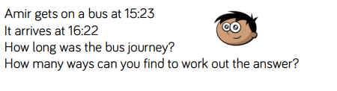
2.
3.
Day 3

Answer here

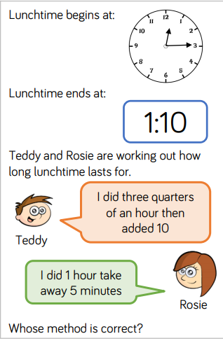
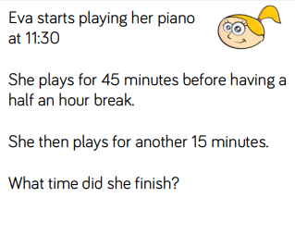
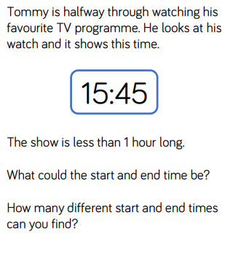
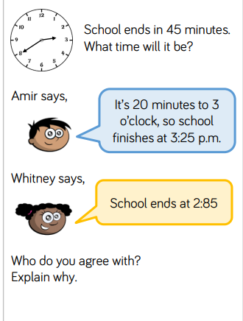
1.
2.
3.
4.
Answers
Answer here
Answer here
Answer here
Answer here
Day 1
- 15 minutes past 12, 25 minutes to 5.
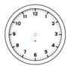
- 4:35/ twenty-five minutes to five.
12:15/quarter past twelve.
11:15/quarter past eleven.
10:55/five minutes to eleven.
4.:50/ten minutes to five.
Day 2.
- 11:10
2:35
3 hours, 20 minutes (200 minutes)
11:13am
12:20
4 hours, 30 minutes
- a) 13:30
b) Spooky Movie
c) 15 minutes
d) 12:30

- 59 minutes.

Day 3.
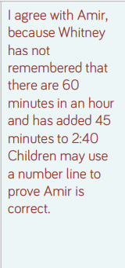
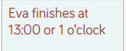
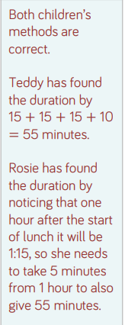
- 2. 3.



