6th July
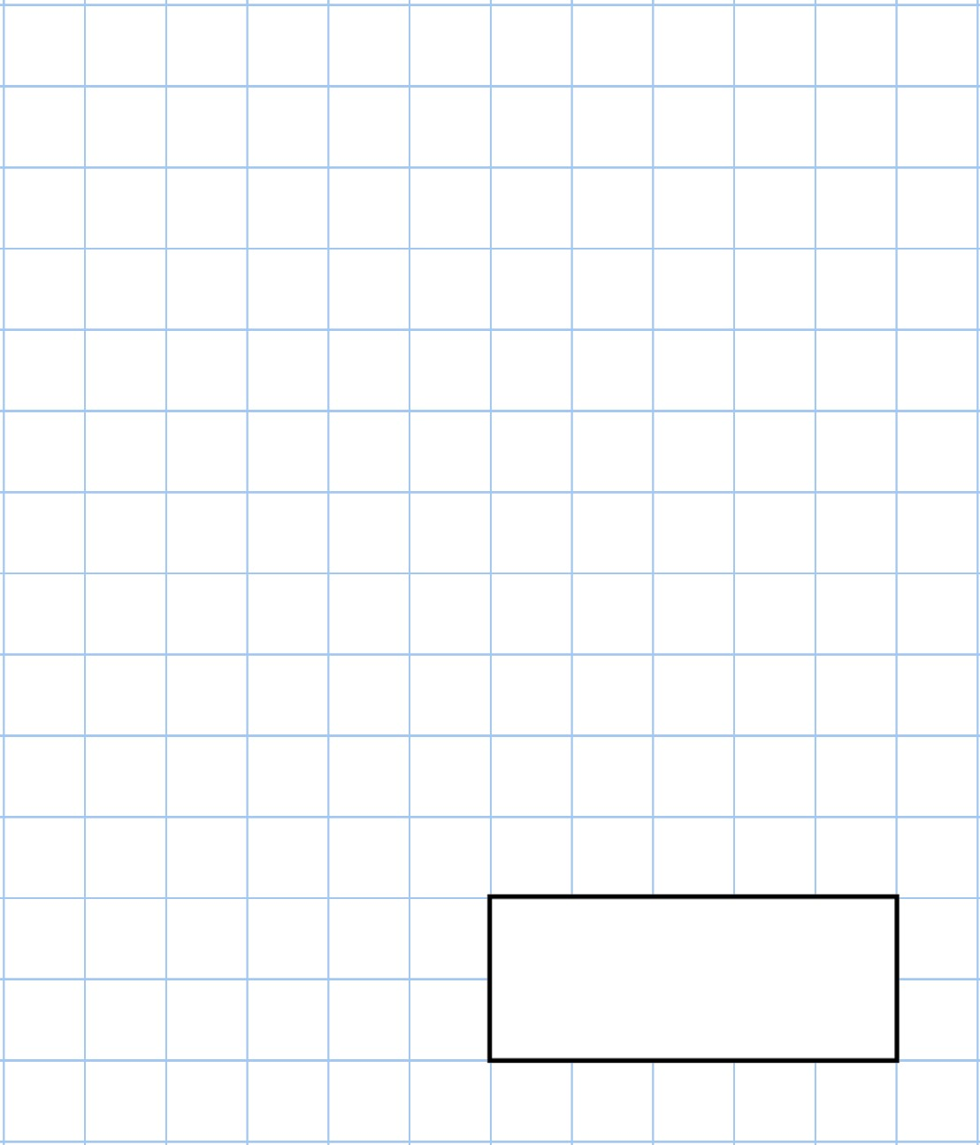    40  ÷  20 | 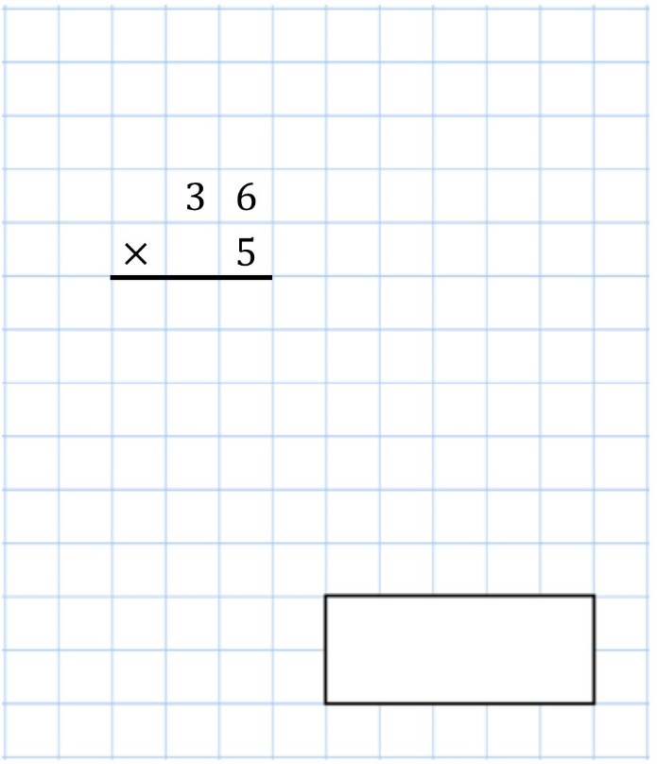
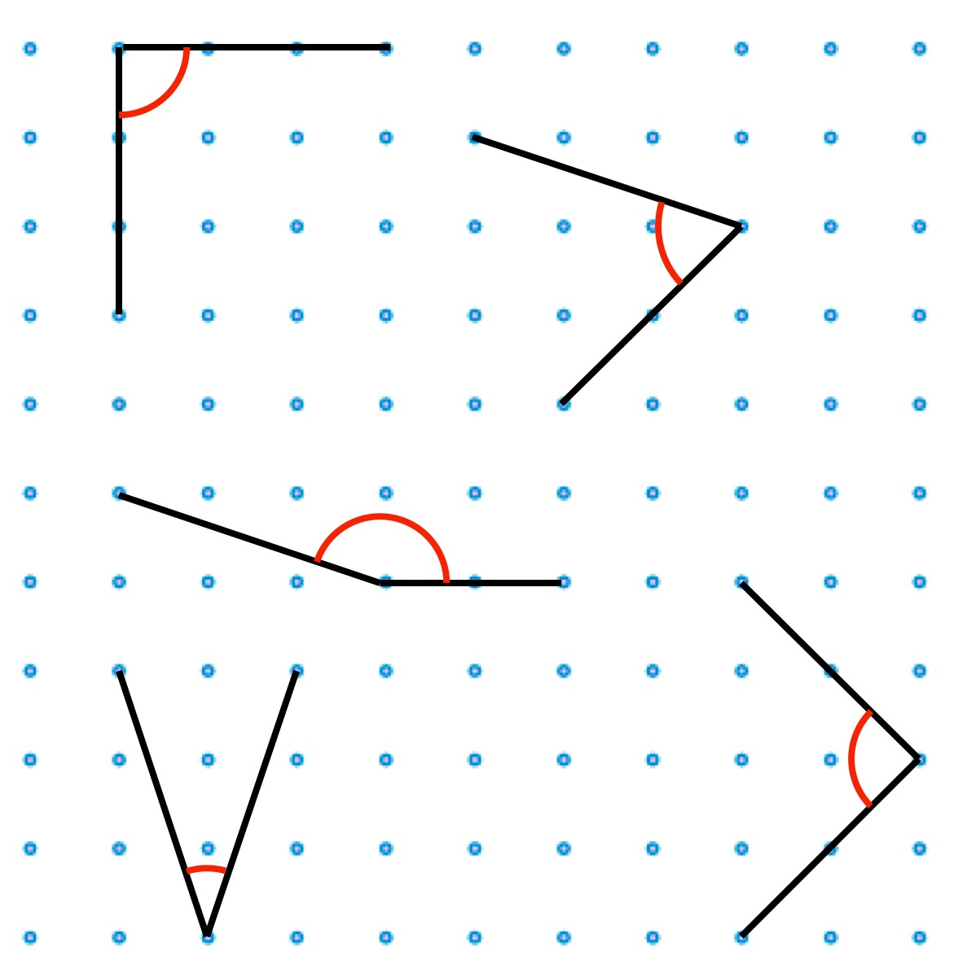 | Tick the two acute angles
 | Circle the obtuse angle
Draw a 5cm line

7th July
1  ,  900  −  1  ,  500 | 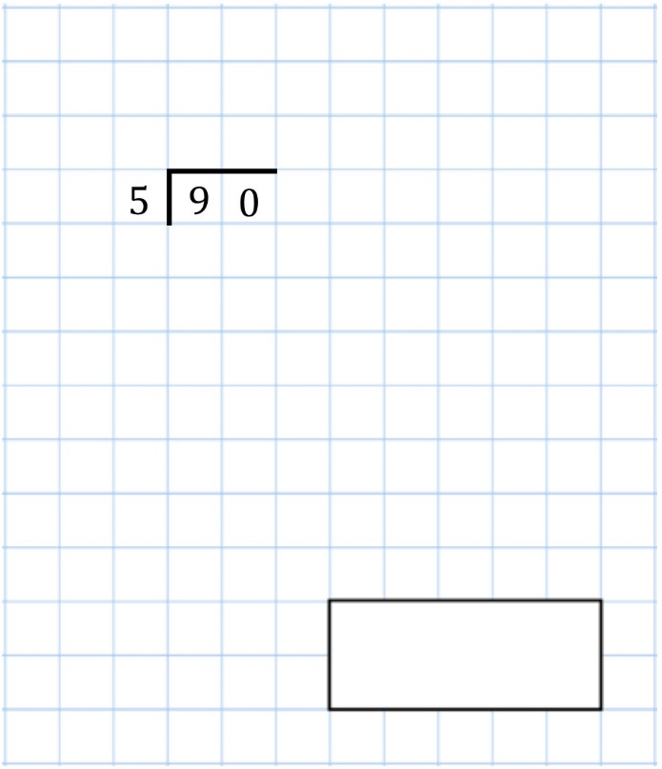
This chart shows the number of gold and silver tokens collected by some children  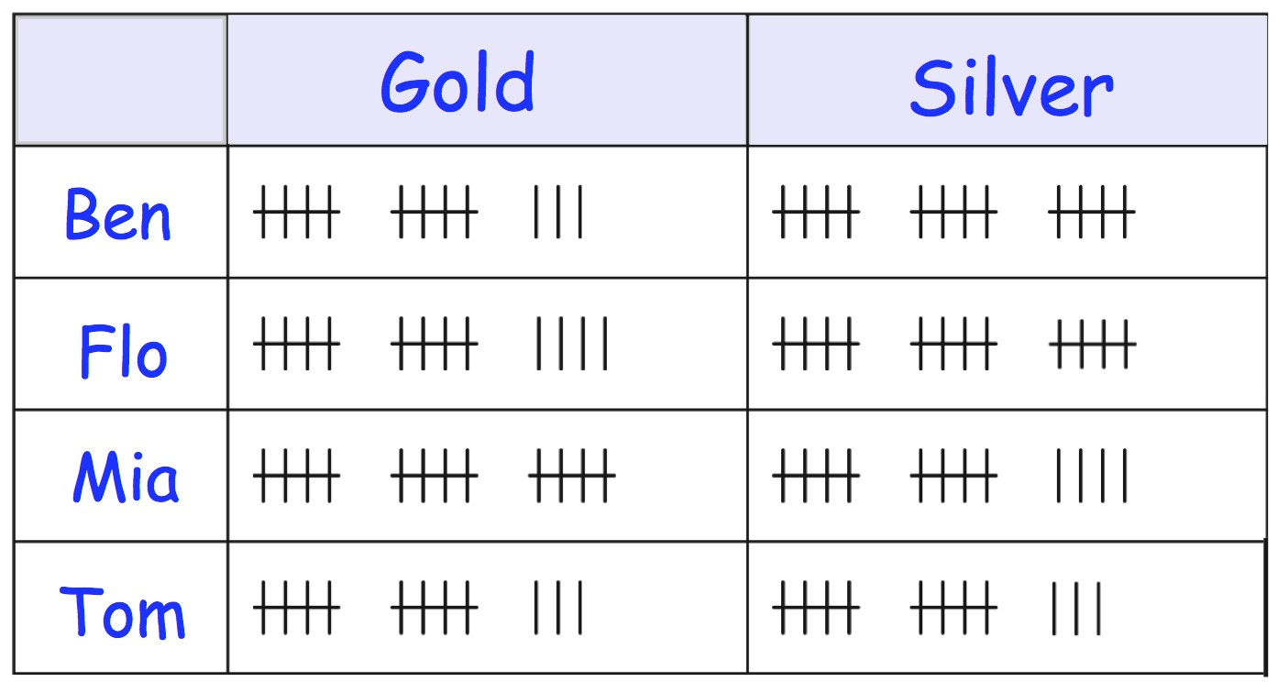 | Who has more gold token than silver tokens?
 | Who has 14 gold tokens?
Seven children share a bag of grapes.  Each child gets 7 grapes.  There are 5 grapes left over. | How many grapes were in the bag altogether?

8th July
4  ×  4  ×  2 |     6  ×  6  =  50  −
How much does one yellow block weigh? | 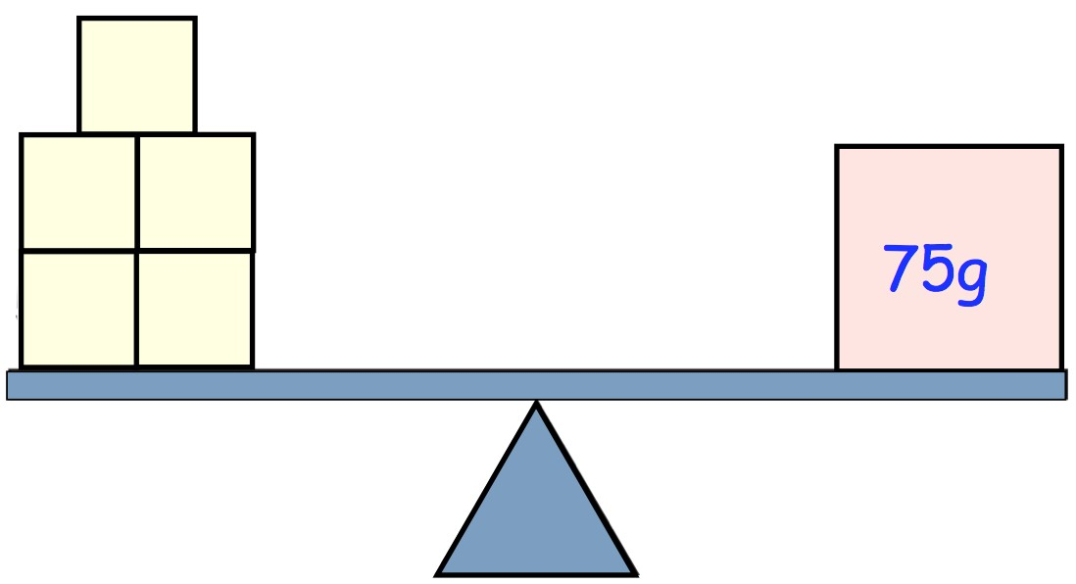
Circle all the numbers that are multiples of six

10 16 24 28 32
Sidney has 40p Jessica has 52p

Jessica gives some money to Sidney. They now have the same amount of money.

How much money did Jessica give Sidney?

9th July
700  +  700 | 9  ×  9
53 children get on a bus 28 of them are boys.  How many are girls? | 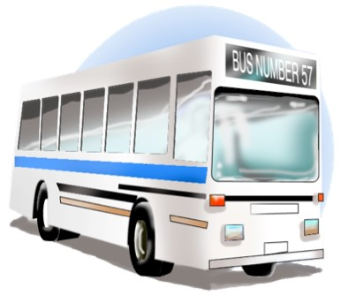
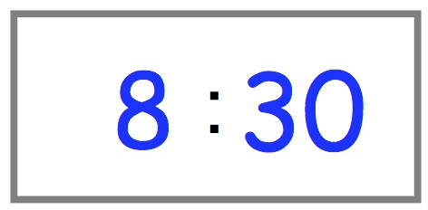  The bus leaves school at this time  It gets back to school three and a half hours later | At what time does it get back?  :
Complete the reflection of this pattern in the mirror line | 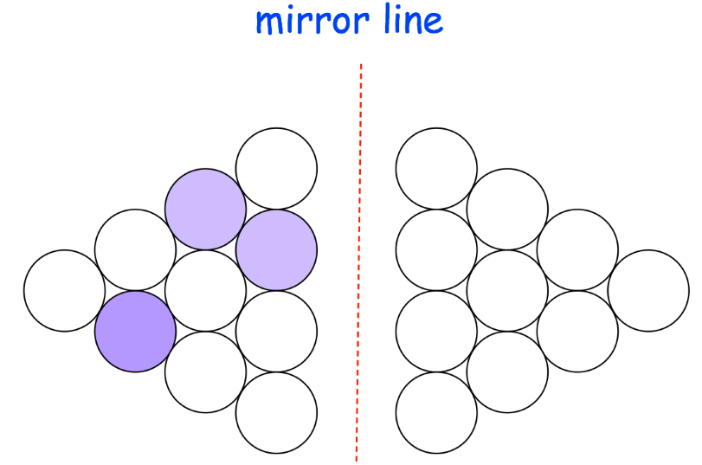

10th July
56  −  9 | 145  −  50
The children in a class vote for their favourite school trip. Each child voted once.  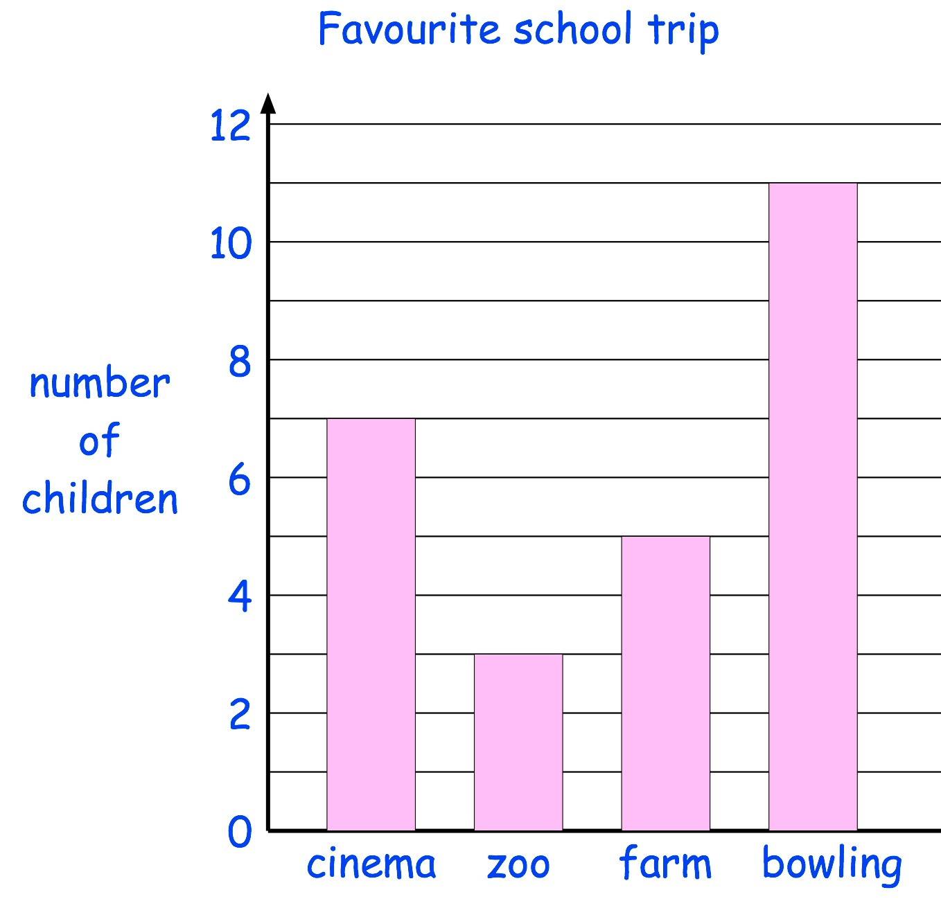 | How many more children voted for bowling than for the zoo?
 | How many children voted altogether?
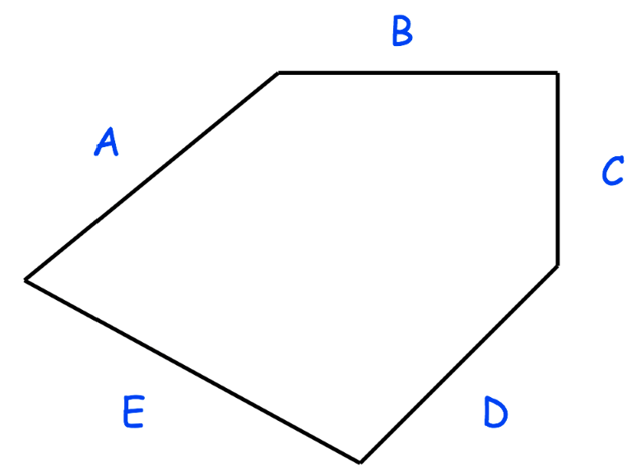 | Two sides of this shape are the same length.  Write their letters.



