5-a-day – Day 1
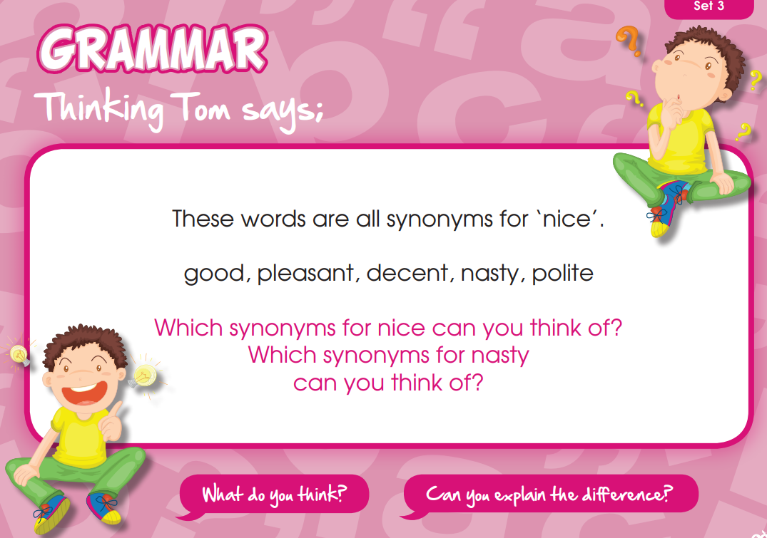

5-a-day – Day 2
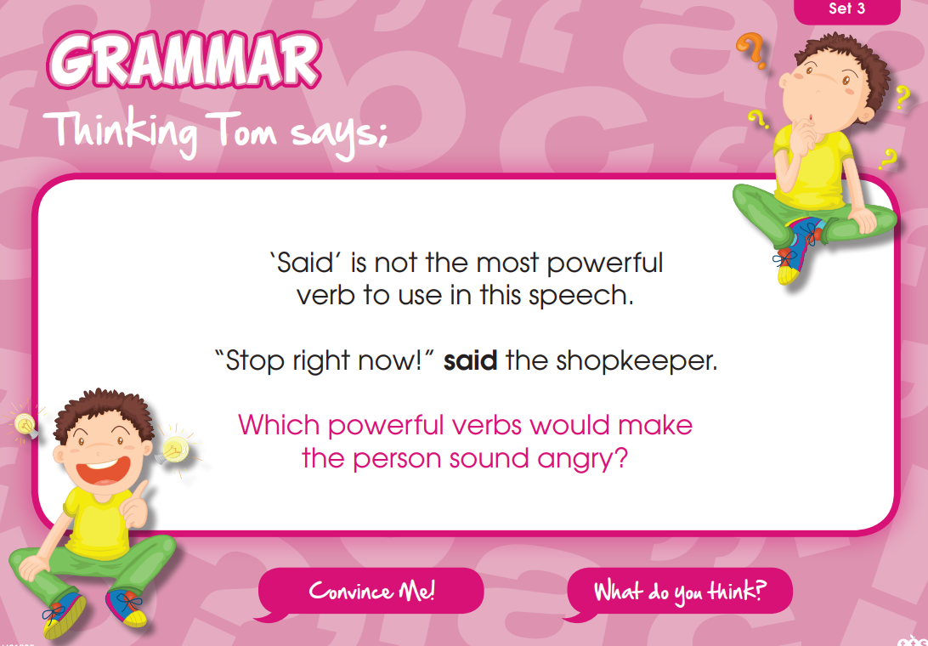
5-a-day – Day 3
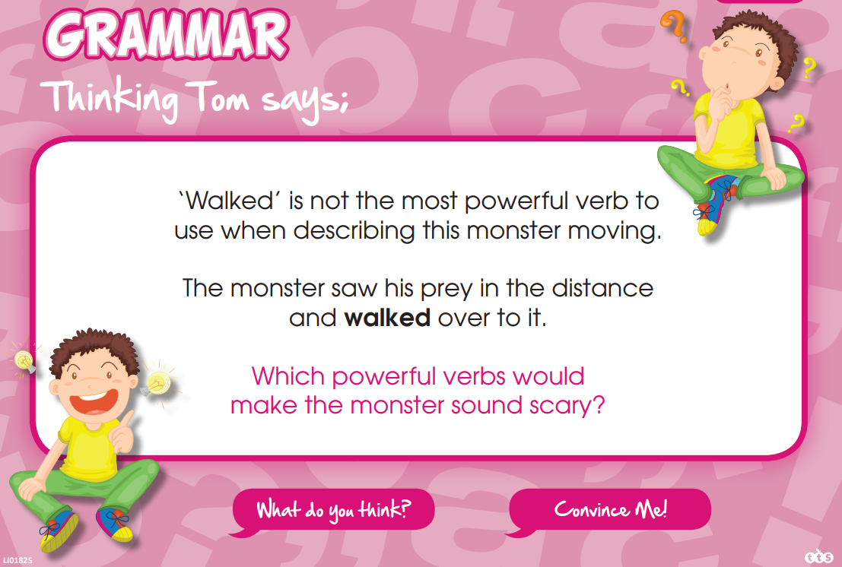

5-a-day – Day 4
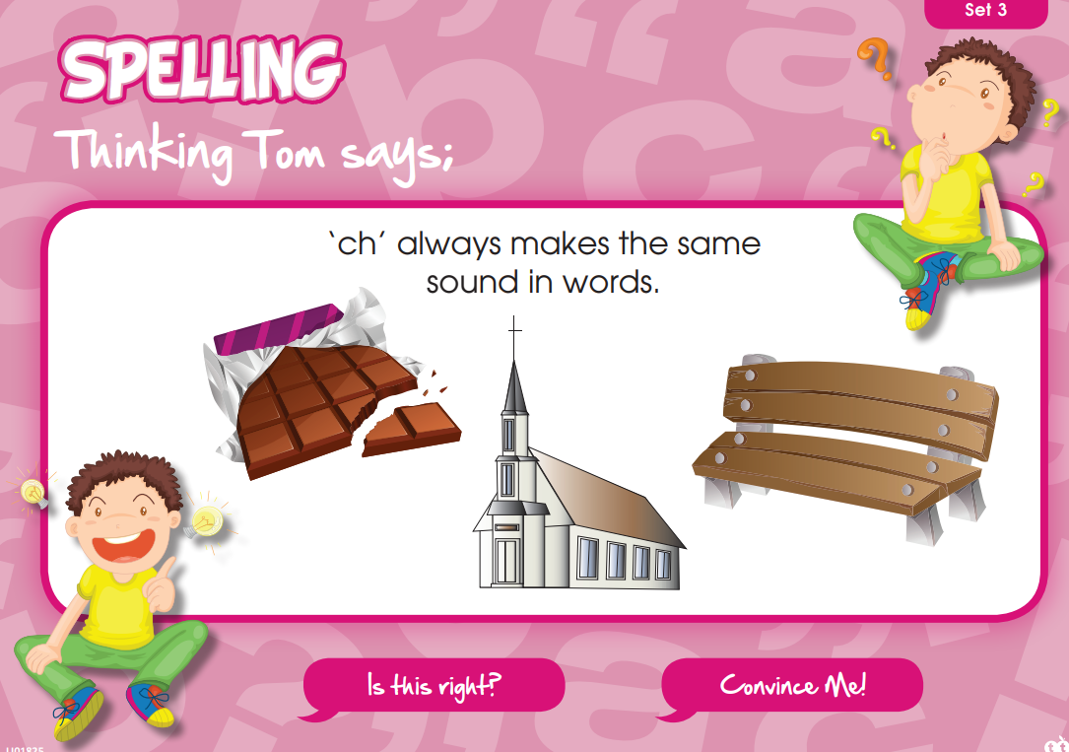
5-a-day – Day 5

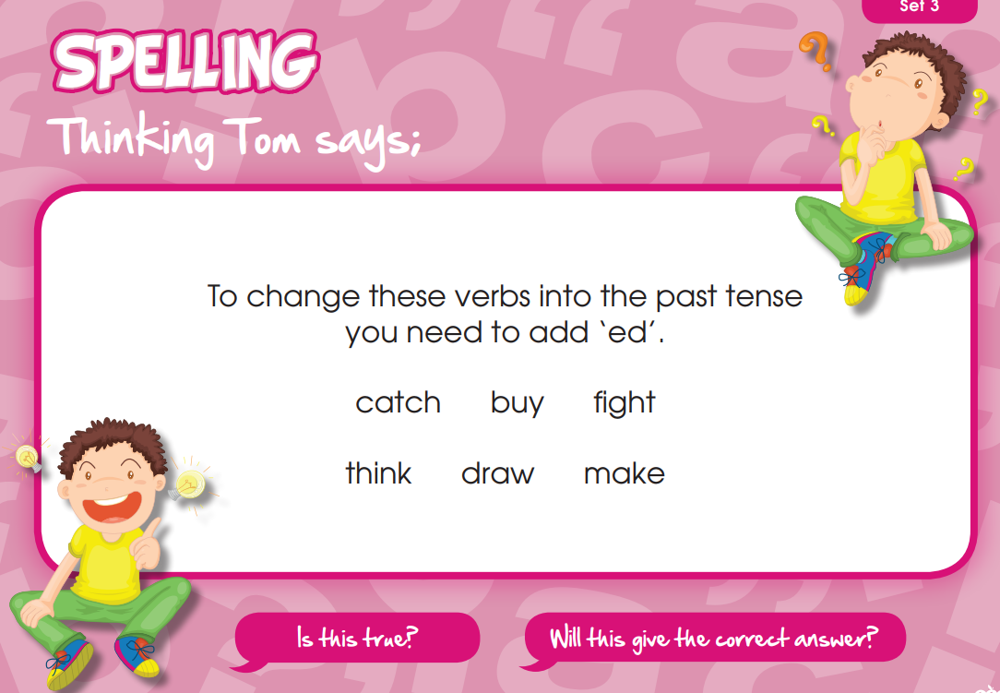
Summer 2 Week 6
Creating Characters
Lesson 1
When authors create a new character they have to know everything about them. This means answering a lot questions about what that character is like.
Visit this website and watch the clip about creating characters: https://www.bbc.co.uk/bitesize/articles/zd6n2v4
Authors need to know everything about their characters so they know how they will act throughout the story.
They ask themselves questions like:
- What's the character's name?
- How does the character behave?
- What do they like to do?
- How old are they?
- What do they feel and what are they thinking?
Now play the clip to hear ex-England player Eniola Aluko read an extract from Matilda by Roald Dahl.
Listen carefully to the conversation between Matilda and Miss Trunchbull and think about what each character is like.
Copy and complete the table below. You need to think of two more adjectives (describing words) for each of the characters
Top tip: Think about what the characters say and do.

Matilda | Miss Trunchbull
1. Brave | 1. Mean
2. | 2.
3. | 3.

Choose three of the adjectives and explain how you know that by referring to what happened in the story. Use the word ‘because’.
For example: I know that Matilda is brave because she stands up to Miss Trunchbull.
Click here to type

Lesson 2
Imagine you are writing a story set in a school, like in Matilda.
You’re going to create a character that would be in that story. It could be anyone - the head teacher, a teacher, a student, a coach, a caretaker.
Complete the ‘Character Profile’ activity sheet. You need to draw your character in the centre of the page and then fill in the surrounding boxes with information about them.
If you can’t print the activity sheet, you can draw your character and answer the questions on a piece of paper instead.
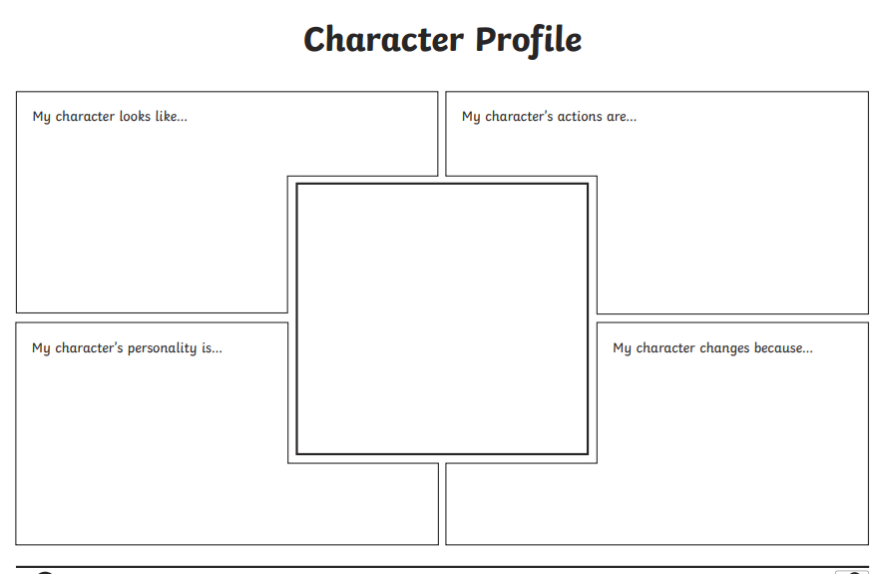

Lesson 3
Read this character description of a school caretaker called Mr Simmons.
He is a kind and happy person who likes to help others. This is shown through his actions.
Mr Simmons is the caretaker at Dillon Road Primary School. He is a small man, with white-grey hair and bright brown eyes. He wears round spectacles and the same blue overalls every day. He has been at Dillon Road for as long as anybody can remember.
Mr Simmons can often be found with his old yellow bucket and mop cleaning the corridors. When the children run in from play time, leaving shoe marks and muddy footprints behind them, Mr Simmons will tut, roll his eyes and clean up the mess. Although he’s always hard at work, if he ever sees anyone who looks sad or upset, he’ll pull funny faces in order to make them smile.
At the end of the day, when everyone has gone home, he cleans the classrooms and leaves happy messages on the whiteboards for the children and teachers to find in the morning. If ever he finds a missing jumper, a lost toy or some hidden sweets (which are strictly forbidden) he always finds out who they belong to (and won’t tell you off!).

Write your own character description using the character profile you filled out in Lesson 2.
You should write between five and ten sentences.
Top tip!
Try to include:
- What your character looks like.
- What their job or role is.
- What their personality is like.
- Their actions – what they do in the school.
You could add an illustration of your character. We would love to see your finished character profiles!

