29th June
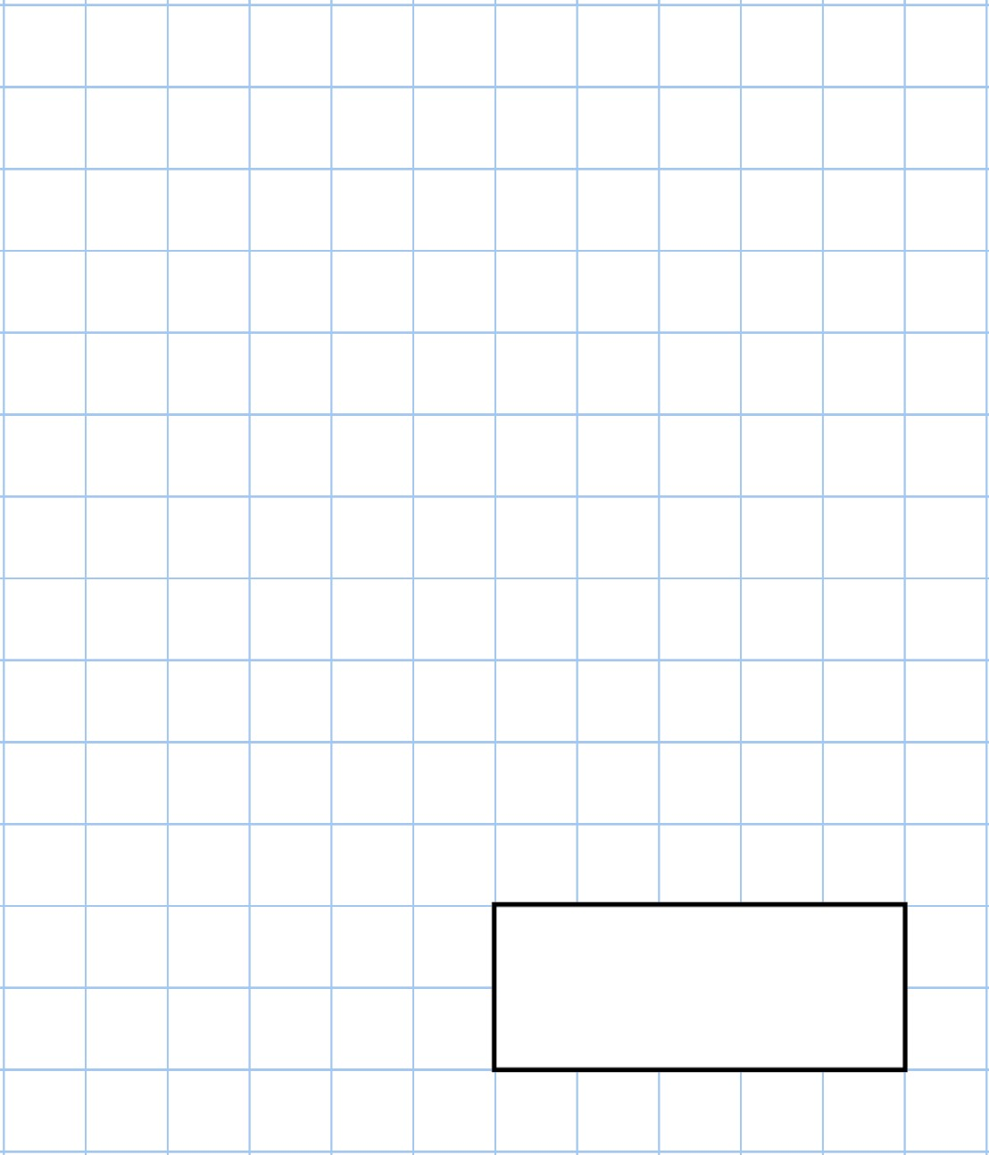    100  −  21 |   3  ×  12  =  4  ×
Ted scores 75 points  Claire scores 48 points  How many more points does Ted score than Claire? | 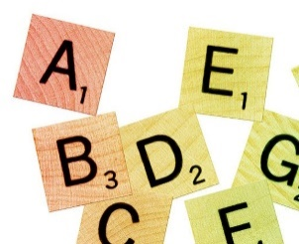
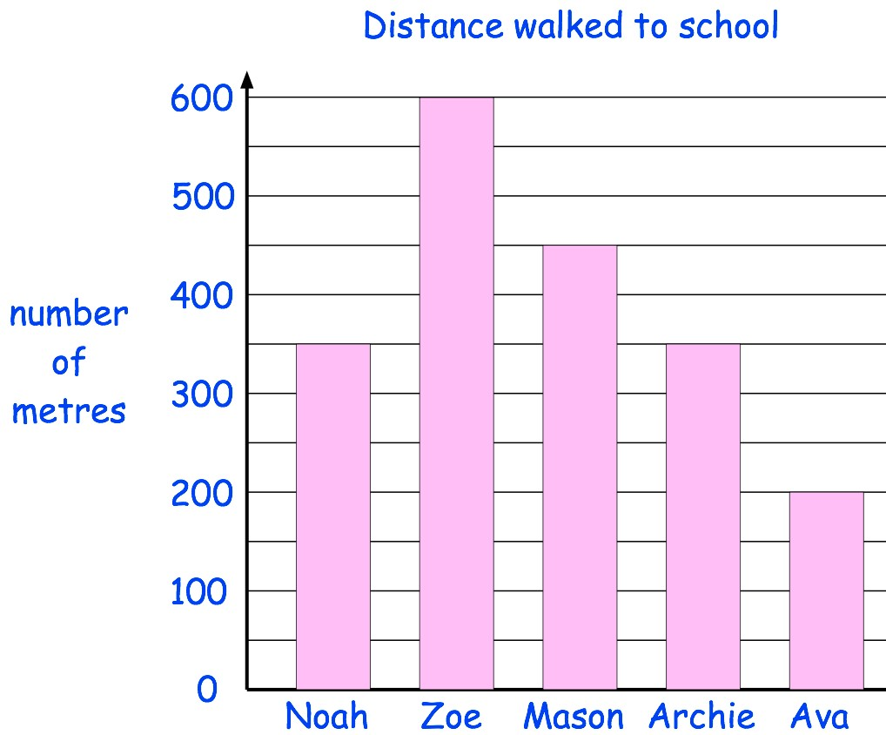 | Who walks the shortest distance to school?
 | Which two children walk the same distance to school?

30th June
40  +  100  +  30 | 72  ×  3
Some children share 32 cherries.  Each child gets 4 cherries.  How many children are there? | 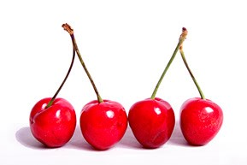
Write these numbers in order, from  smallest to largest  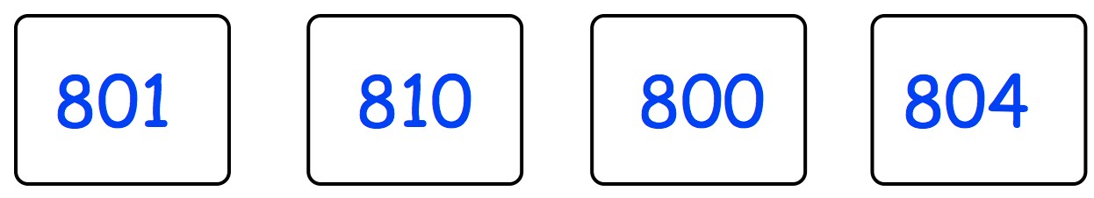
  Smallest |  |  | Largest
Katy has four coins.

She has £5 in total.

What coins could she have?

1st July
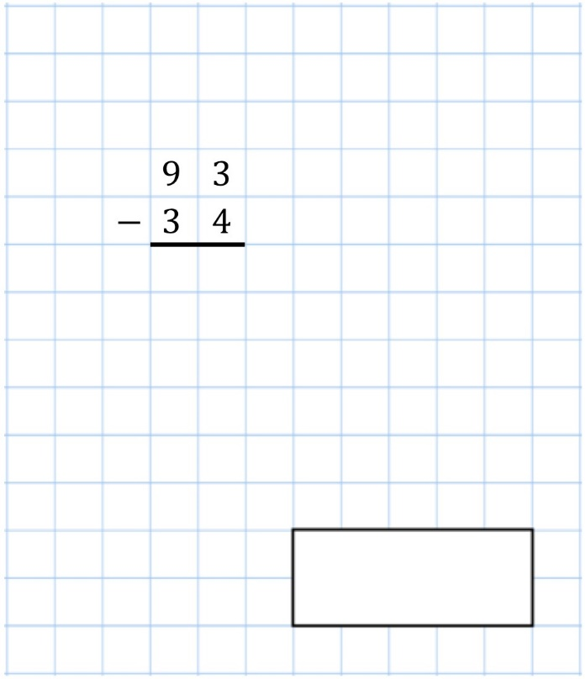 | 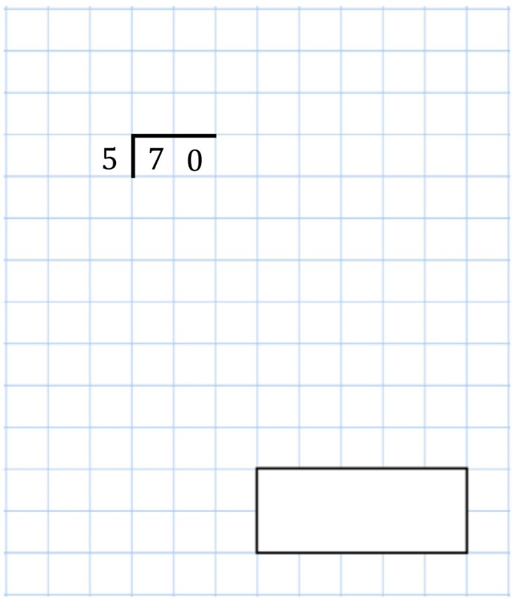
How many days are there in July? | 
Write in the missing numbers | 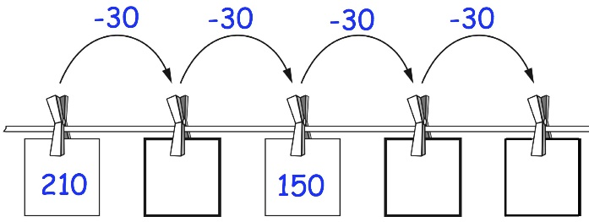
Chloe weighs 28kg  David weighs 26kg more than Chloe  Draw an arrow on the scale to show how much David weighs | 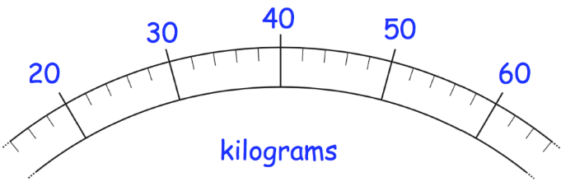

2nd July
34  ÷  2 | 90  −  58
Write down 4 even numbers
Tasmin wants to buy a drink.

She has 75p and needs 15p more to buy the drink.

How much does the drink cost?
Shade 1/3 of this shape | 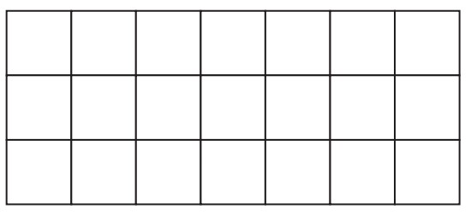

3rd July
305  −  20 | 7  ×  7
Sharon has a bag of 32 biscuits.

¼ of the biscuits are chocolate.

How many biscuits are chocolate?
Jessica asked her friends their favourite colour.  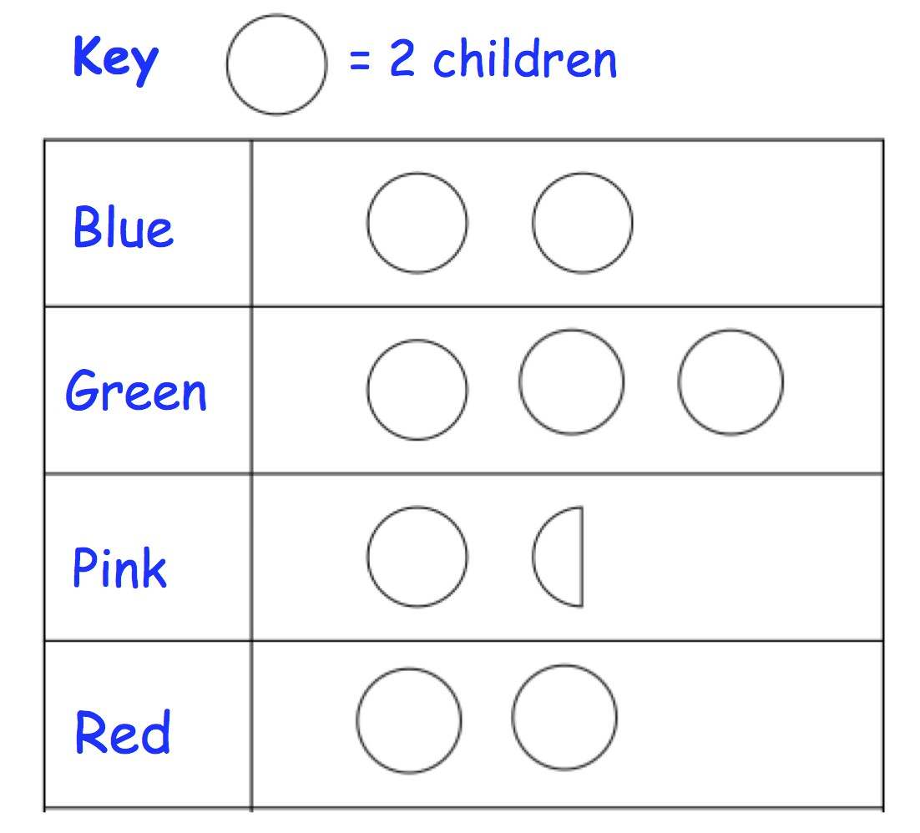 | How many picked blue?
 | How many friends did she ask altogether?



