Summer 2 Week 5
Curriculum Spellings Words
This week we are going to focus on the second set of 28 that you learnt this time last year.
You need to ask someone to test you on these words. You could colour in the ones you get right on the ‘spelling fish’ from last week.
You then need to learn the ones that you have forgotten.
You can choose from the activities listed.
Spelling words:
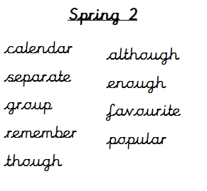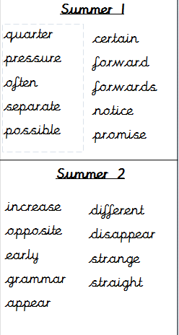
Activities


