Day 1

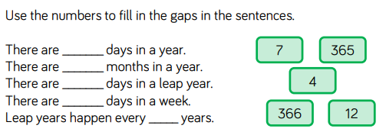
1.

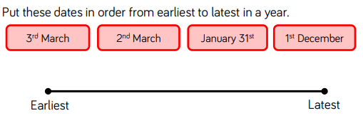
2.

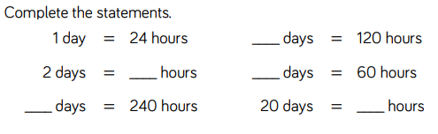

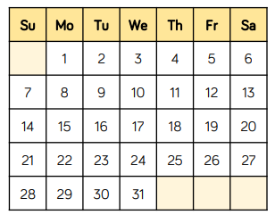
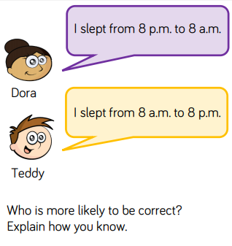
3.
4.
Day 2

Answer here
1.
Answer here

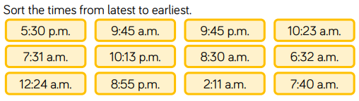
2.
Earliest
Latest

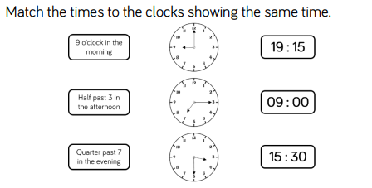
3.

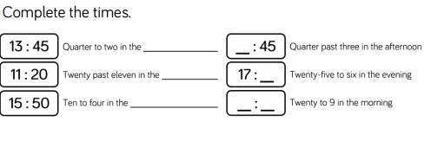
4.

5. Convert the times between 12 or 24 hour clocks.
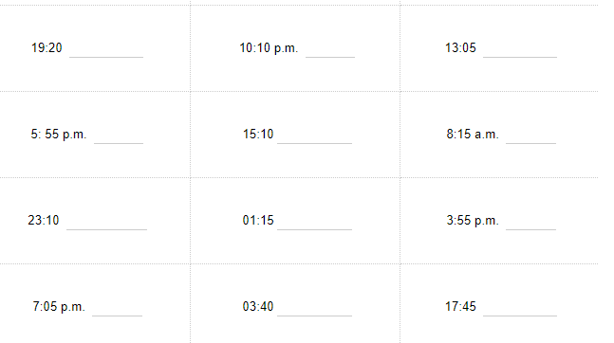

Day 3 – reasoning and problem solving

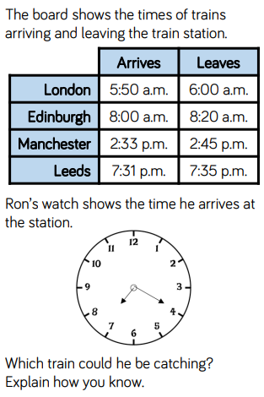
Answer here.
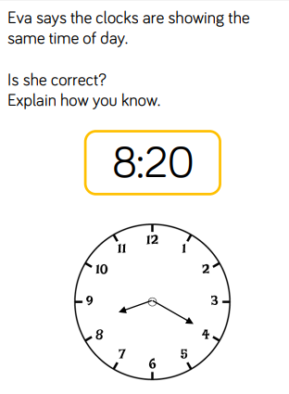
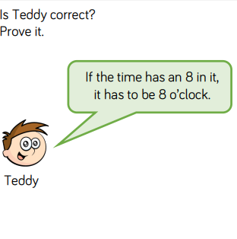
Answer here.
Answer here.

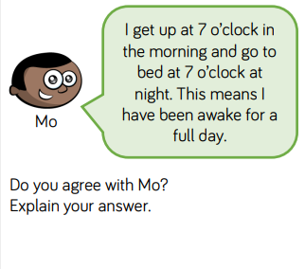
Answer here.

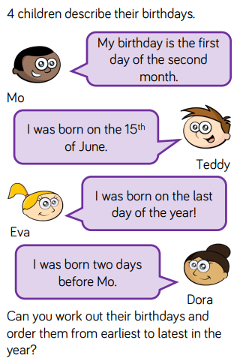
Answer here.
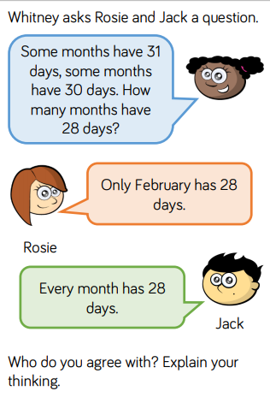
- Answers
Answer here.

Day 1


- 365, 12, 366, 7, 4 5.
- Jan 31st, March 2nd, March 3rd, December 1st.
- 2 days = 48 hrs
10 days = 240 hrs
5 days = 120 hrs
2.5 days = 60 hrs
20 days = 480 hrs

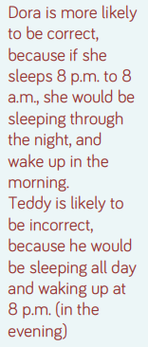
Day 2
- 2. 10.13pm, 9.45pm, 8.55pm, 5.30pm
10.23am, 9.45am, 8.30am, 7.40am
7.31am, 6.32am, 2.11am, 12.24am

3.

4.
afternoon
morning
afternoon
14
35
09:20
5. 7.20pm 22:10 1.05pm
17:55 3.10pm 08:15
11.10pm 1.15am 16:55
19.05 3.40am 5.45pm

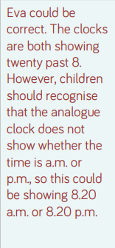
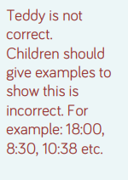
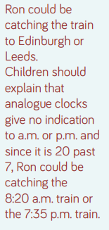
Day 3
- 2. 3.

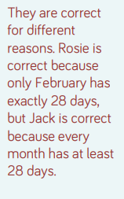

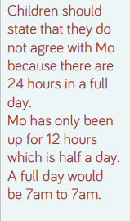
4. 5. 6.

