Summer 2 Week 4
Curriculum Spellings Words
As you know, you are asked to learn about 10 spelling words at home every half term. These words can be found in your planners on page 28.
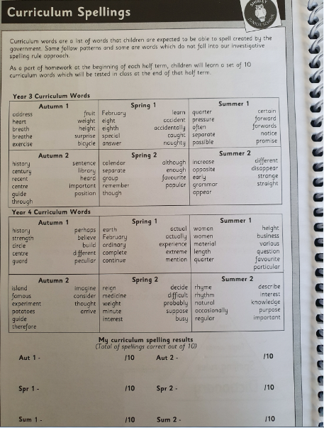
This week we are going to focus on the first 31 that you learnt way back at the beginning of Year 3.
You need to ask someone to test you on these words. You could colour in the ones you get right on the ‘spelling fish!’
You then need to learn the ones that you have forgotten.
You can choose from the activities listed.
Spelling words:
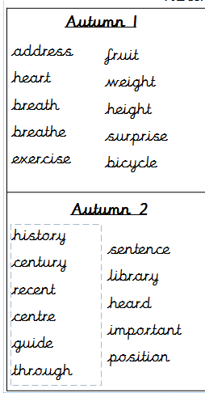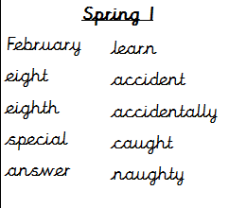

Activities
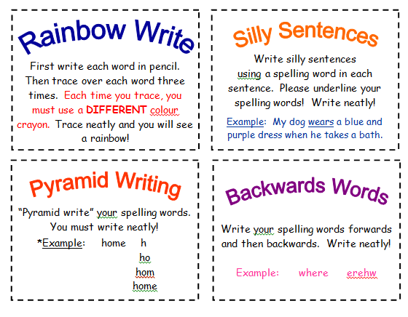
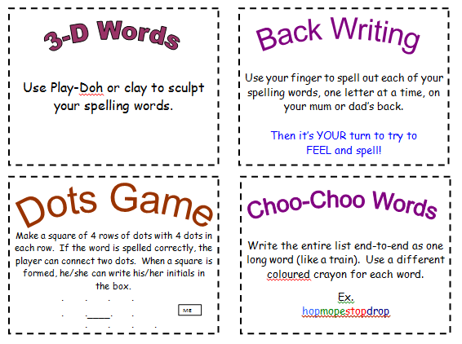

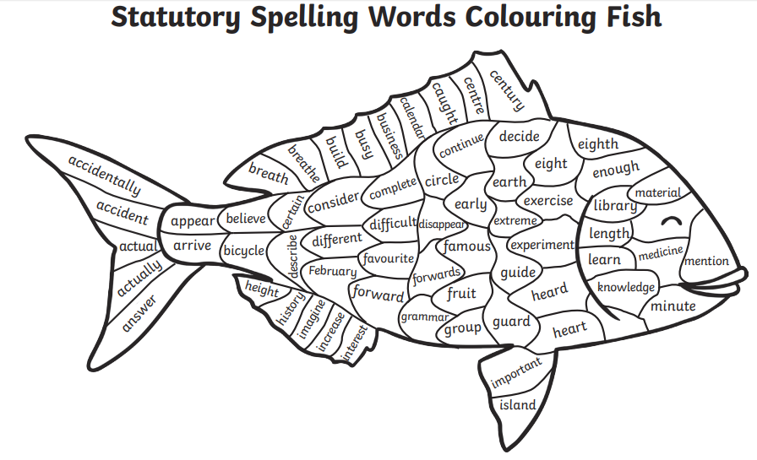
Spelling fish!



