22nd June
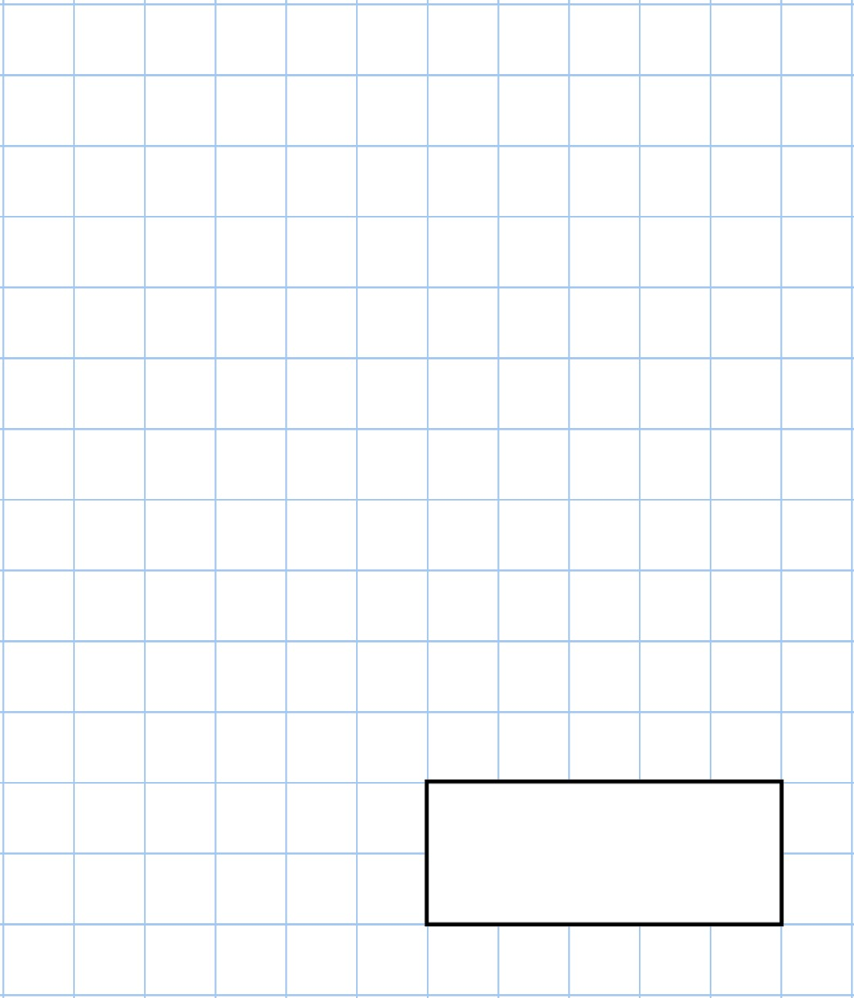    45  ÷  5 |   1  ,  007  +  3
What fraction of this shape is shaded? | 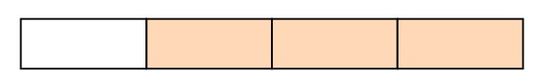
Circle the letter below that has parallel lines  Z A E X Y | Copy and drag the circle
What number is halfway between 10 and 24? | 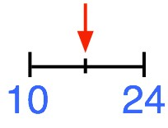

23rd June
600  −  20 | 15  ×  3
Add together the number of days in March and May
A teacher asked the children in a primary school if they had visited Wales or Scotland.  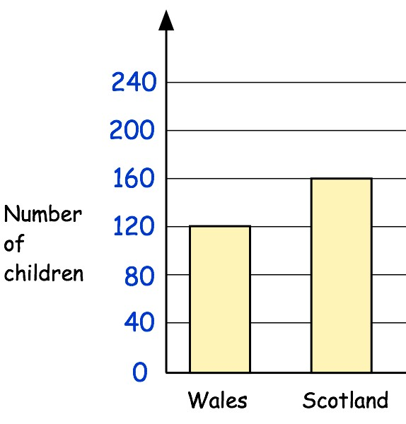 | How many more children have been to Scotland than Wales?
Jack thinks there are 280 children at the primary school.

Why might Jack be wrong?

24th June
47  +  58 | 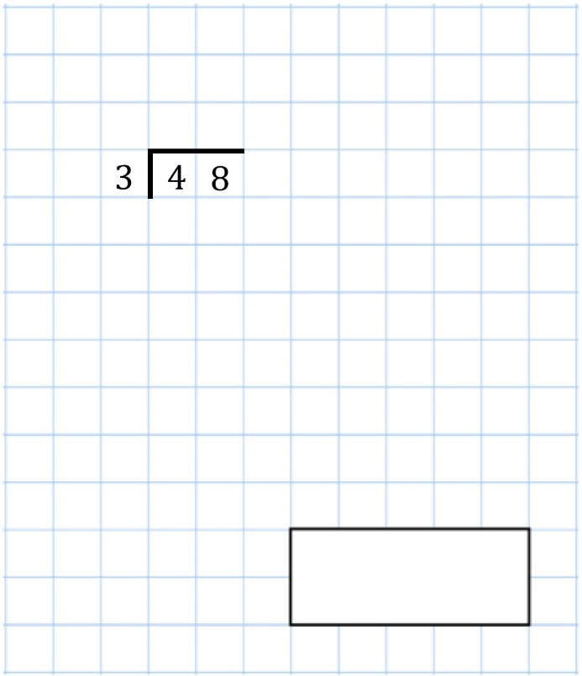
There are 100 toffees in a bag.

3 children each take 12 toffees.

How many toffees are left in the bag?
Name this shape | 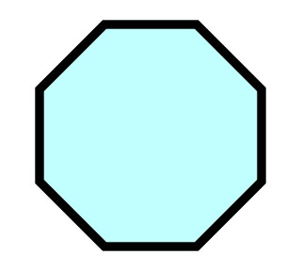
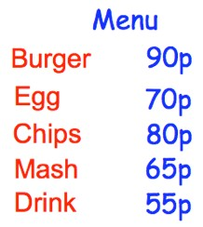 | Amelia buys a portion of chips, an burger and a drink.  How much does that cost?

25th June
15  ÷  1 | 1  3  of  90
Write these numbers in order, starting with the smallest.  172 217 273 198
  Smallest |  |  | Largest
A small bag of doughnuts has 5 doughnuts.  A medium bag of doughnuts has 9 doughnuts.  Mr Jones buys 9 small bags of doughnuts.  Miss Henderson buys 7 medium bags of doughnuts. | Who bought the most doughnuts?
 | How many doughnuts were bought in total?

26th June
12  ×  2  ×  0 | 103  metres  −  20  metres
A film begins at 4:30pm

The film ends at 6:10pm

How long did the film last?
Bethany puts eight 20p pieces into the piggy bank.  Her mum then puts eight 50p pieces into the piggy bank.  How much money is in the piggy bank? | 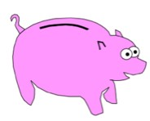
Jonah has 250 letters to post.  On Monday he posted 90 letters.  On Tuesday he posted 120 letters. On Wednesday he posted half of the remaining letters. | How many letters did Jonah post on Wednesday?



