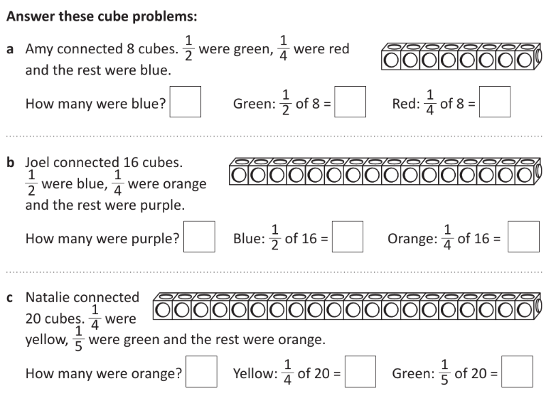
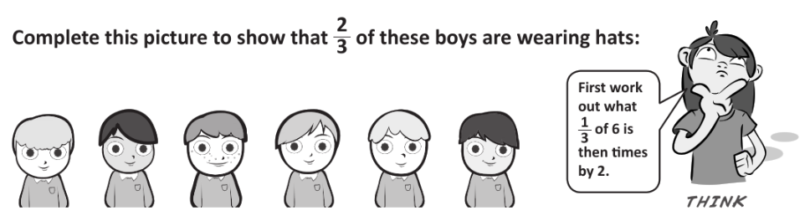
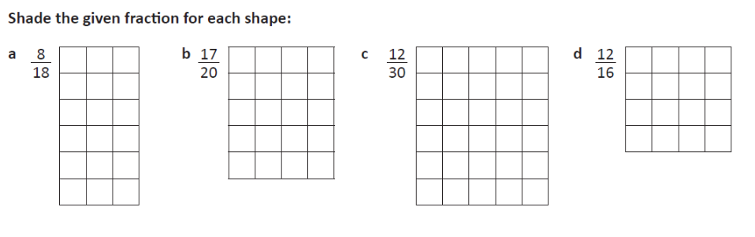
Day 1
1.
2.
3.
Day 2
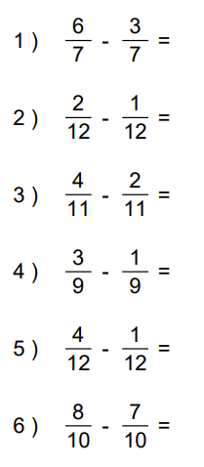
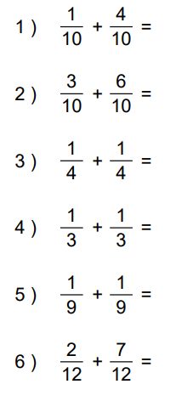
1. 2.

3.

- Steve and Jen are sharing a pizza. Steve has 3/8 and Jen has 2/8. How much of the pizza have they eaten altogether?
______________________________________________________________________

- 2/6 of the class like football and 1/6 of the class like basketball? What fraction of the class don’t like either?
_________________________________________________________________________

- 4/10 of the books were handed out in the morning and 3/10 of the books were handed out in the afternoon. What fraction of the books still needed to be handed out?
__________________________________________________________________________

- Pete and Fred share a pizza. Pete has 2/5 and Fred has 2/5/What fraction of the pizza is left for Helan?
___________________________________________________________________________

- Steve and Jen are sharing a cake. Jen has 3/8 and Mark has 2/8. How much of the pizza have they eaten altogether?
___________________________________________________________________________

Day 3

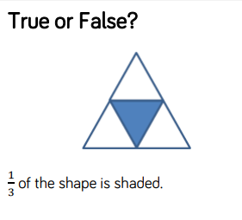
1.
Answer here

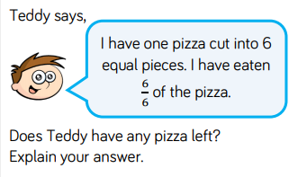
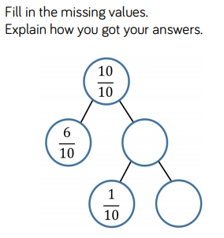
2.
3.
Answer here
Answer here

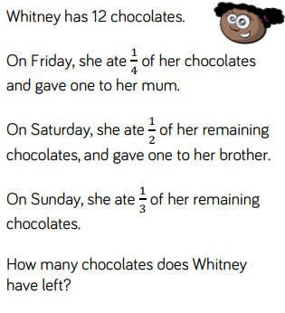
4.
Answer here

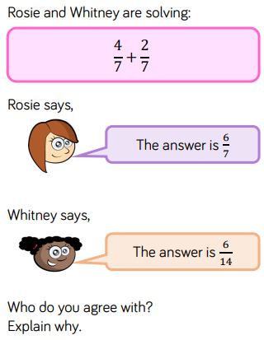
5.
Answer here

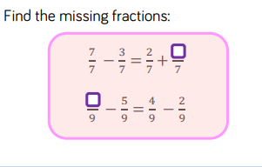
6.
Answer here

Answers

Day 1
- A) any 8 squares coloured
B) Any 17 squares coloured
C) Any 12 squares coloured
D) Any 12 squares coloured
- 4 boys need hats

- A) Blue = 2, Green = 4, R = 2
B) Purple = 4, Blue = 8, Orange = 4
C) Orange = 11, Yellow = 5, Green = 4

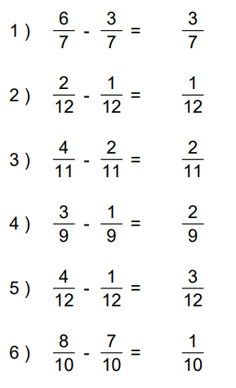
Day 2
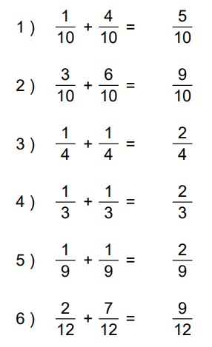
1. 2.

3. a) 5/8 b) 3/6 c) 3/10 d) 1/5 e) 5/8

Day 3

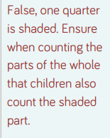
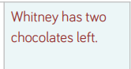
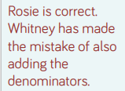
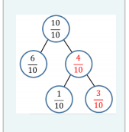
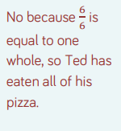
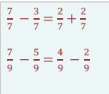
- 2.
3. 4.
5. 6.

