15th June
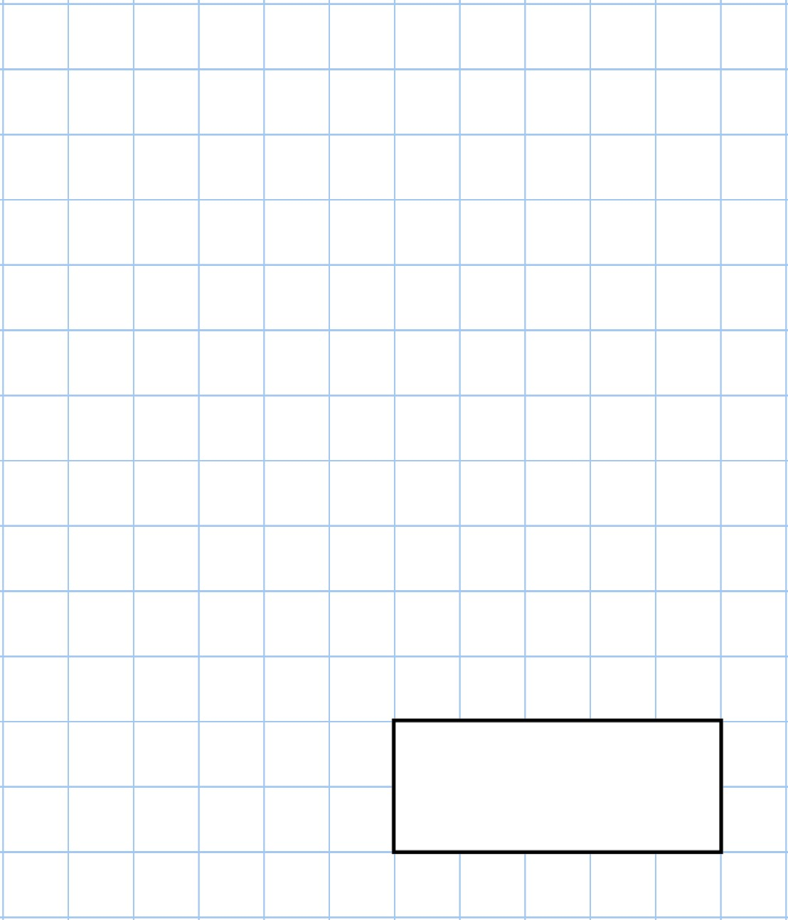    10  ×  100 |   15  cm  +  26  cm
There are 7 apples in a bag.

Harry buys 12 bags of apples.

How many apples does Harry buy?
Complete the tally chart  White Red Red Green White  Blue White Green Red Green  Red Blue Red Green Red
   | Colour | Tally | Frequency
  Blue
  White
  Red
  Green
Which colour is the most common? | Which colour is the least common?

16th June
140  +  80 | 156  −  17
Write a digit in each box to make the addition correct | 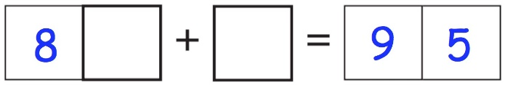
A can of beans has a mass of 350 grams  Draw an arrow on the scale to show 350g | 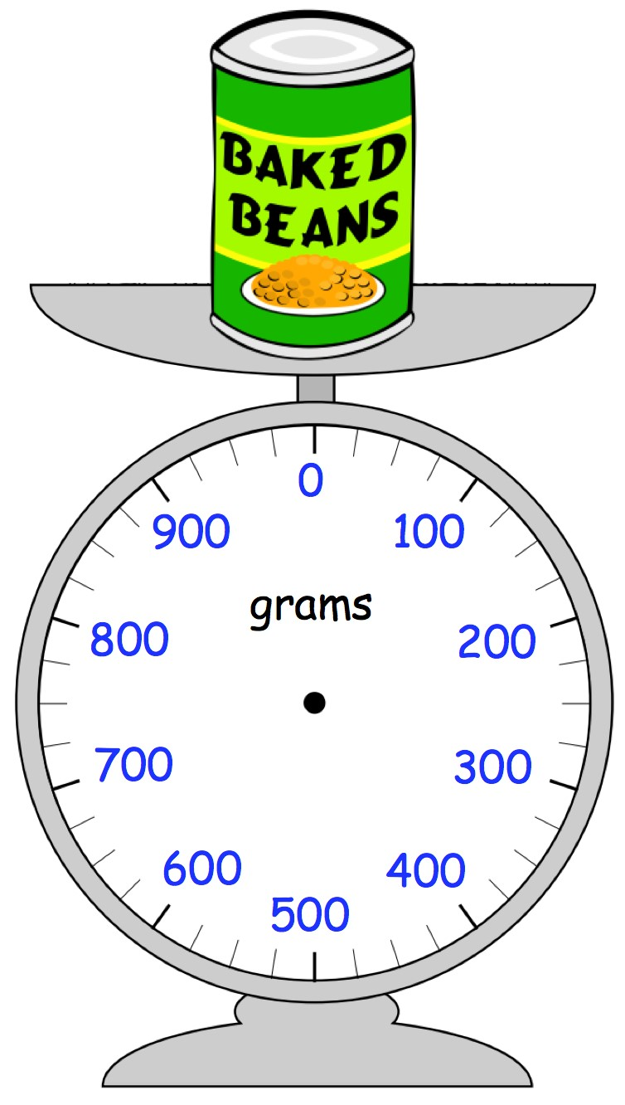
Olivia has two cans of beans.

How much do two cans of beans weigh?

17th June
4  ×  4  ×  3 | 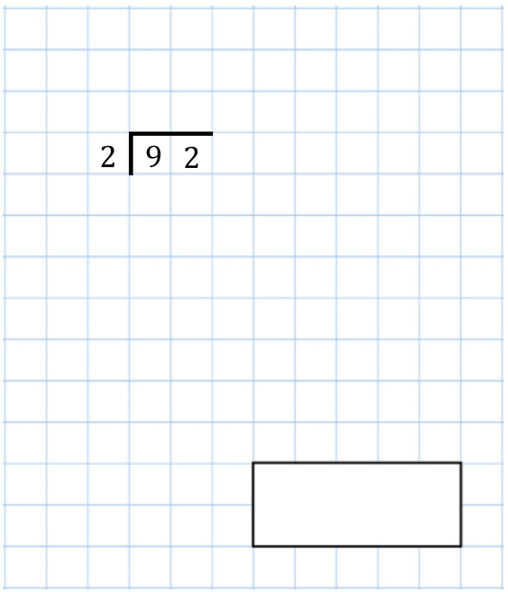
Aarav buys an ice cream for £1.20 He pays with a £2 coin.  How much change should Aarav receive? | 
Kayleigh is early arriving at the dentist.  Her appointment is at 1pm.  The clock shows the time she arrived.  How many minutes is it until her appointment? | 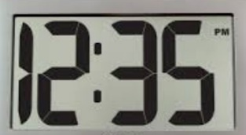
Draw a heptagon

18th June
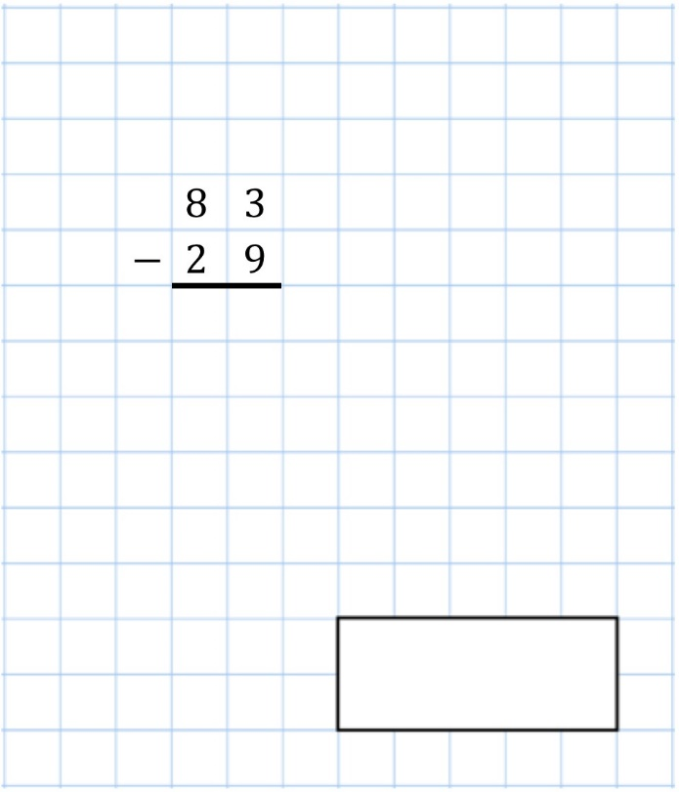 | 17  ×  5
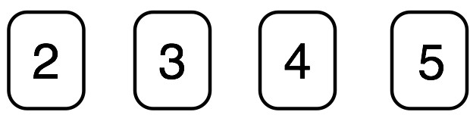  Look at the four digit cards above  You can only use each digit once. | Create the smallest possible two digit  even number
Jasmin has 50p
Erin has 90p

How much money should Erin give Jasmin so that they have the same amount of money?
Megan is buying carrots.  1 kilogram of carrots costs 50p  How much should Megan pay for the carrots? | 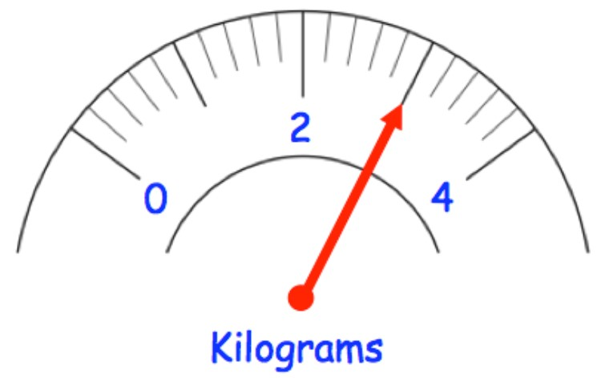

19th June
8  ×  0 | 42  +  71  −  19
Write 9 in Roman numerals
Max has brought 100 bags of popcorn to sell at a school fair.  He sells 40 of them for £3 each  He sells the rest for £2 each | How much money did Max receive?
Work out the length of the pink block | 

