Summer 2 Week 3
Inference
Lesson 1
Visit this website and open the lesson
https://www.bbc.co.uk/bitesize/articles/zf7qmfr
When we read stories, watch films or TV shows, look at pictures or play video games, we use lots of different skills to work out what is happening. One of these skills is called inference.
Inferring is a bit like being a detective. You have to find the clues to work out the hidden information.
Watch the clip and see if you can work out what is going on.
In the video, custard pies were stolen. The housekeeper looked nervous and her apron had a yellow stain. From this we can infer that the housekeeper stole the pies.
You have to do the same thing when you’re reading.
Imagine the main character in a story skips into a room, smiling brightly and waving to their friends. You could infer that the character is happy. The text hasn’t told you the character is happy, but you can work it out from the clues given.

To answer inference questions, you have to examine the whole scene.
Look at these ‘Inference Challenge Cards’ and choose three to focus on.
Read the information carefully then answer the questions.
Write your answers down or discuss them with a family member.
Top tip!
Look carefully at the vocabulary that is used - particularly the adjectives and verbs. They will give you clues to help answer the questions

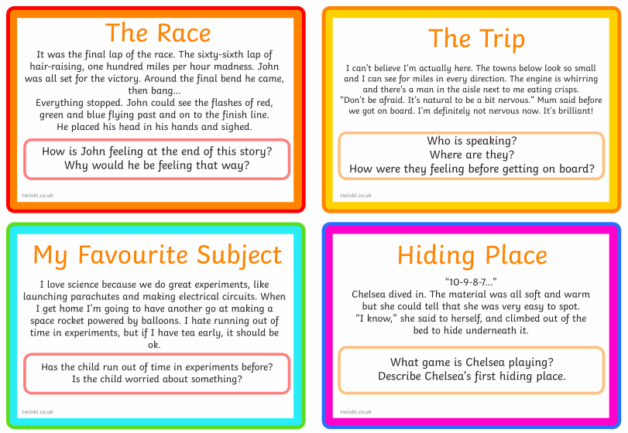
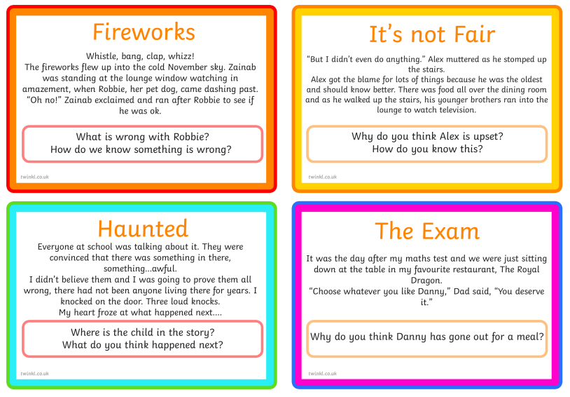
Click here to type

Lesson 2
Revisit the website and watch the video of part one Tiddalik the Frog.
Think carefully about the characters that are introduced, then answer the questions below.

When answering inference questions, your answer needs to be clear and backed up with evidence. This makes your answer much stronger.
Top tip!
Use the word ‘because’ to introduce your evidence.
For example:
Question: Does Tiddalik think about others?
No. Tiddalik doesn’t think about anyone but himself because he drank up all the water in the stream and didn’t care that there was no water left.
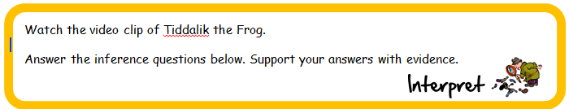
- What did Tiddalik do to show how selfish he was?
- What season of the year is the story set in? How do you know?
- How did Tiddalik talk to the other animals? What does this tell us about him?
- What are Kangaroo and Koala’s personalities like? How do you know?
- How do the animals feel at the end of the video? How do you know?
Click here to type

Lesson 3
The video only showed part one of Tiddalik's story.
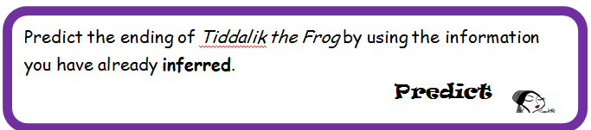
Think about:
- What Tiddalik and the other characters are like.
- How Tiddalik will be feeling after drinking all that water.
- Whether you think the other animals will help Tiddalik.
- Whether you think Tiddalik will change by the end of the story.
- Will it be a happy ending?
Write in full sentences, add lots of description and chose interesting vocabulary to make your writing fun to read.
Click here to type

Check that your writing is correctly punctuated.
When you’ve finished you can go back to the website and click on the link to watch part 2 of the story.
How does it match to your story? Was your ending similar or completely different?

Now, you could add an illustration to your prediction.

