Summer 2 Week 3
You're a Bad Man, Mr Gum
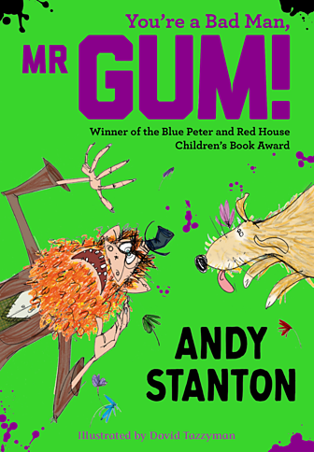
Lesson 1
Mr Gum hates children, animals, fun and corn on the cob. This book is about him, an angry fairy, a dog called Jake and a little girl called Polly.
Visit this website
https://www.bbc.co.uk/bitesize/articles/zkttpg8
and watch actor Joanna Lumley read an extract from You're a Bad Man, Mr Gum.
Think about the following:
- What do we learn about Mr Gum?
- How can the carpet be 'the colour of unhappiness'?
- Can you believe that the bed has never been made?
- Are you surprised that Mr Gum has a pretty garden?
Now watch Joanna read another extract from You're a Bad Man, Mr Gum and think about the following:
- Could you visualise what is happening in this extract?
- Did you think Mr Gum would talk like this?
- Can you believe that he is scared of the fairy?
Read Extract 1 yourself.

Extract 1
Mr Gum’s bedroom was absolutely grimsters. The wardrobe contained so much mould and old cheese that there was hardly any room for his moth-eaten clothes, and the bed was never made. (I don’t mean that the duvet was never put back on the bed, I mean the bed had never even been MADE. Mr Gum hadn’t gone to the bother of assembling it. He had just chucked all the bits of wood on the floor and dumped a mattress on top.) There was broken glass in the windows and the ancient carpet was the colour of unhappiness and smelt like a toilet.
Anyway, I could be here all day going on about Mr Gum’s house but I think you’ve got the idea. Mr Gum was an absolute lazer who couldn’t be bothered with niceness and tidying and brushing his teeth, or anyone else’s teeth for that matter.
BUT (and as you can see, it’s a big but) he was always extremely careful to keep his garden tidy. In fact, Mr Gum kept his garden so tidy that it was the prettiest, greeniest, floweriest, garden in the whole of Lamonic Bibber.

In extract one, the writer tells us lots of information about Mr Gum.
If you could only tell your friend three things about Mr Gum, what would they be?
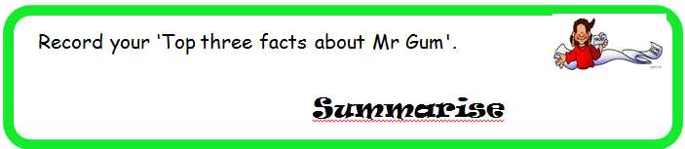
Click here to type

Ask somebody else at home to do the same and compare your answers. See if you have chosen similar facts or if there are some differences.
Lesson 2
Read Extract 2 yourself.
Extract 2
'Sort out the garden, you lazy snorer!’ yelled the fairy, and down came the frying pan.
Mr Gum was too fast this time and shot out of bed like a guilty onion. PFFF! went the frying pan as it hit the bedcovers, sending up a little cloud of dust and ants.
Mr Gum legged it out of the bedroom and went hurtling down the stairs. He stepped on an old slice of pizza lying in the hall and half skidded into the kitchen, riding it like a cheese and tomato surfboard. He could hear the fairy right behind him, shrieking with fury.
'I ’aven’t done nothin’ wrong! I kept the flippin’ garden TIDY!’ shouted Mr Gum as he flung open the back door and ran outside. He started to say something else but when he saw the garden the words got stuck in his throat. They tasted horrible.
The garden was not tidy. The garden was a total wreck. The lawn was tufted up and torn. The flowerbeds were trampled and chewed. Rose petals and sunflower heads lay scattered all over the place like rose petals and sunflower heads. There was something lying under the oak tree that Mr Gum did not even want to think about. And in the centre of the wreckage played the most monstrous dog Mr Gum had ever seen.

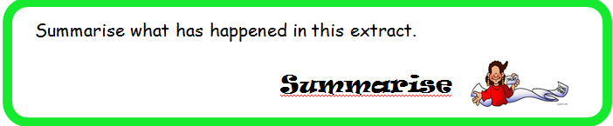
Click here to type

Check that your sentences have capital letters and full stops.

Lesson 3
Think about what you know so far about the story.
- We know that Mr Gum has an extremely messy house but that he has the prettiest garden in the whole town.
- We know that he is scared of the fairy which is why he keeps his garden so tidy.
- Jake the dog has messed Mr Gum’s garden and Mr Gum is not happy.
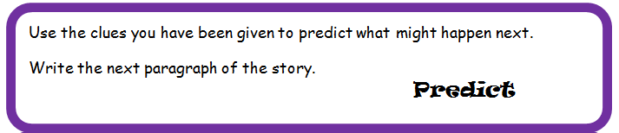
Will it be Mr Gum talking? Will it be a description of his garden? Or will it be something completely different?
You are the author – you decide!
Click here to type

Check that your sentences have capital letters and full stops.

Now, you could design an alternative front cover for this book.

