8th June
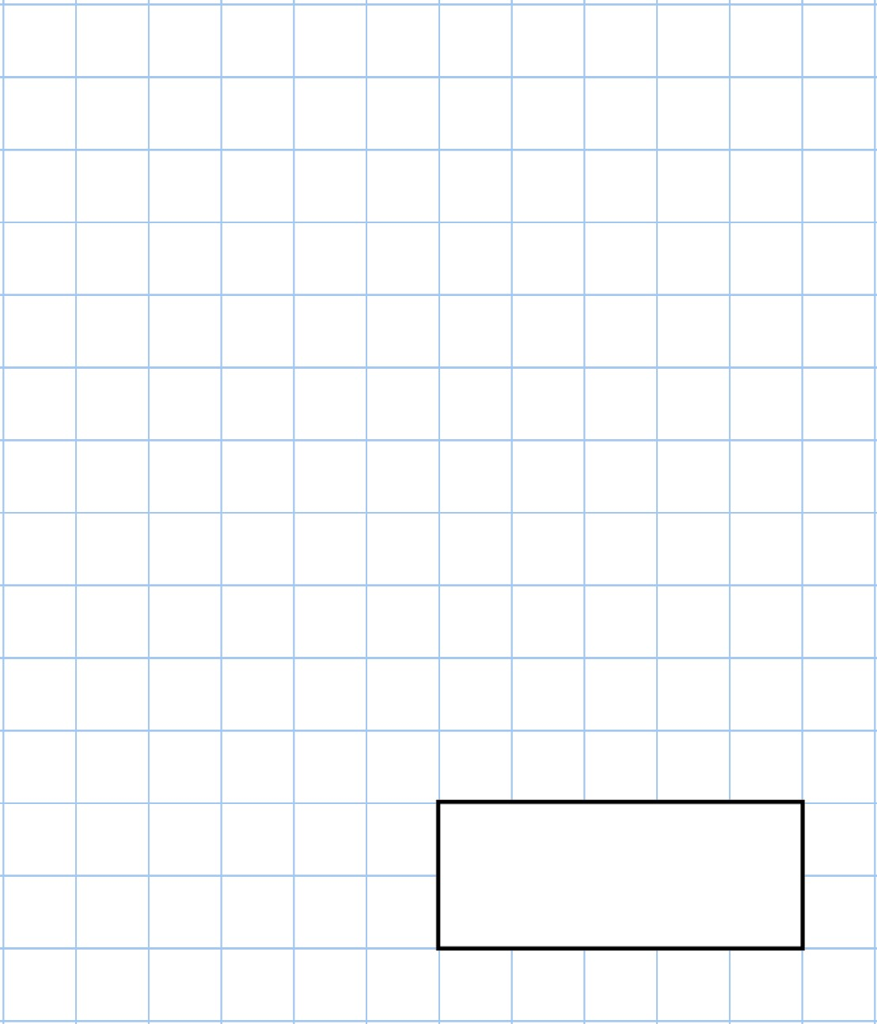  Double  51 |   5  ×  3  ×  2
Muhammad is given £8 pocket money each week.

He is saving for a computer game that costs £64.

How many weeks will it take Muhammad to save enough money?
Which clock shows the time Hannah arrives at school in the morning? | 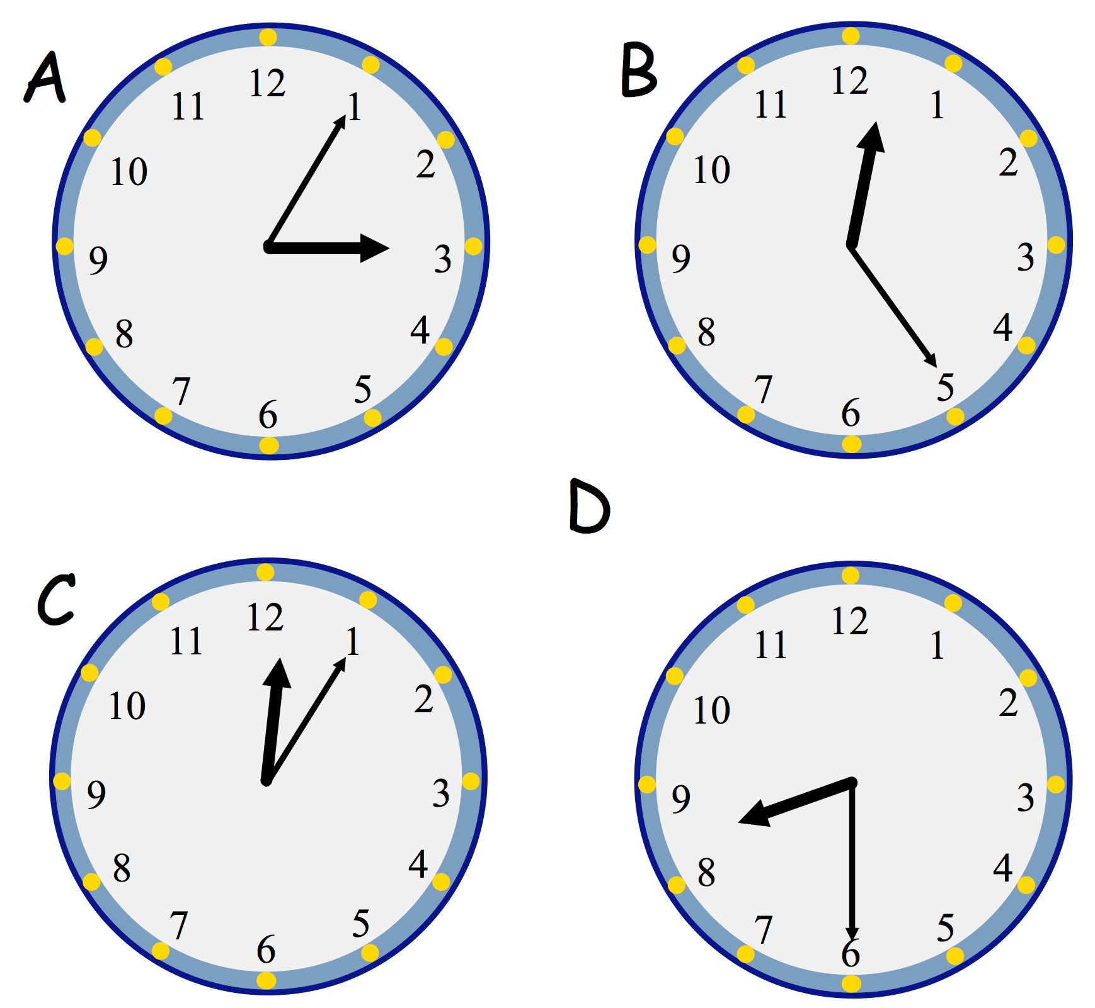
Which clock shows the time that Hannah finishes school each day?

9th June
8  ×  3 | 1  4  of  =  6
Add together the number of days in one week and the number of months in a year.
All the children in a primary school have pizza, curry or a sandwich for lunch.  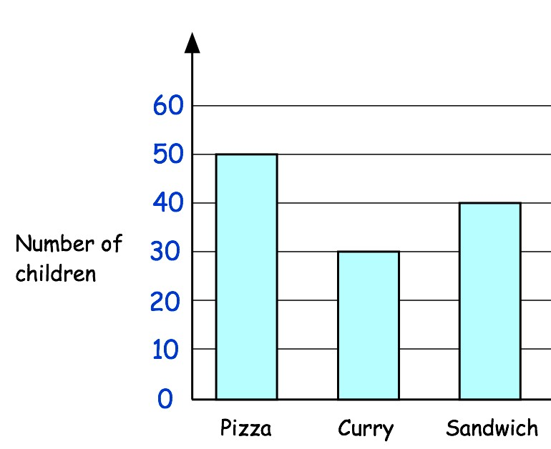 | How many more children have pizza than sandwiches?
 | How many children had lunch altogether?

10th June
38  +  15 | 24  ×  3
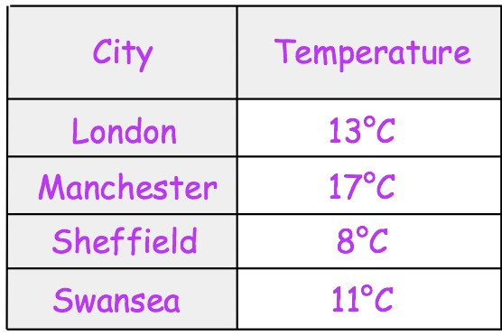 | List the cities in order of temperature, starting with the coldest.
What is the difference between the warmest and coldest temperatures?
Russell buys a sandwich in a shop.  He pays with a £5 note.  He receives these coins in his change.  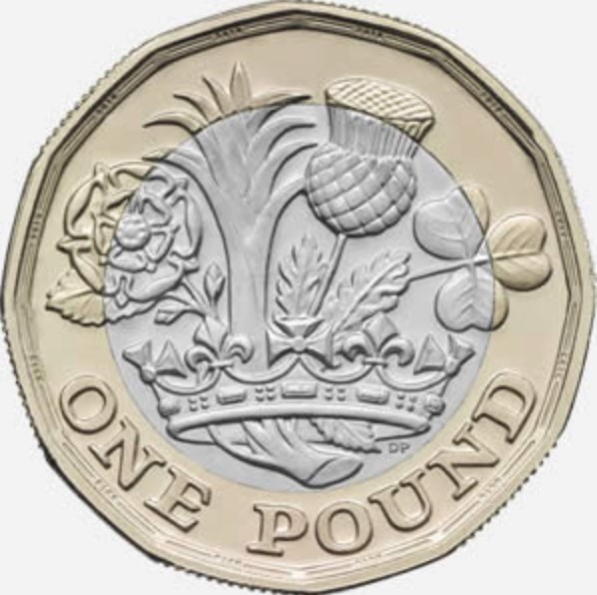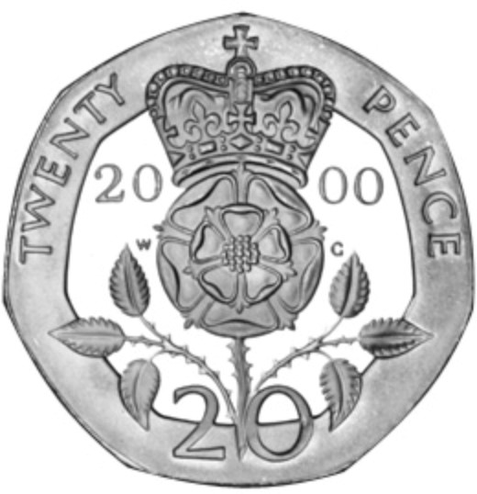 | How much was the sandwich?

11th June
44  +  95 | 700  −  31
Show the time five past eight on the clock | 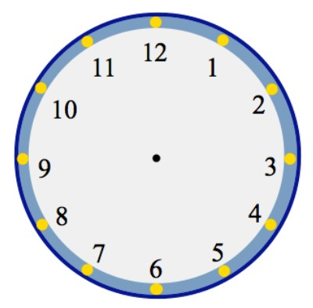
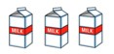
A carton of milk costs 60p

Find the cost of six cartons of milk
Write 4 in Roman Numerals

12th June
62  +  19  +  24 | 561  −  7
Arrange these temperatures in order, from lowest to highest  15°𝐶 23°𝐶 19°𝐶 13°𝐶 | 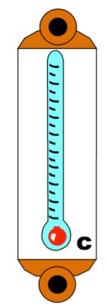
What fraction of this shape is shaded? | 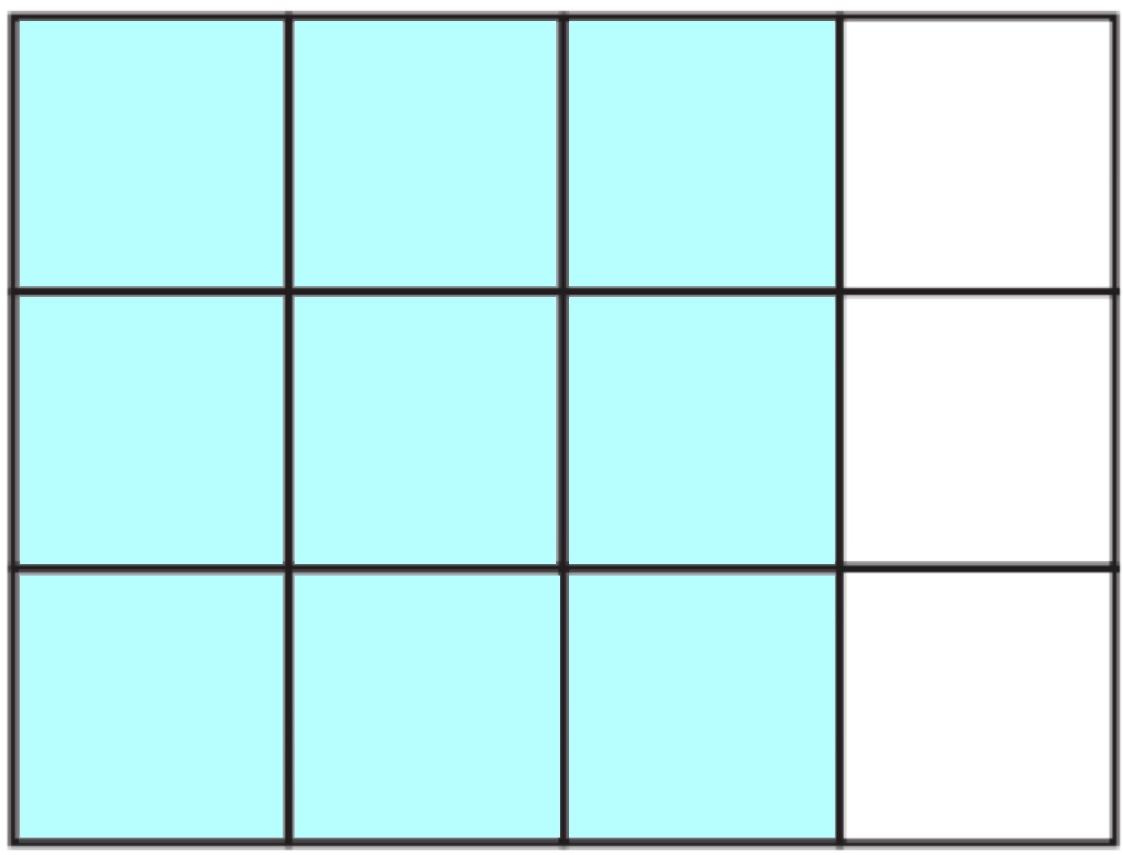
How many vertices does a cuboid have? | 

