Summer 2 Week 2
Punctuating Speech
Lesson 1
What can you remember about punctuating speech?
Visit this website and open the lesson
https://www.bbc.co.uk/bitesize/articles/z7s6t39
Watch the short clip to learn about what inverted commas are and when they need to be used.
When you are writing, inverted commas (also called speech marks) go before and after any words that a character says.
For example: "I'm hungry," complained Goldilocks.
‘I’m hungry’ are the words that Goldilocks says out loud (also called direct speech), so the inverted commas go at the start and end of those words.
If another character replies, the rule is to:
- use another set of inverted commas
- put the new person speaking on a new line
For example:
"There’s some porridge on the stove,” said her mum.
"But I've already had some porridge today!” exclaimed Goldilocks.
Any punctuation goes inside the inverted commas at the end of what the character is saying.
Now watch the fun Super Movers video (same link as above) and listen carefully to what is said about inverted commas.
Let's recap on Mr Smith's groovy ground rules for using inverted commas.
1. If it's a new speaker, start a new line.
2. Use inverted commas when a character starts to speak.
3. Write the actual words the character is saying (starting with a capital letter).
4. End the speech with punctuation.
5. Show the speech has ended using inverted commas.
6. Don't forget to tell your reader who said it.
For example:
"It's time to learn about inverted commas. Here we go!" said Mr Smith.

Complete Activity 1 online.

Watch the Super Movers video again.
This time, join in! Make sure you have some space, copy Mr Smith’s moves and see if you can sing along.
Pause the video at 2 minutes and 25 seconds. The four sentences below are just about to appear on your screen.
- How are you? Mr Ahmed asked.
- I’m really hungry, Rohan exclaimed.
- Morgan said, I’m nearly ten.
- What time is it? Terrance requested.
Either copy out these sentences and put the inverted commas in the right places, or explain where the inverted commas should go to someone at home.
Click here to type
Once you have identified where the inverted commas should go in all four sentences, play the video and Mr Smith will show you the answers.

Lesson 2
Complete these tasks. (If you do not have a printer, write the sentences in a list on a piece of paper. Alternatively, you can select Insert, shape and the scribble tool, this will allow to write on the screen.)
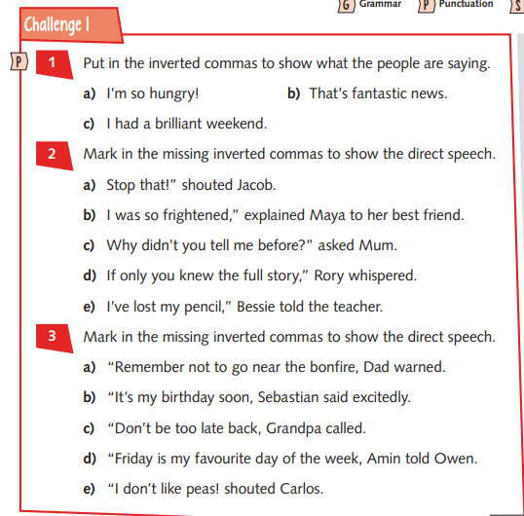
Click here to type

Now have a go at Activity 4 which is an online quiz (same link as yesterday).

Lesson 3 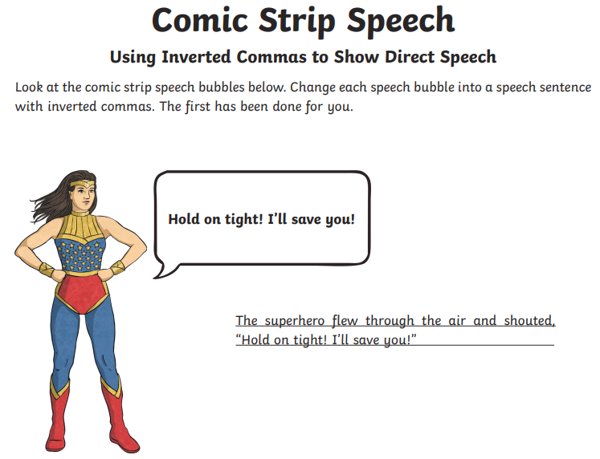

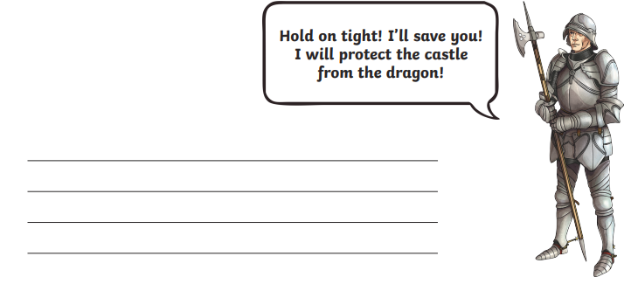
Click here to type
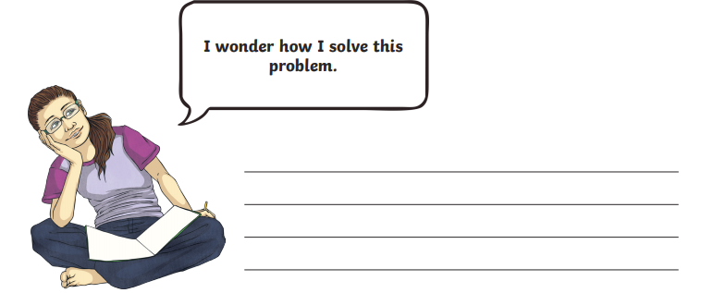
Click here to type

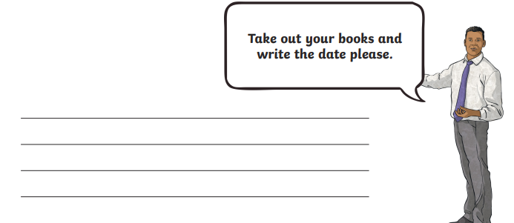

Click here to type
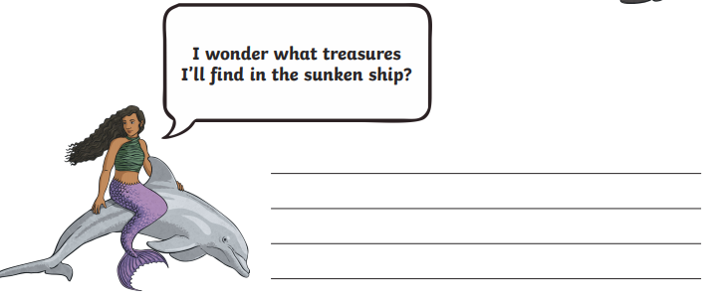
Click here to type
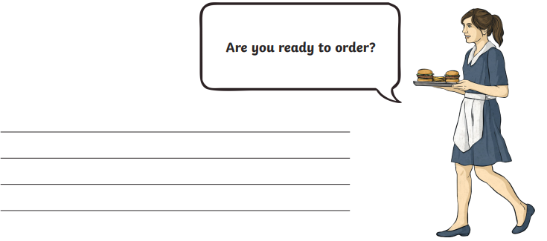
Click here to type

Now, you could make a poster to help you remember the rules for punctuating speech.

