Day 1 tasks
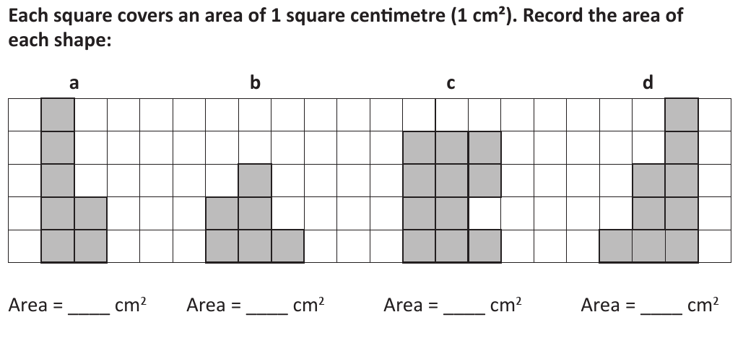
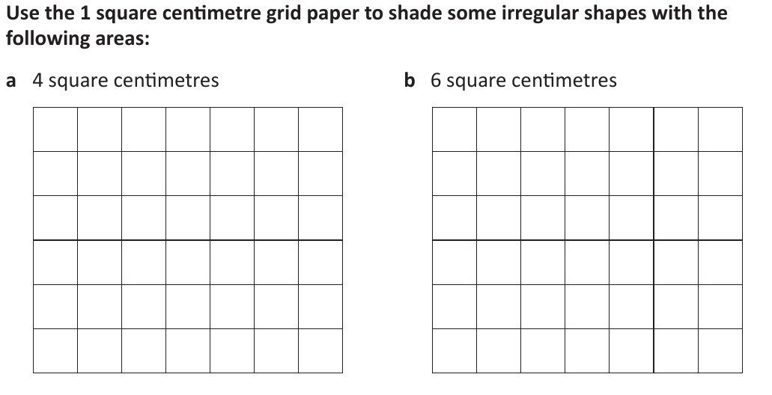
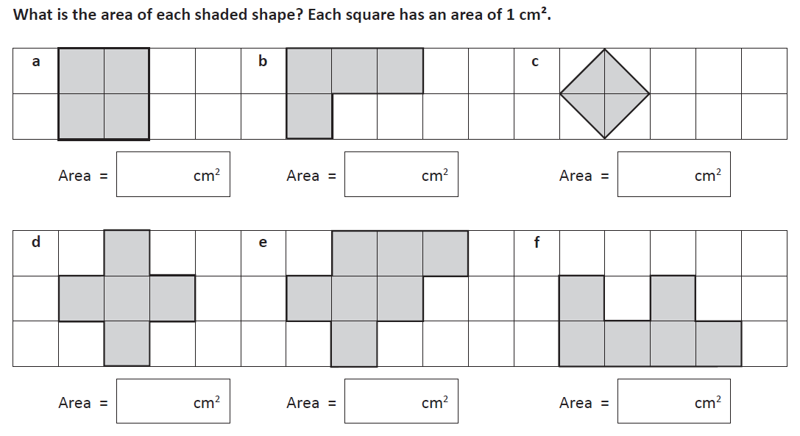
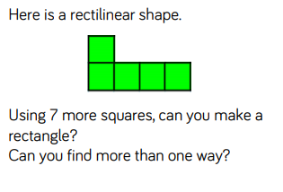

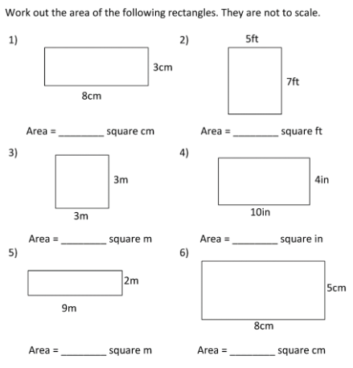
1.
2.
3.
4.
Day 2
If working on the computer, do this on squared paper by hand

If working on the computer, do this on squared paper by hand
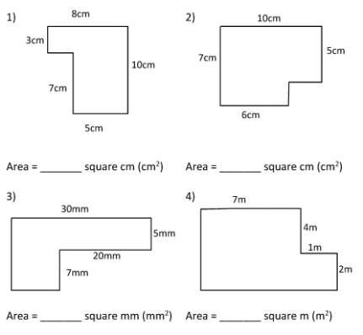
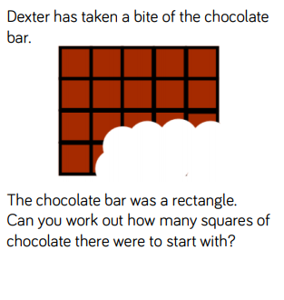
1.
2.
3.
Day 3 tasks

Answer:

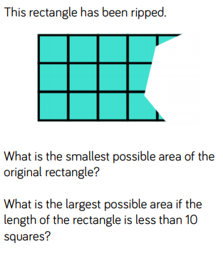
1.
Answer:

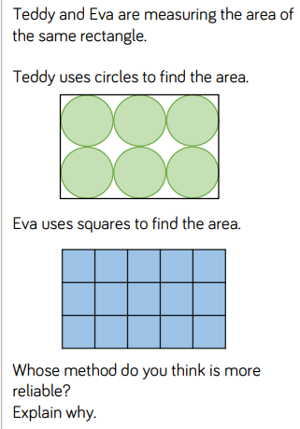
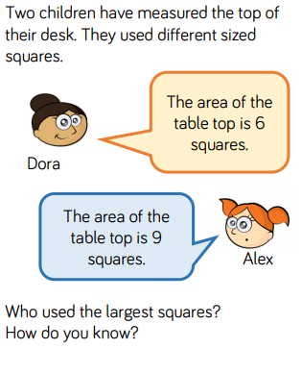
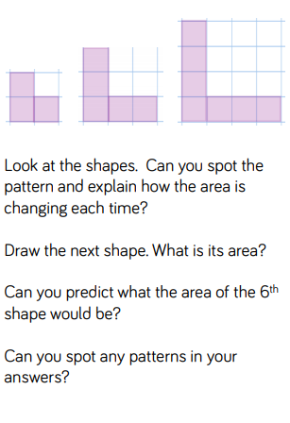
2.
3.
4.
Extra challenge!
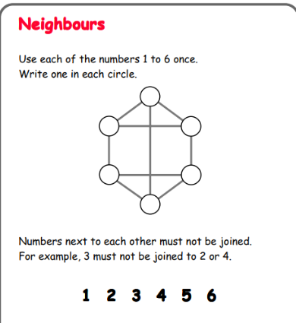
Answer:
Answer:
Answer:

Answers.
Day 1
- a) 4 b) 4 c) 2
d) 5 e) 7 f) 6

- a) 7 b) 6 c) 11 d) 9

- Various solutions

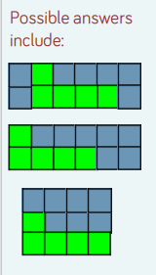
Day 2
- a) 24 b) 35 c) 9
d) 40 e) 18 f) 40
2. a) 24 + 35 = 59 b) 12 + 50 = 62
c) 150 + 70 = 210 d) 28 + 16 = 44

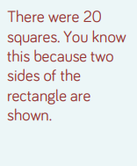
3.

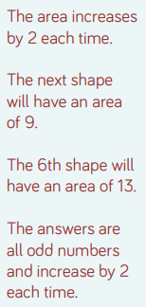
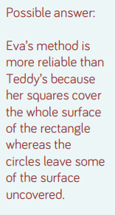
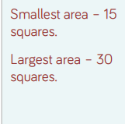
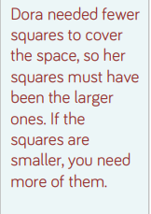
Day 3.
1. 2. 3.
4.

