Day 1
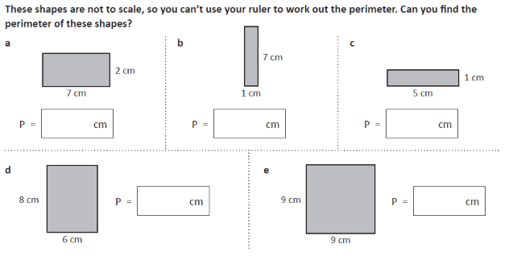
1.
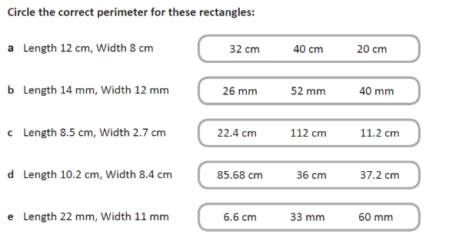
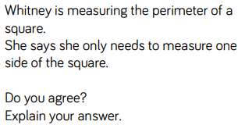
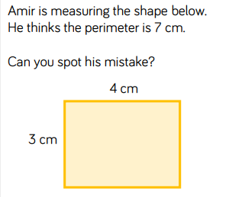
2.
3.
4.
Day 2
cm
cm
cm
cm
cm
Answer
Answer

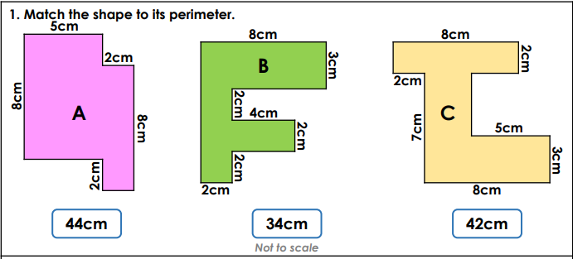
Drag and position the lines to match the
shape to its perimeter.
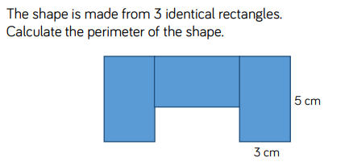
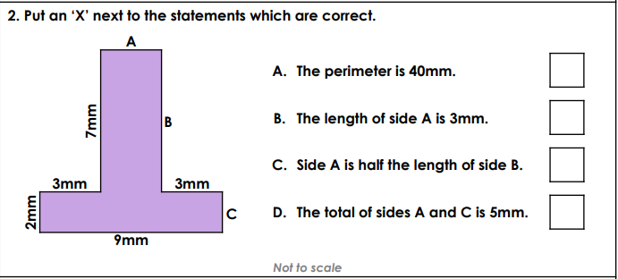
3.

Hint – if working on a computer, sketch this out on a piece of paper to find the answer!
Answer
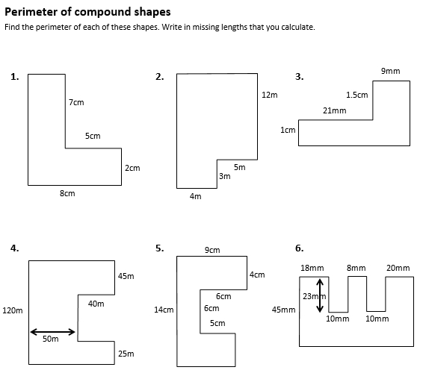
Day 3
Here is a whole variety of questions on perimeter.
Make sure you read them carefully!
A)
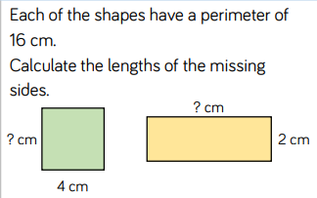
B)
Answers
Answer
Answer
Answer
Answer
Answer
Answer

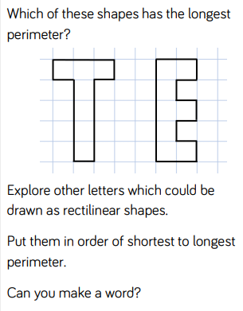
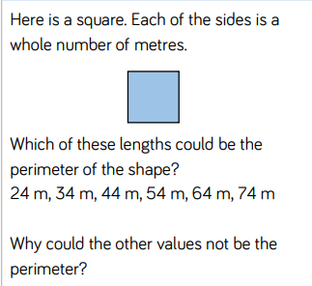
C)
D)
Answers
Answers

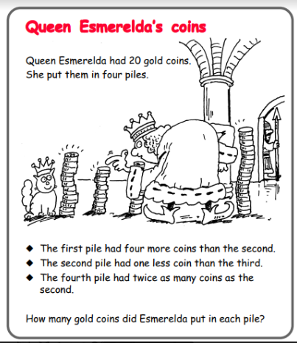
Extra Challenge!
Answers
Day 1
1 a) 18 b) 16 c) 12 d) 28 e) 36
2 a) 40 b) 52 c) 22.4 d) 37.2 e) 6.6
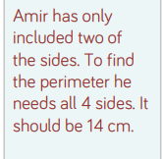
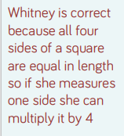
3. 4.
Day 2
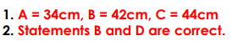
3.
5cm
3cm
3cm
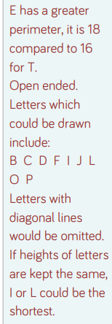
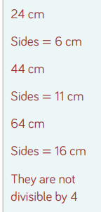
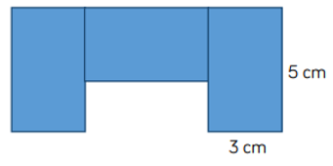
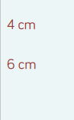
Day 3
A) B) C) D)
Answers
- 34cm
- 48m
- 11cm or 110mm
- 500m
- 56cm
- 314mm

Answer = 36cm
5cm
2cm
2cm
3cm
5cm

