This week: Place value of 4 digit numbers and 1000 more or less than a number

Session 1: Counting in 1000s
It is important to remember that
10 ones = 1 ten 10 tens = 1 hundred
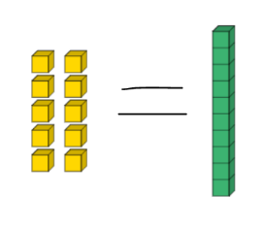
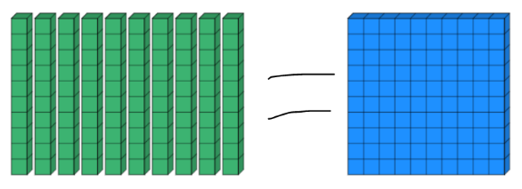

10 hundreds = 1 thousand
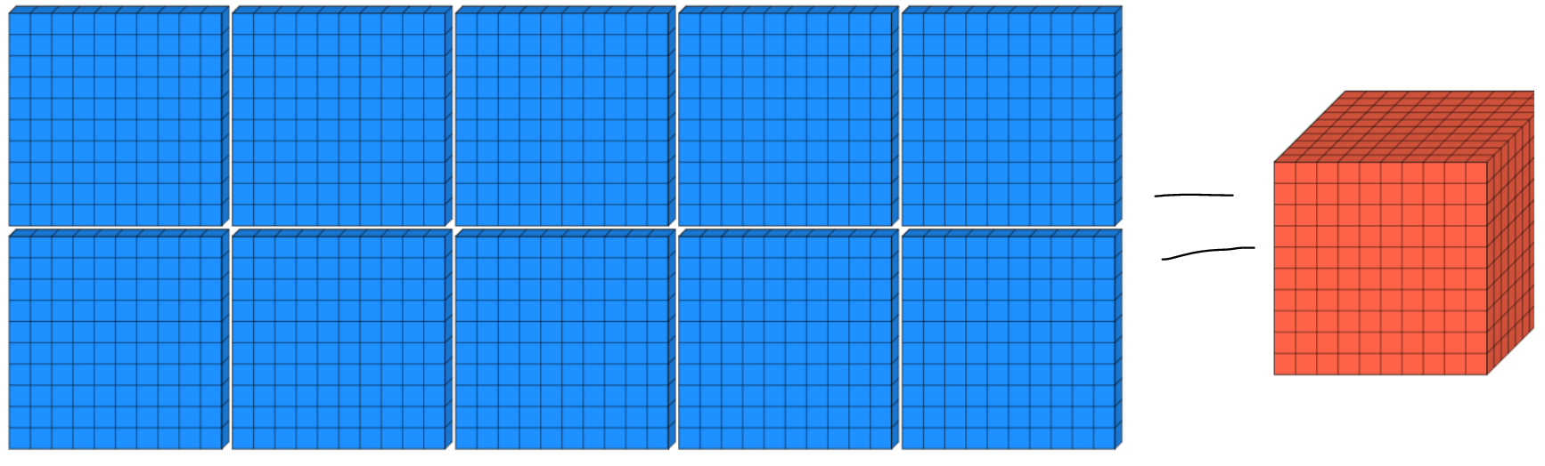

10 thousands can be written as 10,000

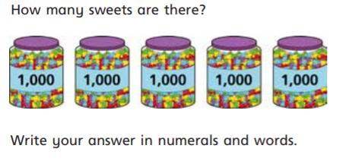

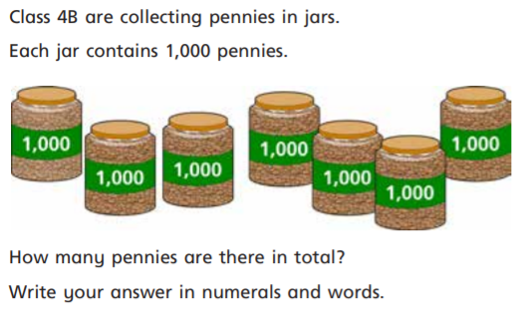

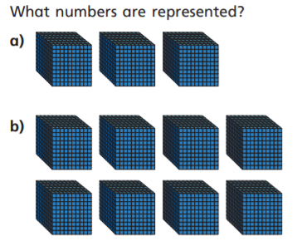
a)

b)

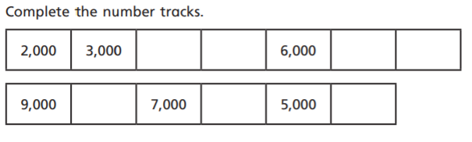
4)

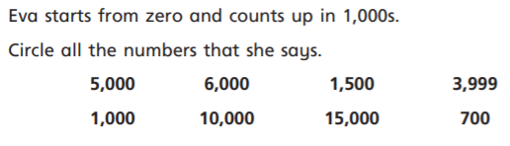
5)

Drag and copy me

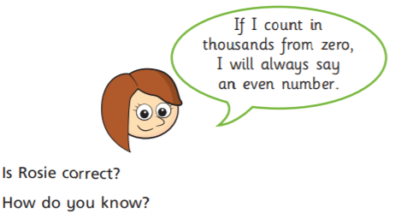
6)

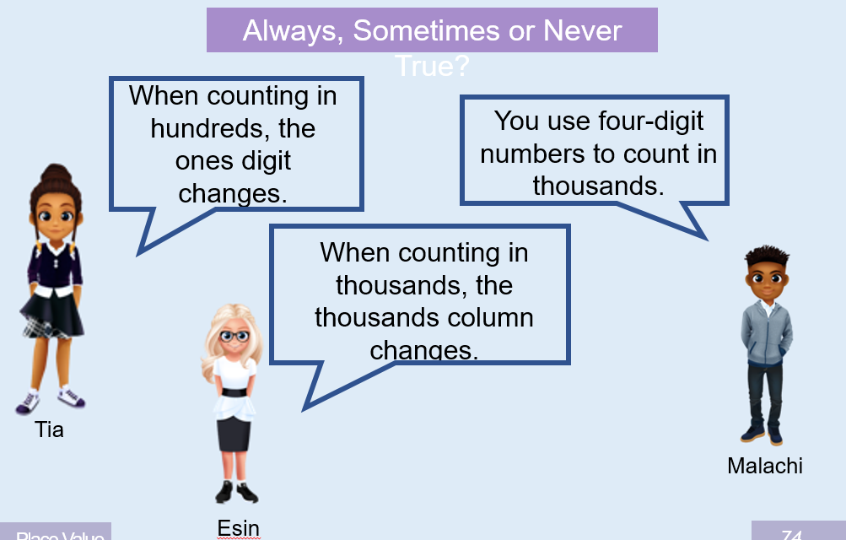
7)

Session 2: 1000s, 100s, 10s and 1s
This session is a reminder about the different ways to represent numbers and the value of different columns.

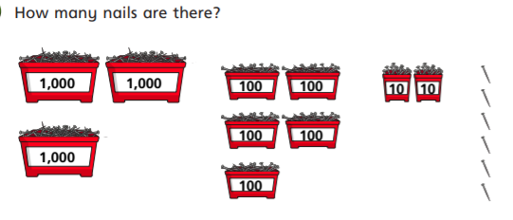

a)

b)
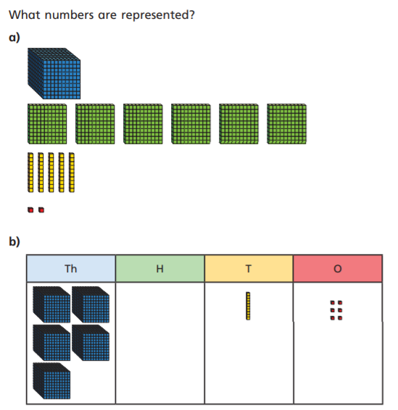

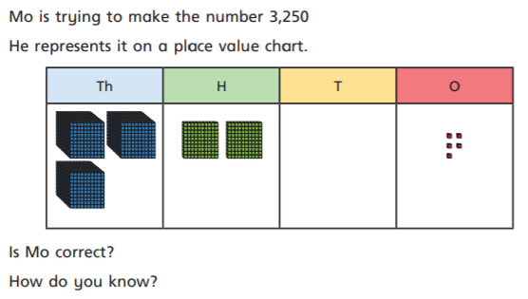

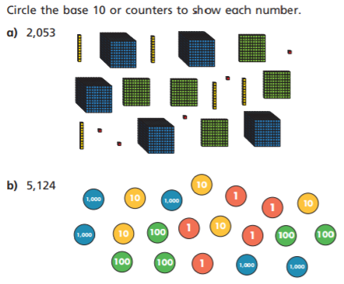
Drag and copy me

- True or False?

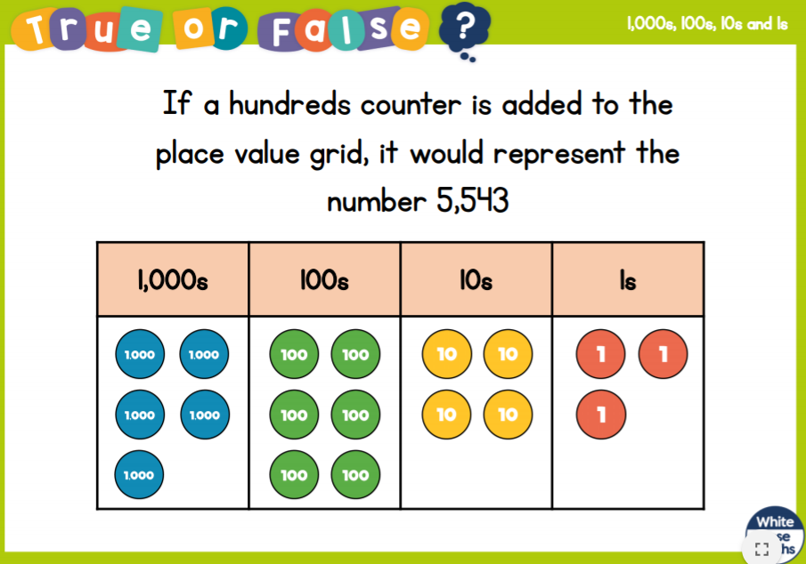

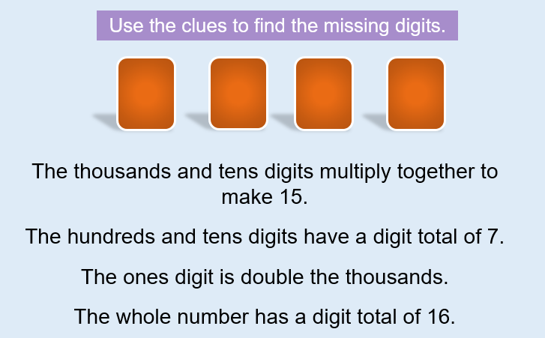

- How many four-digit numbers can you create using the following rules?
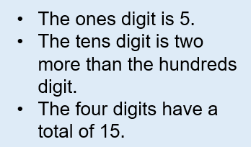

Session 3: Find a 1000 more or less than a number
Remember:
- When adding to the thousands place value column the hundreds, tens and ones columns will not change.
- If you have 10 or more thousands you will need to exchange 10 of them for 1 in the next column.

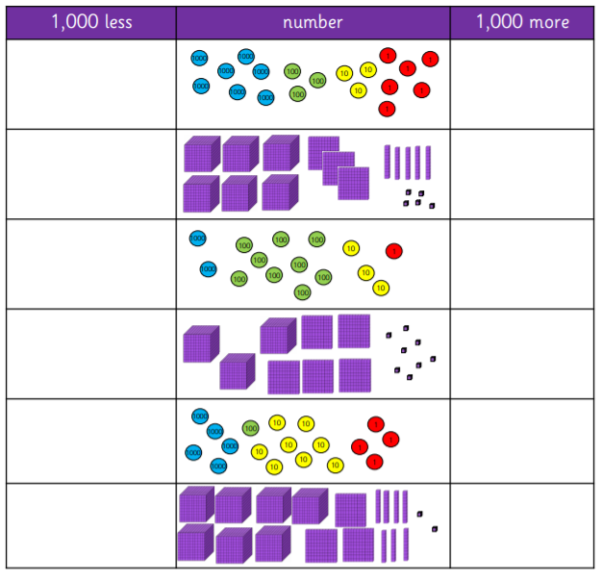

- 2493 + 1000 = _______ 6347 + 1000 = ______
5734 + 1000 = ______ 1000 + 3951 = _______
2493 – 1000 = _______ 6347 – 1000 = _______
1567 – 1000 = ______ 4222 – 1000 = _______
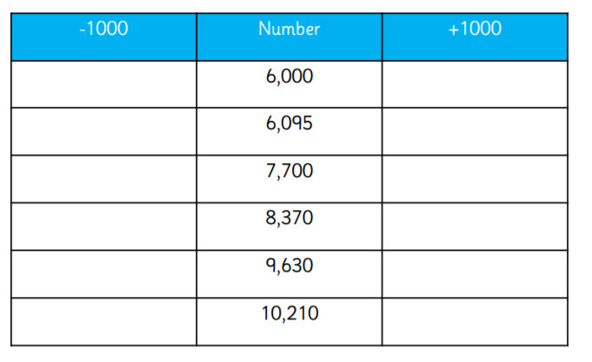

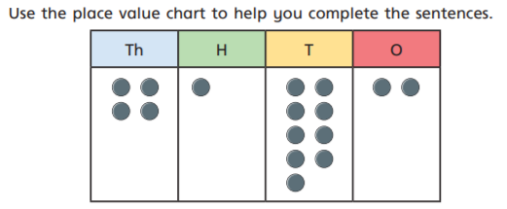

- 1000 more than 4132 is _____
c)10 less than 4192 Is _____
10 more than 4192 is ____
- 1 more than 4192 is _____
1 less than 4192 is ____

1000 less than 4192 is ____
- 100 more than 4192 is ______
100 less than 4192 is ______

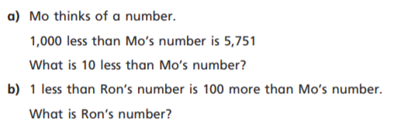

A)

B)

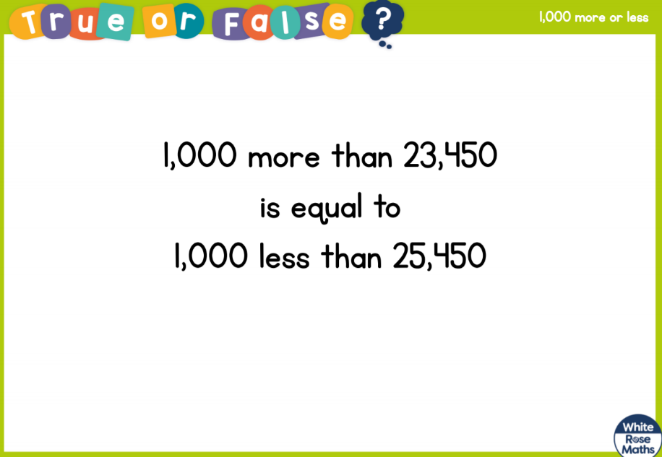
- True or False

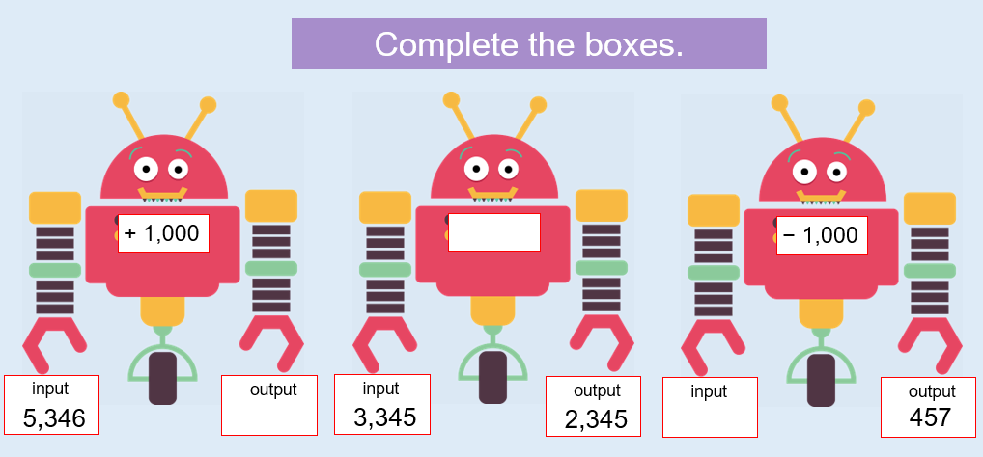

Maths Challenge!
I am thinking about trying to solve this by making a boat out of lego and then choosing some object or cuddly toys as my passengers. What will you try?
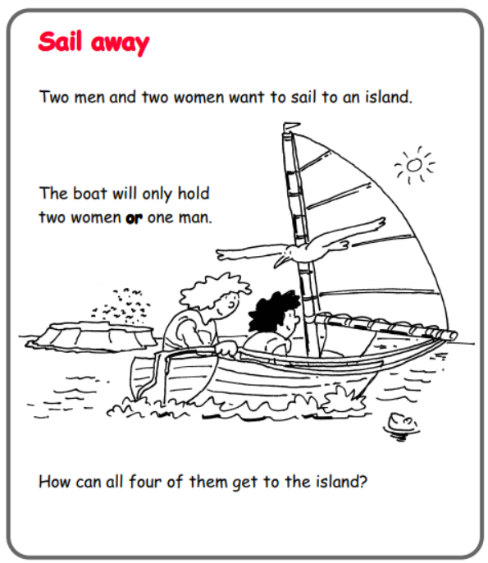

Session 1 – Answers
- Five Thousand – 5000
- Seven Thousand – 7000
- a - Three Thousand – 3000 b- Eight Thousand – 8000
- a - 4000, 5000, 7000, 8000 b – 8000, 6000, 4000
- 5000, 6000, 1000, 10000, 15000
- Rosie is correct. 1000 is divisible by 2 without leaving a remainder so any 1000 is an even number.
- Tia – Never True. Esin – Always. Malachi – Sometimes

Session 2 – Answers
- 3526
- a – 1552 b – 5016
- No. Mo has put 5 ones instead of 5 tens. His number is 3205
- a - 2 thousands, 5 tens and 3 ones
b – 5 thousands, 1 hundred, 2 tens and 4 ones.
- False. The new number would be 5743. If you wanted to represent the number 5543 you would need to subtract a hundreds counter
- 3256
- 6135, 4245, 2355

Session 3 – Answers
- 6337 – 8337 5365 – 7365 1931 – 3931
2508 – 4508 4184 – 6184 6372 – 8372
- + 3493 7347 6734 4951
- 1493 5347 567 3222
- 5000 – 7000 5095 - 7095 6700 – 8700
7370 – 9370 8630 - 10630 9210 – 11210
- a – 5132, 3192
b – 4292 , 4092
c – 4182, 4202
d – 4193, 4191
- a – 6741
b – 6852
- True. 23450 + 1000 = 24450. 25450 – 1000 = 24450
- Output – 6346 Function -1000 Input - 1457

