Monday
 | 9200 – 2100
   | 4 | 2
  + | 3 | 9
2 Apples cost the same as 1 pineapple

One apple costs 45p

How much does one pineapple cost?
Circle the right angle | 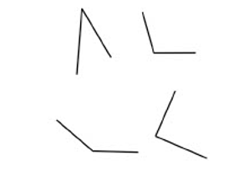
Circle the multiples of 4 | 14 30 26  16 28

Tuesday
 | 106 – 57
   | 4 | 5
  x |  | 3
Draw a pair of parallel lines
Draw lines to join all the pairs of number cards that have a total of 300 | 80 285  190 220  35 265  15 140  160 110
Match each shape to the correct name | 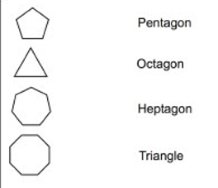

Wednesday
Double 48
   | 1 | 7
  X |  | 5
Name this shape | 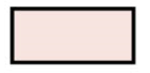
Find the two missing numbers | _____, 12, _____, 16 ______, 24
Tick any shape that has a right angle | 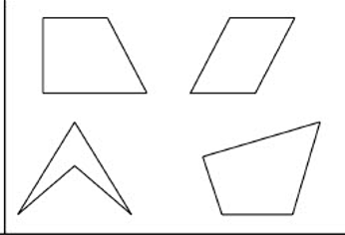

Thursday
 | 75 + 130
   | 9 | 9
  - | 2 | 7
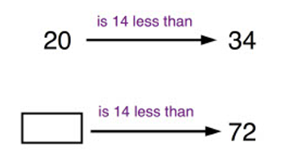
Put these prices in order, starting with the smallest  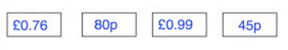 | Smallest Biggest
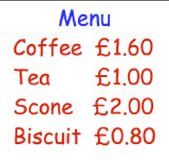 | Maddie buys two biscuits  She pays £2  How much change does she get?

Friday
6 x 8 | 491 - 6
In the diagram, three circles in a straight line add to 40.  Write the missing numbers
   | 9 | 20
  14 |  | 11
  15 |  | 9
Write down the mass of the apple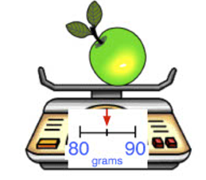
Write 4 in Roman numerals

Monday Answers
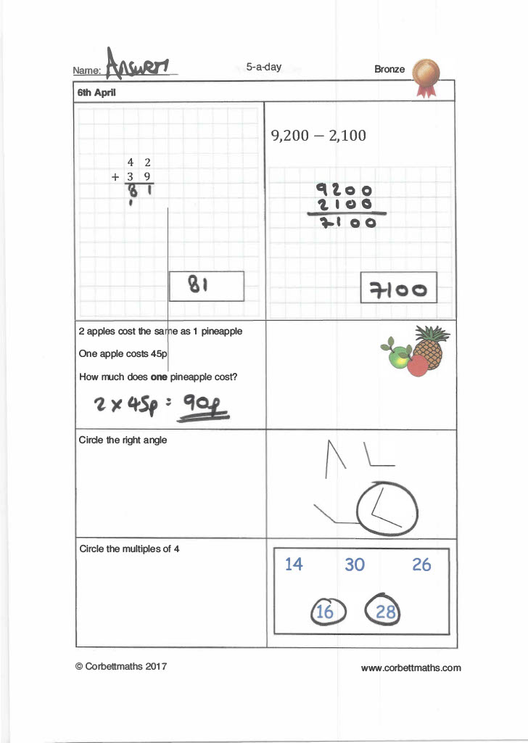

Tuesday Answers
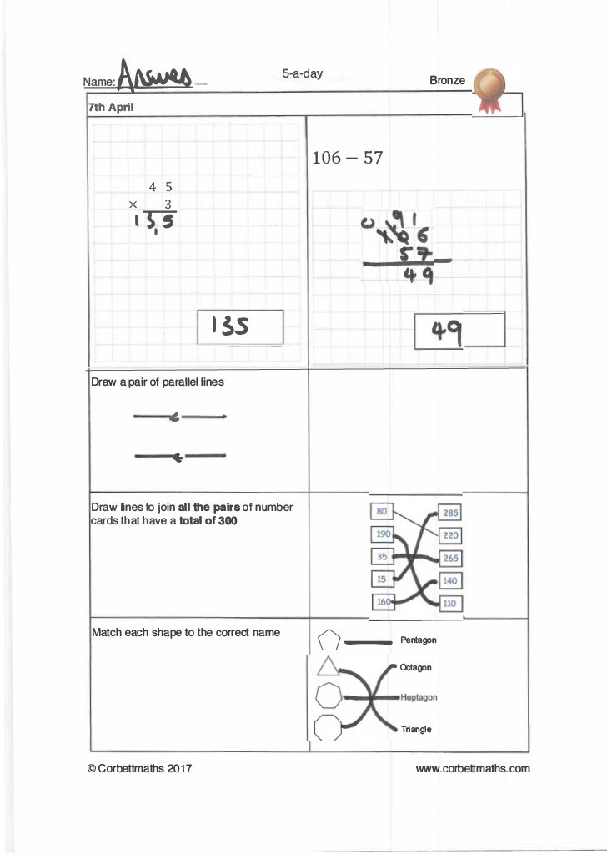

Wednesday Answers
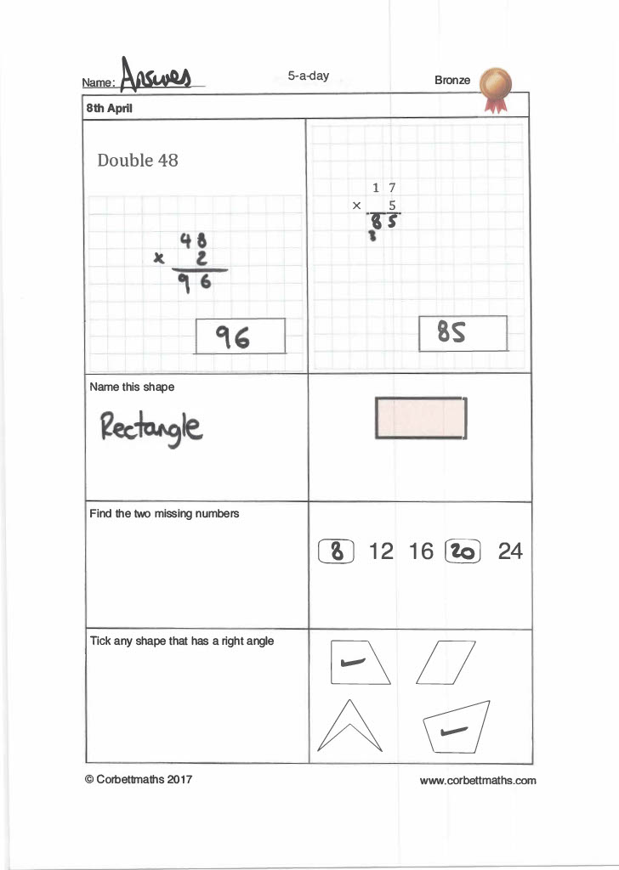

Thursday Answers
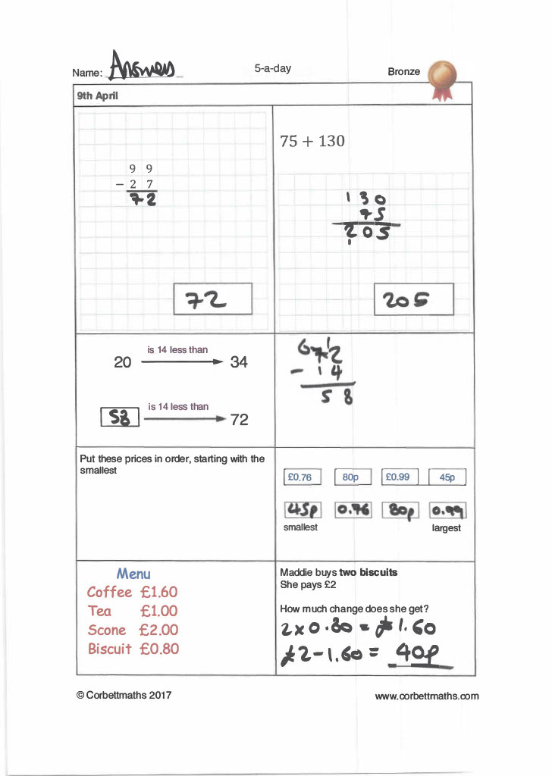

Friday Answers


