Summer Term Week 4
Pronouns
Lesson 1
Visit this website and open the lesson called Year 4 Identifying when to use pronouns (20th April)
https://www.bbc.co.uk/bitesize/articles/z64q7nb
Today, we would like you to complete Activity 1 (on-line) and Activity 2. (If you do not have a printer, write the pronouns in a list on a piece of paper. Alternatively you can select Insert, shape and the scribble tool, this will allow to write on the screen.)
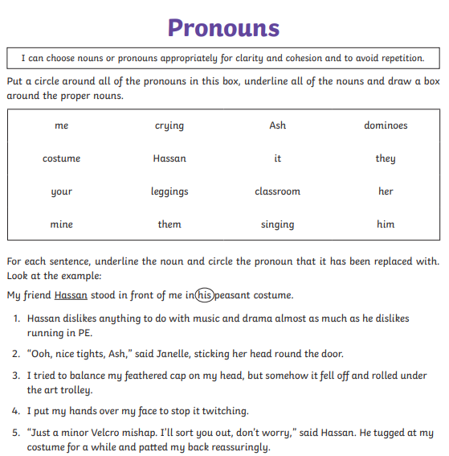
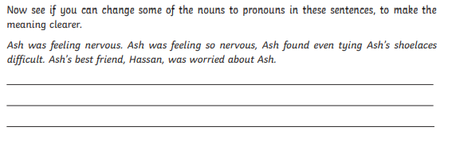
Click me to write
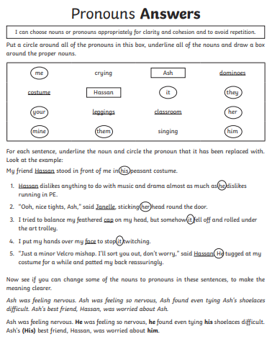

Lesson 2
Open up the website from yesterday. Today we would like you to complete Activity 3. Re-write Nathan’s paragraph using pronouns.
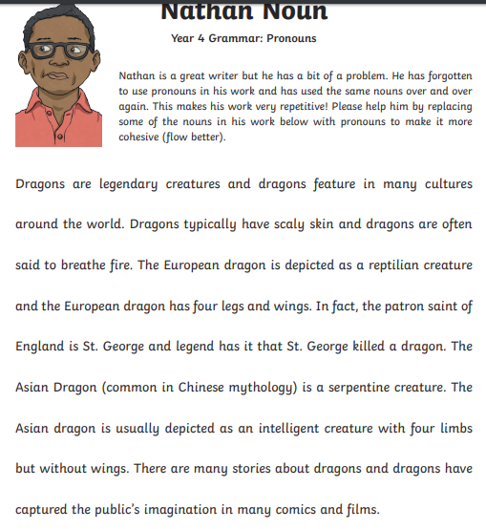
Click me to write

Lesson 3
Nathan wrote about dinosaurs because that is something that interests him. Today we would like you to write a paragraph about something that interests you BUT we do not want you to use any pronouns! (Warning! This is trickier than you might think!)
Here is mine:
In Formula One, the driver puts on the driver’s helmet and sits in the driver’s car. The driver then drives the driver’s car as fast as the driver can. The winner is the driver who puts the driver’s car over the finish line first. Lewis Hamilton wins lots of races and Lewis Hamilton is the current world champion. Lewis Hamilton is hoping to win Lewis Hamilton’s seventh world title this year.

Now, write your paragraph again using pronouns where appropriate.
In Formula One, the driver puts on his helmet and sits in his car. He then drives it as fast as he can. The winner is the driver who puts his car over the finish line first. Lewis Hamilton wins lots of races and he is the current world champion. He is hoping to win his seventh world title this year.
Click me to write
Much better! Check that you have remembered all your capital letters and full stops. Underline your pronouns.
This might help you:


