Monday
42 ÷ 7 | 120 − 45
Write am or pm in each box  Fabian has his lunch at half past twelve  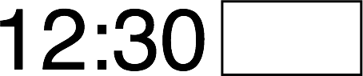 | Fabian wakes up each morning at quarter past six  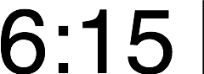
The bar chart shows how children at a primary school travelled to school each morning  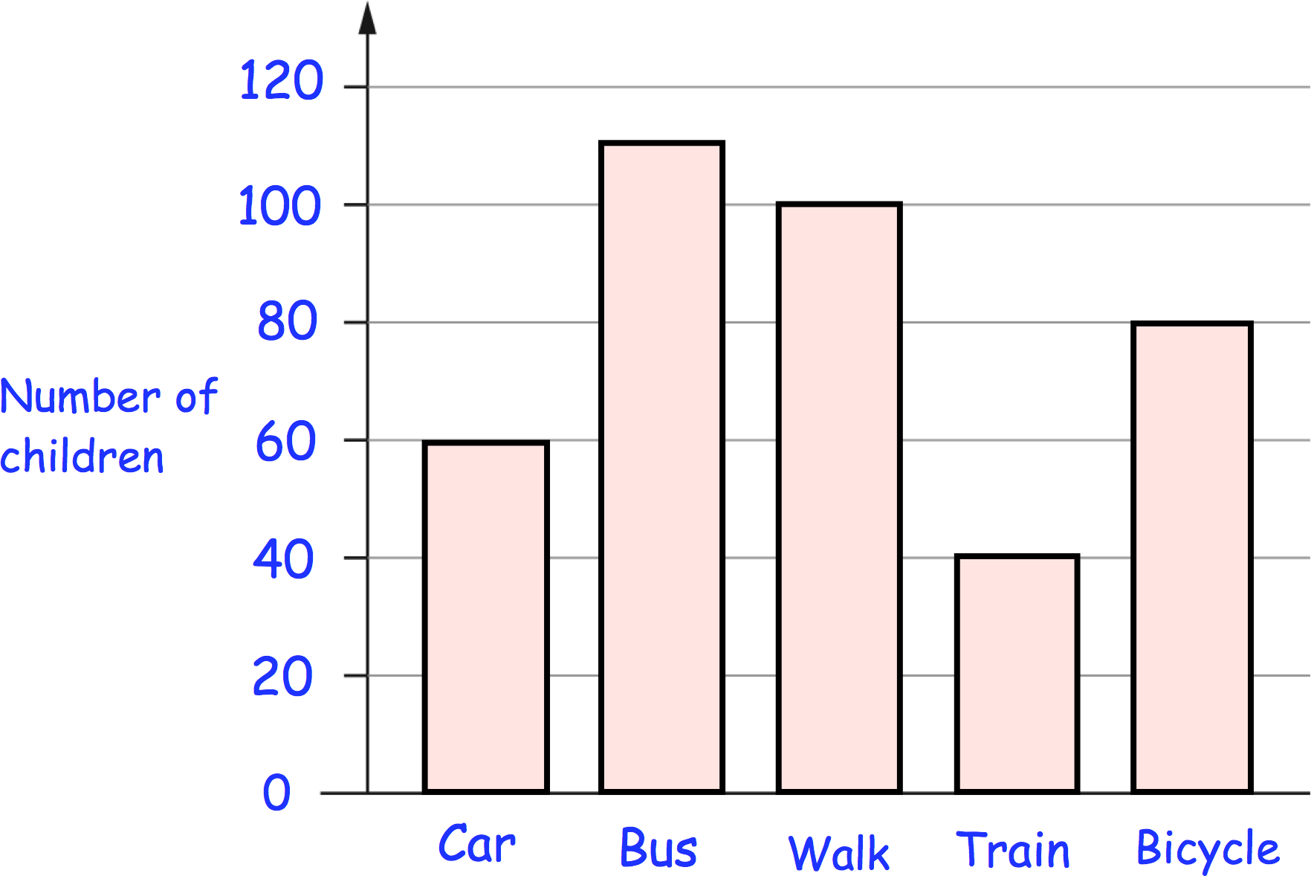 | How many children travelled to school by  bicycle?
 | How many more children travelled to school by walking than by train?

Tuesday
29 + 88 | 1,025 − 100
A group of friends earn £40 by cutting grass.  They share the money equally  They get £5 each.  How many friends are in the group? | 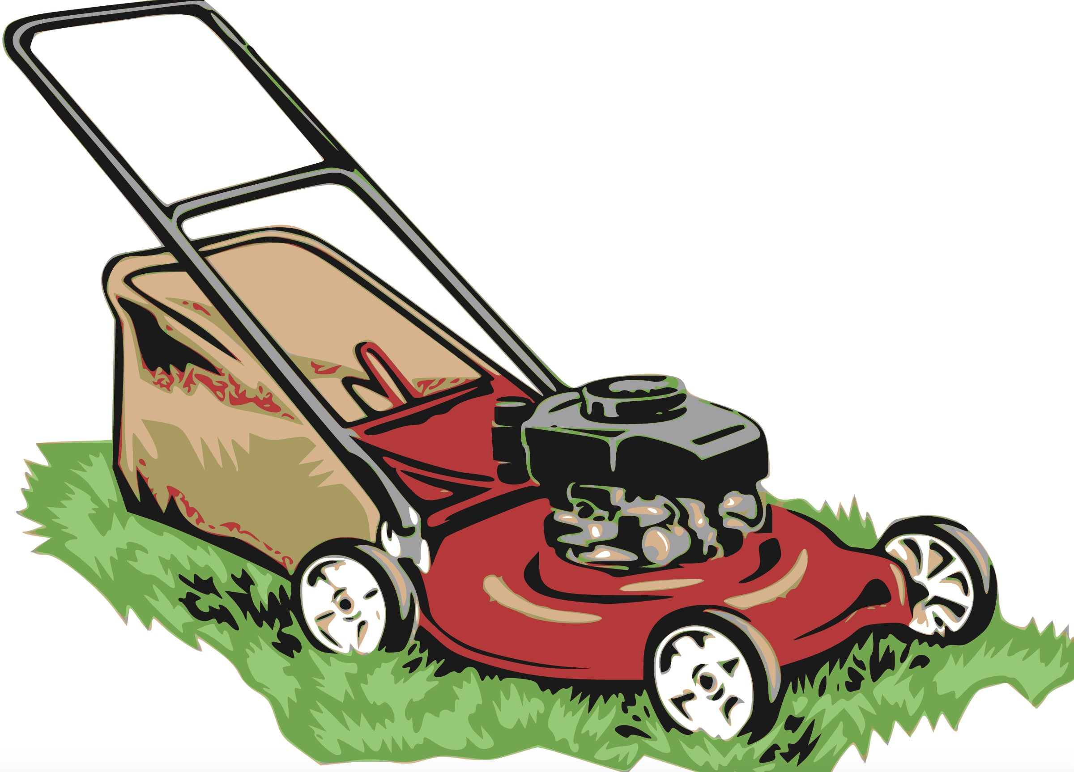
Draw a 4cm line
Andrea has these digit cards  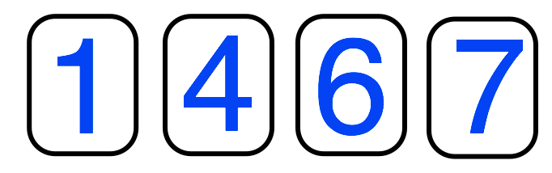  She makes a 2-digit number and a 1-digit number.  She adds them together.  Her answer is a multiple of 10 | What could Andrea’s addition be?  +

Wednesday
120 × 2 | 400 + 900
Georgia bought 3 items in a shop. Her receipt is shown below.  The price of the milk has been torn off. How much was the milk? | 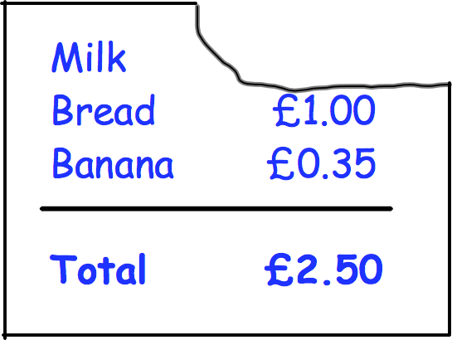
Draw a hexagon
Harry has £25
Harry has £16 less than Jenna

How much money do they have in total?

Thursday
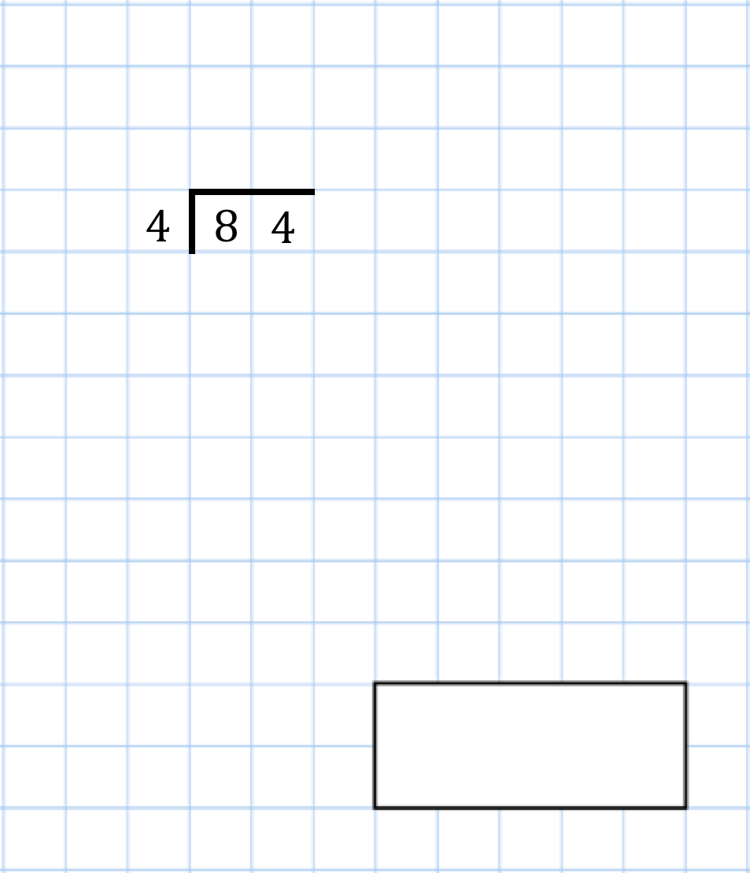 | 31 + 16 + 25
Bristol City play some football matches Here are the results  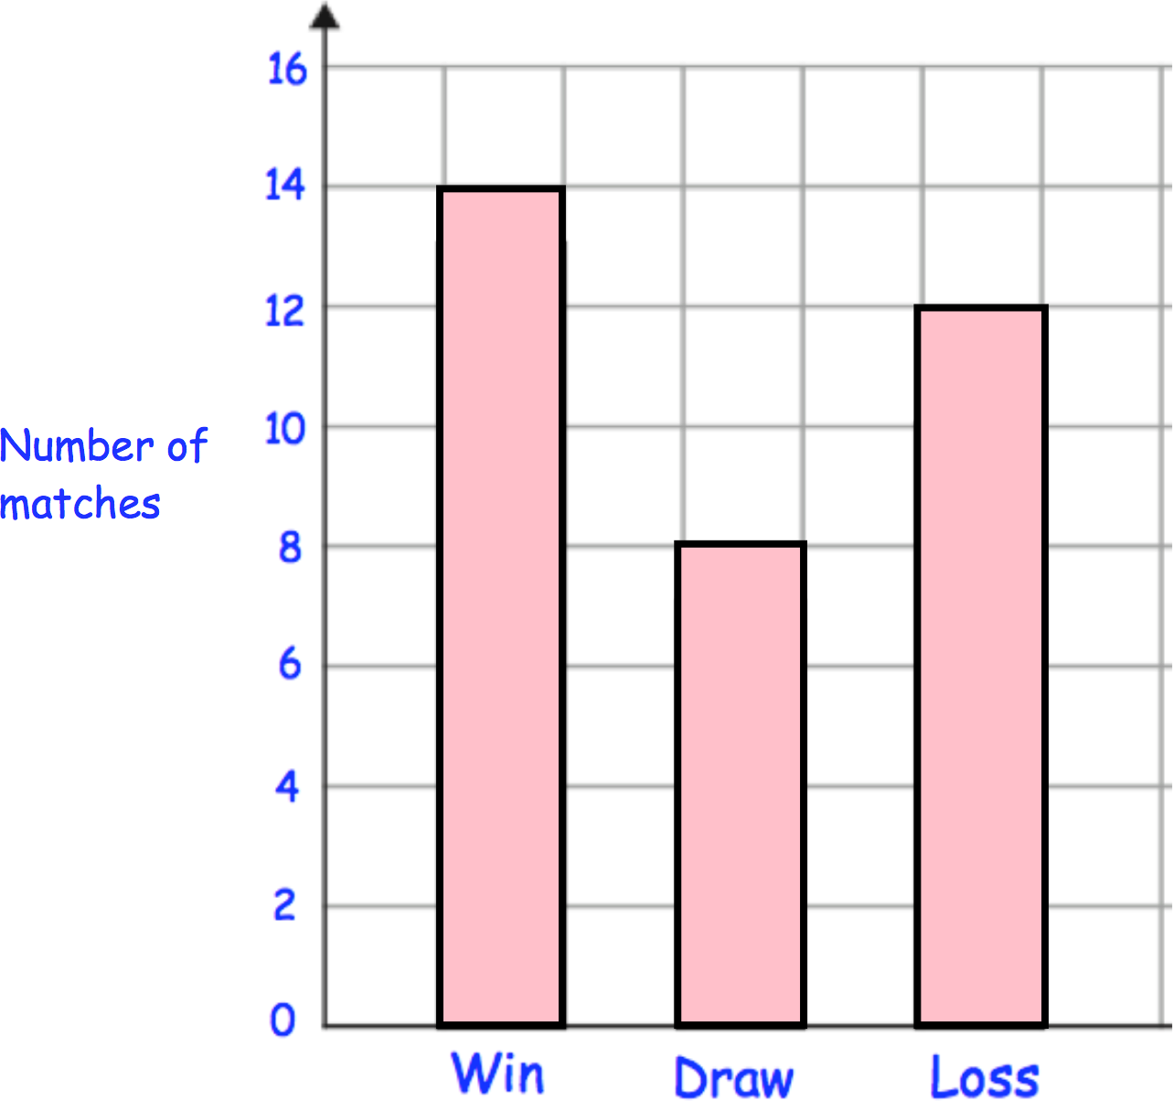 | How many matches did they draw?
 | How many matches did they play in total?
The children at Highfield School are collecting money for charity.  Their target is £200  So far they have collected £135 | How much more money do they need to reach their target?

Friday
1 of 16  2 | 3 × 18
A bottle of water holds 750 millilitres 200 millilitres of water is poured out How much water is left? | 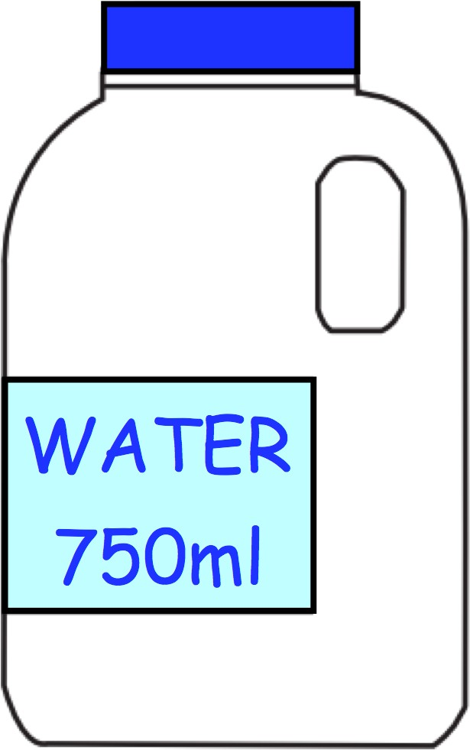
What number is the arrow pointing to? | 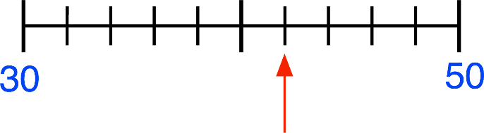
Gianluca, James and Henry run a charity cake sale.  They want to make 42 cupcakes in total  How many cupcakes should each boy make? | 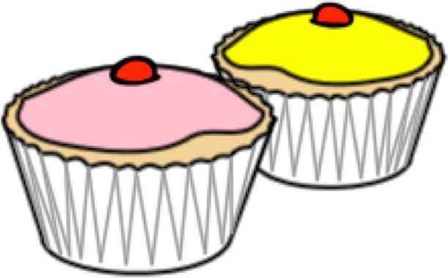

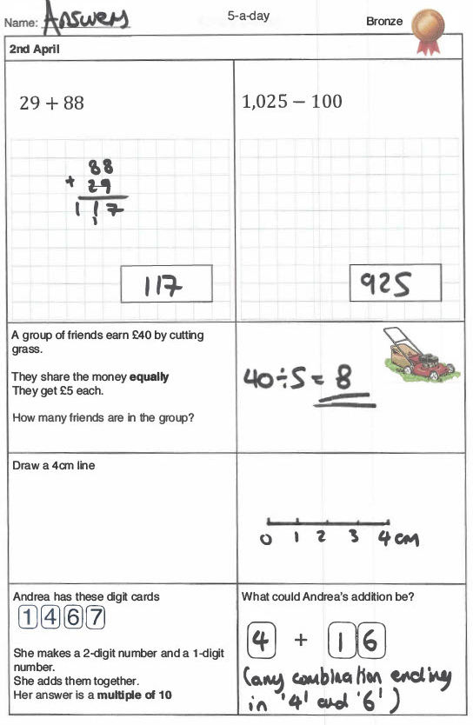
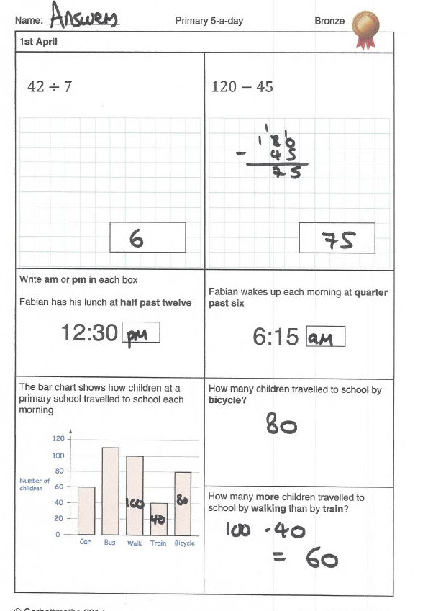
Tuesday
Tuesday
Monday
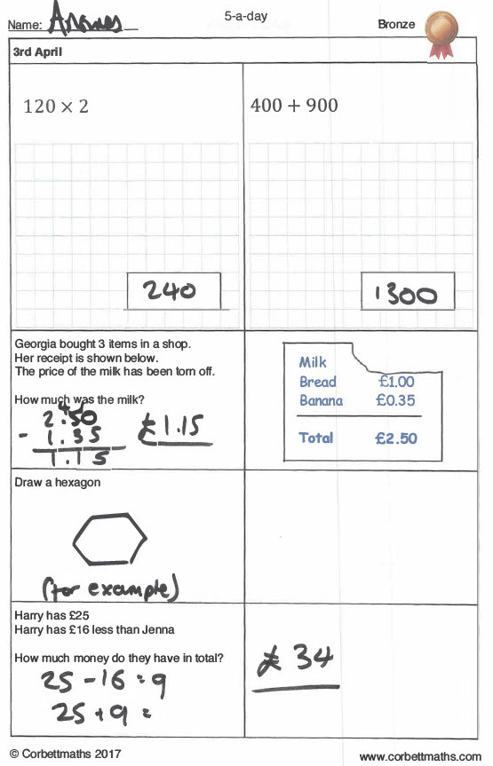
Thursday
Wednesday
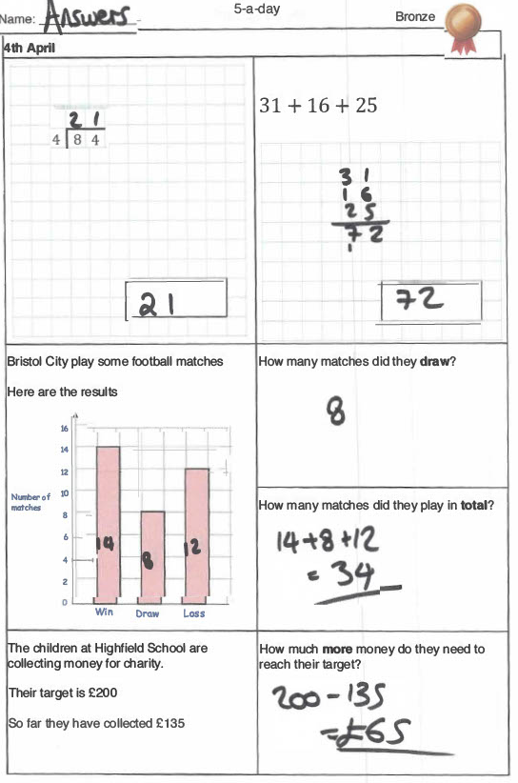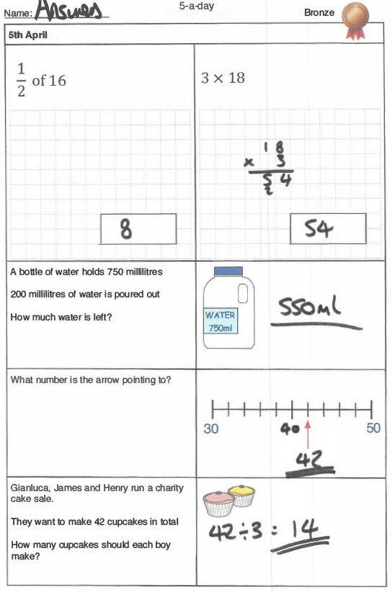
Friday

