Summer Term Week 3
Expanded noun phrases
Lesson 1
Visit this website and open the lesson called Year 4 Expanding noun phrases
https://www.bbc.co.uk/bitesize/articles/znpbgwx
(This should link to the Expanded Noun Phrases Lesson set on 21 April)
Today, we would like you to complete Activity 1 and 2.
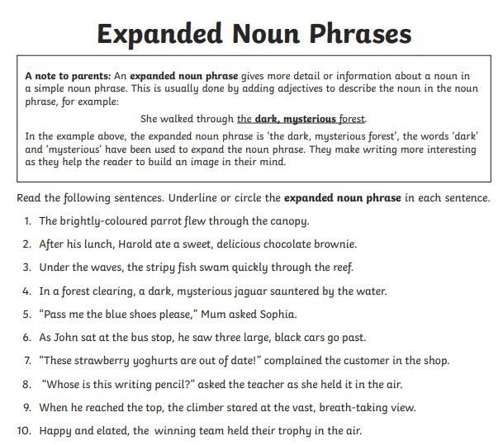
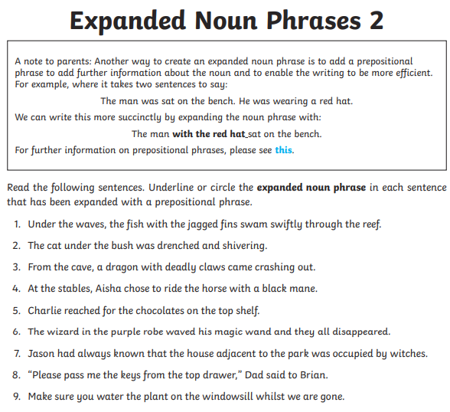
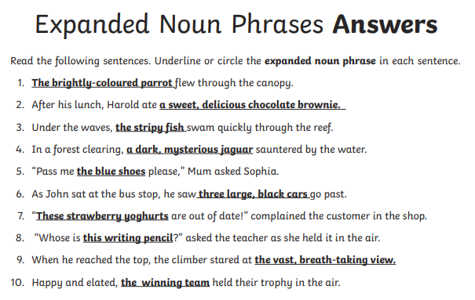
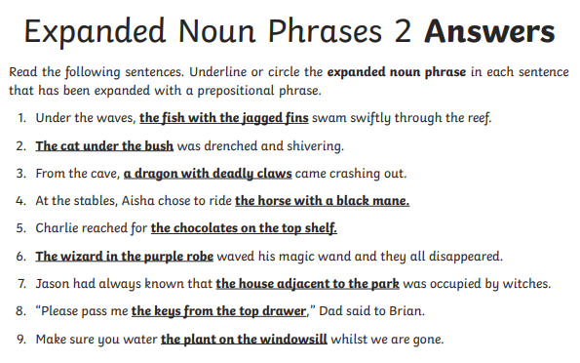

Lesson 2
Open up the website from yesterday. Today we would like you to complete Activity 3. 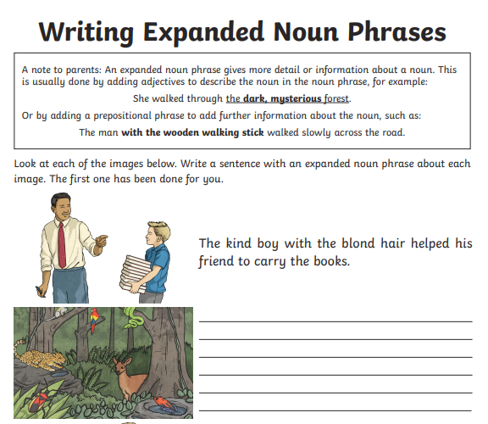
___________________________________________________________________________________________________________________________________________________________________________________________________________________________________________
___________________________________________________________________________________________________________________________________________________________________________________________________________________________________________
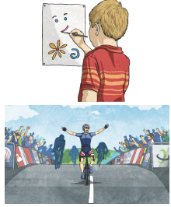
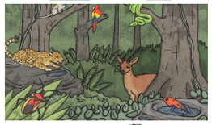
___________________________________________________________________________________________________________________________________________________________________________________________________________________________________________
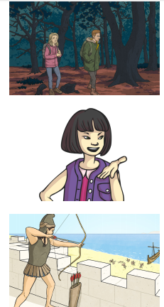
___________________________________________________________________________________________________________________________________________________________________________________________________________________________________________
___________________________________________________________________________________________________________________________________________________________________________________________________________________________________________
___________________________________________________________________________________________________________________________________________________________________________________________________________________________________________

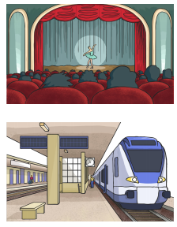
___________________________________________________________________________________________________________________________________________________________________________________________________________________________________________

___________________________________________________________________________________________________________________________________________________________________________________________________________________________________________

Lesson 3
Today we would like you to apply your knowledge of expanded noun phrases to write a setting description. You can choose one of these pictures to describe. When you have finished, neatly underline your expanded noun phrases.
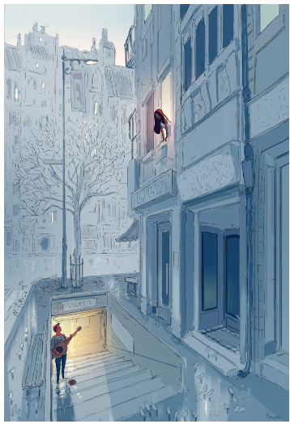
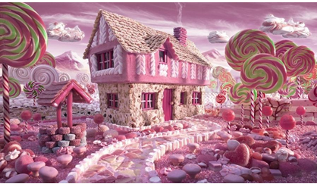

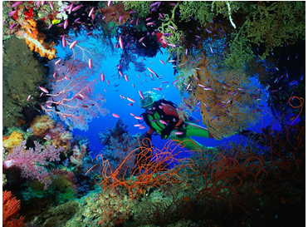

Top tip: first of all identify at least 10 nouns. If I were writing about the picture above I might write about:
the driver | the seaweed
his flippers | the seabed
his oxygen tank | the fish
his wetsuit | the water
his belt | the coral

Now you can use these to create your expanded noun phrases.
I might write:
The adventurous driver began to explore the jagged, rocky seabed looking for a shipwreck. On his body, he was wearing a bright yellow, tight-fitting wetsuit with a useful, waterproof belt around his middle.

These resources might help:



