Choose 9 of your trickiest –ly words and complete the shapes.
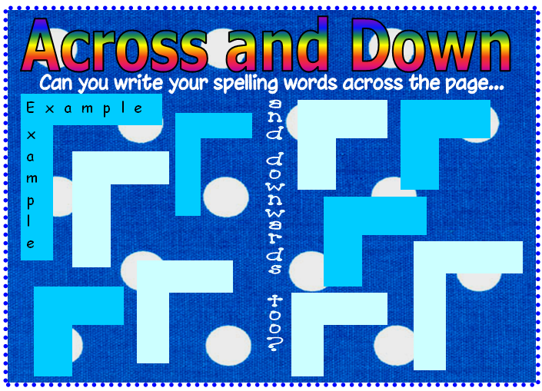
You can choose from these words: finally, truly, nobly, angrily, happily, gently, simply, dramatically, sadly, basically. Look at the example before you start.

