Name | Address | Amount per lap | Total
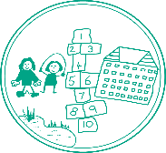Shirley Schools Colour Run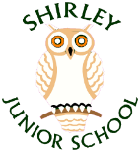
Sponsorship form
Name and class/house…………………………………………..
We are so excited that we are able to return to fundraising with a BANG! As well as being active and healthy we will be having loads of rainbow coloured fun at the Shirley Schools Colour Run on Saturday 25th September.
This is a chance to raise much needed funds across both schools as we have had a very quiet 18 months. As well as the entry fee for the colour run we are asking all runners to get sponsorship to add to our pot. Please see if you can help us to reach our targets and improve the school facilities.
They can be sponsored with cash or also on a paypal money pool. https://l.facebook.com/l.php?u=https%3A%2F%2Fpaypal.me%2Fpools%2Fc%2F8CQn5Gp1Rk%3Ffbclid%3DIwAR0Kg3cGZQkXYwpFo-kgbK-LyCJULDJnch6UVOYs16fOHUBgOj5DLNjdAzs&h=AT1d_--0CvSOIrqOlIjozLZAl-LEMmrX5aV8COoOV77mYhqqioEYWJRPTY5tp4W3zinzx3EgtwaZJejj8R8wdgpJzNOZ9qCmd6gCMg02Iia57_3ZDJc6juj280eoOVtHtjiY8w

